Lesson 10: Multi-step Measurement Problems
- Let’s solve multi-step measurement problems.

Warm-up: Notice and Wonder: Distances Traveled
What do you notice? What do you wonder?
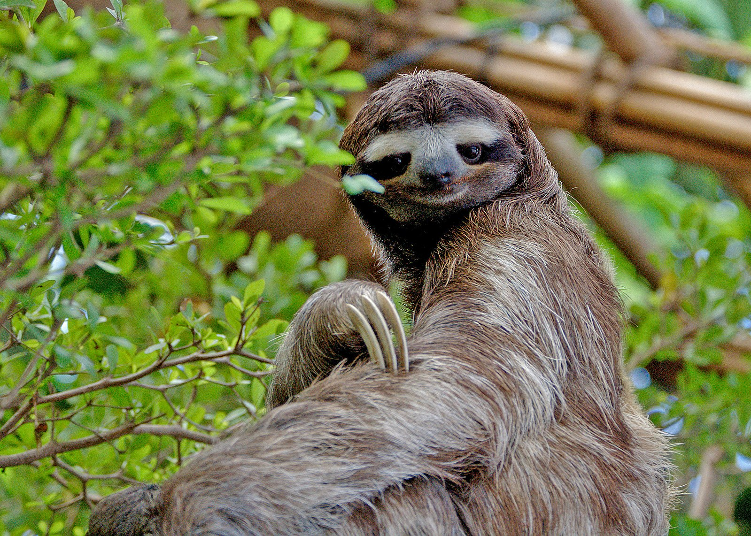
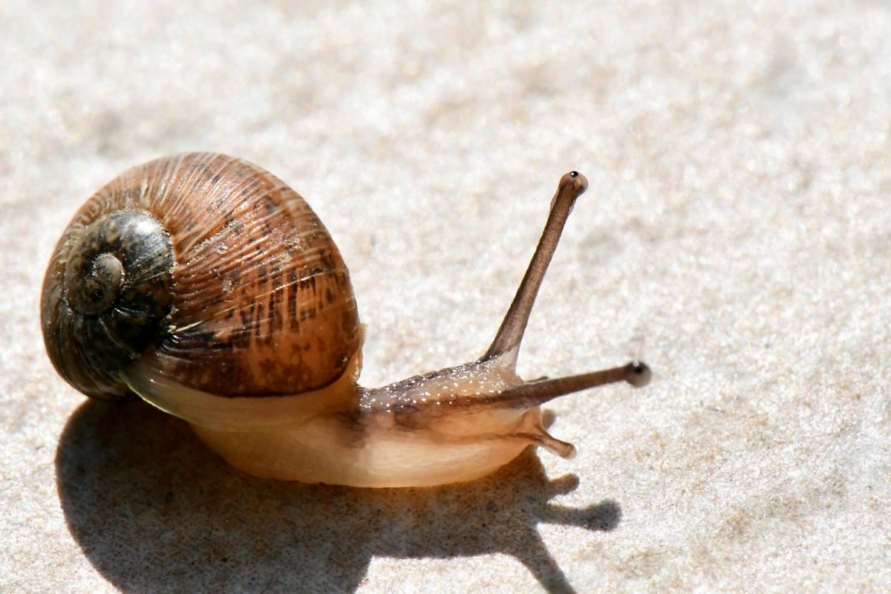
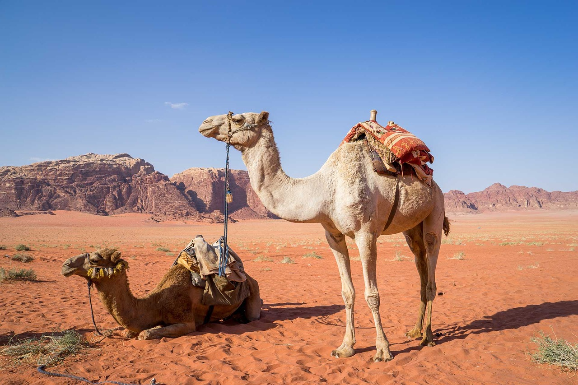
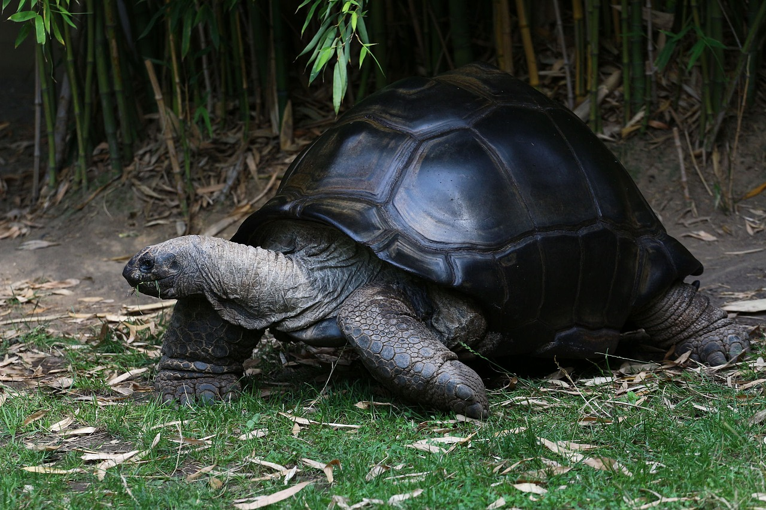
animal | distance traveled in a day
three-toed sloth | 30 meters
snail | 2,500 centimeters
dromedary | 40 kilometers
giant tortoise | 500 meters

10.1: Long Hikes, Short Hikes
Here are estimates of the farthest distances that some animals would move in one day.
animal | distance traveled in a day
three-toed sloth | 30 meters
snail | 2,500 centimeters
dromedary | 40 kilometers
giant tortoise | 500 meters
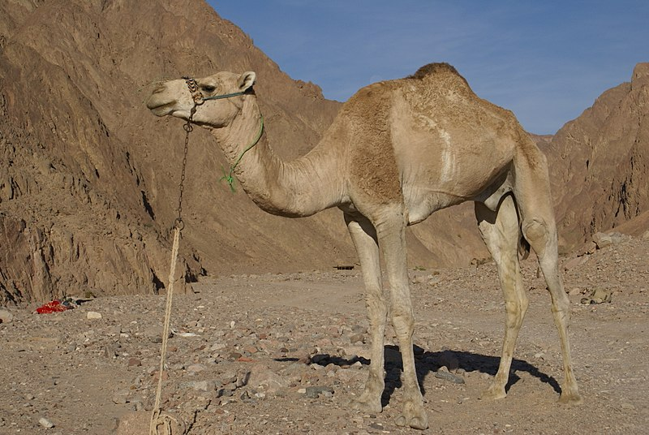
- Put the animals and their travel distances in order, from the shortest to the longest. Explain or show your reasoning.
- Do you agree with each statement? Explain your reasoning.
  - A giant tortoise can move 2 times as far as a snail can move in a day.
  - A dromedary can move 80 times as far as a giant tortoise can move in a day.

10.2: Big Bottles, Little Bottles
Here are six water bottle sizes and four clues about the amount of water they each hold.
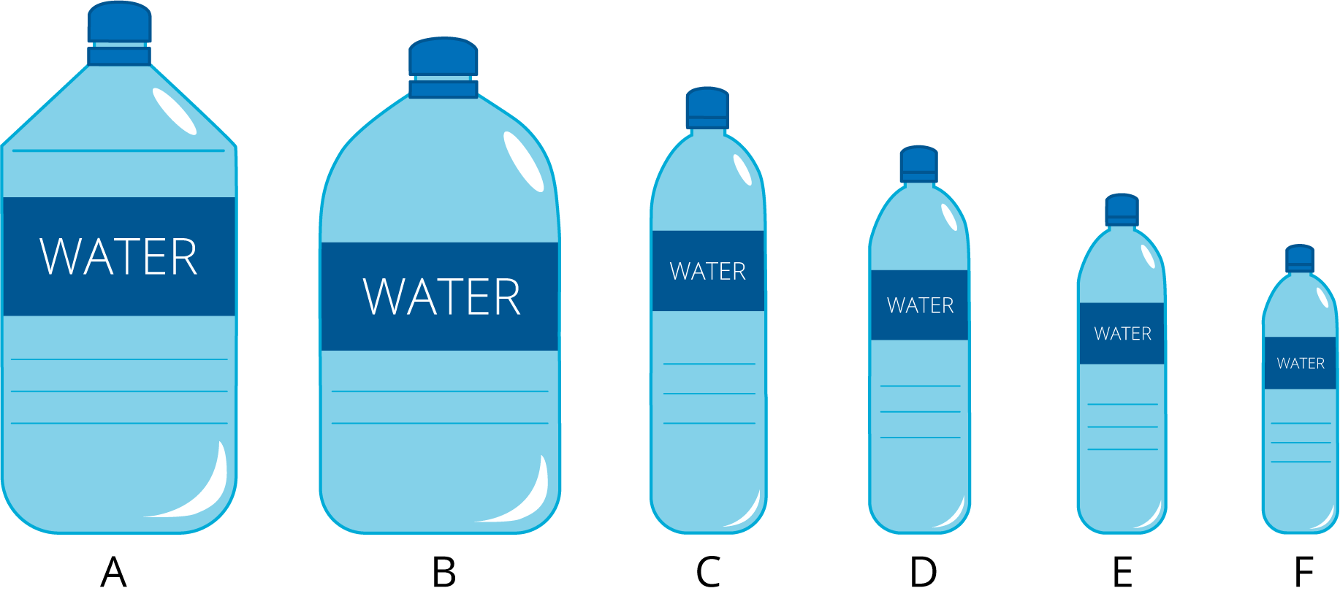
- One bottle holds 350 mL.
- A bottle in size B holds 5 times as much water as the bottle that holds 1 L.
- The largest bottle holds 20 times the amount of water in the smallest bottle.
- One bottle holds 1,500 mL, which is 3 times as much water as a bottle in size E.
Use the clues to find out the amount of water, in mL, that each bottle size holds. Be prepared to explain or show your reasoning.
A: ___________________ mL
B: ___________________ mL
C: ___________________ mL
D: ___________________ mL
E: ___________________ mL
F: ___________________ mL
© CC BY 2021 Illustrative Mathematics®

