Unit 1 Lesson 13: More Standard Deviation

1 Math Talk: Outlier Math (Warm up)

Student Task Statement
Evaluate mentally.
$0.5⋅30$
$1.5⋅30$
$100−1.5⋅30$
$100−1.5⋅18$

2 Info Gap: African and Asian Elephants

Images for Launch
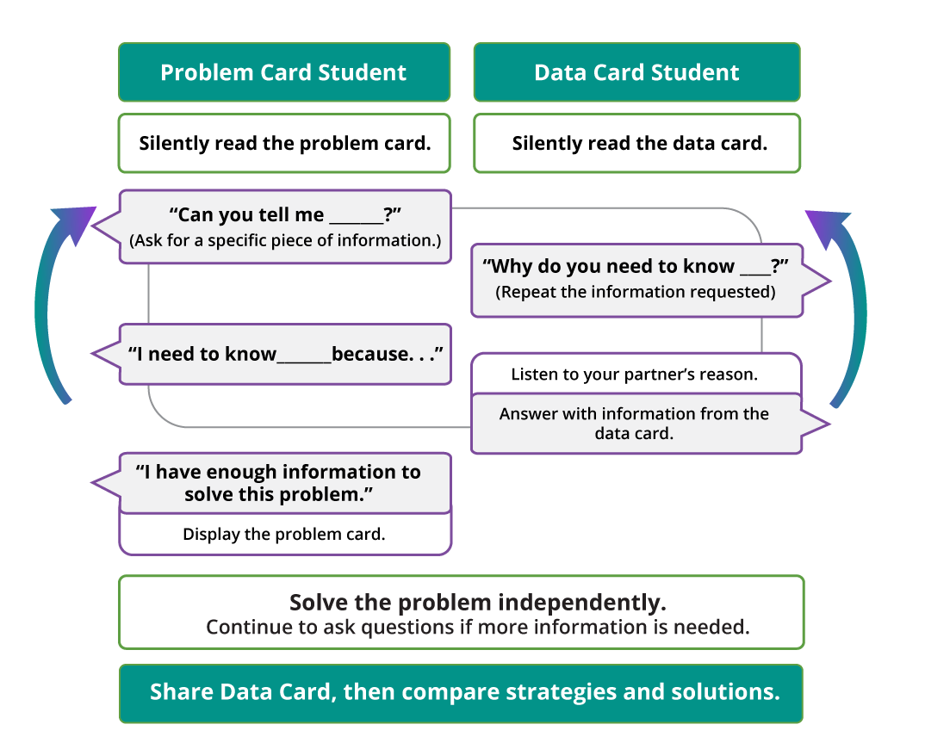

Student Task Statement
Your teacher will give you either a problem card or a data card. Do not show or read your card to your partner.
If your teacher gives you the data card:
- Silently read the information on your card.
- Ask your partner “What specific information do you need?” and wait for your partner to ask for information. Only give information that is on your card. (Do not figure out anything for your partner!)
- Before telling your partner the information, ask “Why do you need to know (that piece of information)?”
- Read the problem card, and solve the problem independently.
- Share the data card, and discuss your reasoning.
If your teacher gives you the problem card:
- Silently read your card and think about what information you need to answer the question.
- Ask your partner for the specific information that you need.
- Explain to your partner how you are using the information to solve the problem.
- When you have enough information, share the problem card with your partner, and solve the problem independently.
- Read the data card, and discuss your reasoning.

3 Interpreting Measures of Center and Variability (Optional)

Student Task Statement
For each situation, you are given two graphs of data, a measure of center for each, and a measure of variability for each.
- Interpret the measure of center in terms of the situation.
- Interpret the measure of variability in terms of the situation.
- Compare the two data sets.
- The heights of the 40 trees in each of two forests are collected.

- mean: 44.8 feet, standard deviation: 4.72 feet

- mean: 56.03 feet, standard deviation: 7.87 feet
- The number of minutes it takes Lin and Noah to finish their tests in German class is collected for the year.

- mean: 29.48 minutes, standard deviation: 5.44 minutes

- mean: 28.44 minutes, standard deviation: 7.40 minutes
- The number of raisins in a cereal with a name brand and the generic version of the same cereal are collected for several boxes.

- mean: 289.1 raisins, standard deviation: 19.8 raisins

- mean: 249.17 raisins, standard deviation: 26.35 raisins
© CC BY 2019 by Illustrative Mathematics®

