Unit 6 Lesson 9: Standard Form and Factored Form

1 Math Talk: Opposites Attract (Warm up)

Student Task Statement
Solve each equation mentally.
$40−8=40+n$
$25+\text{-}100=25−n$
$3−\frac{1}{2}=3+n$
$72−n=72+6$

2 Finding Products of Differences

Student Task Statement
- Show that $\left(x−1\right)\left(x−1\right)$ and $x^{2}−2x+1$ are equivalent expressions by drawing a diagram or applying the distributive property. Show your reasoning.
- For each expression, write an equivalent expression. Show your reasoning.
  - $\left(x+1\right)\left(x−1\right)$
  - $\left(x−2\right)\left(x+3\right)$
  - ${\left(x−2\right)}^{2}$

Activity Synthesis
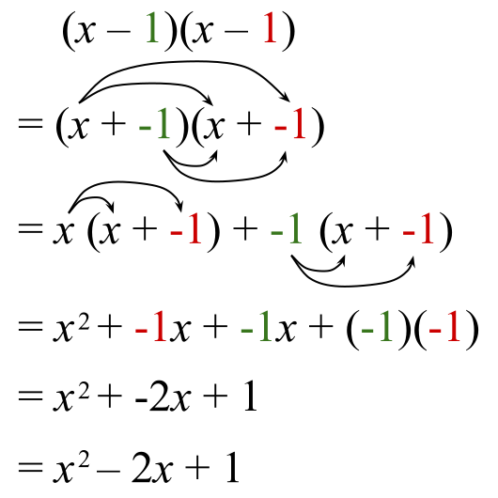

3 What is the Standard Form? What is the Factored Form?

Student Task Statement
The quadratic expression $x^{2}+4x+3$ is written in standard form.
Here are some other quadratic expressions. The expressions on the left are written in standard form and the expressions on the right are not.
Written in standard form:
$x^{2}–1$
$x^{2}+9x$
$\frac{1}{2}x^{2}$
$4x^{2}–2x+5$
$\text{-}3x^{2}–x+6$
$1−x^{2}$
Not written in standard form:
$\left(2x+3\right)x$
$\left(x+1\right)\left(x−1\right)$
$3{\left(x−2\right)}^{2}+1$
$\text{-}4\left(x^{2}+x\right)+7$
$\left(x+8\right)\left(\text{-}x+5\right)$
- What are some characteristics of expressions in standard form?
- $\left(x+1\right)\left(x−1\right)$ and $\left(2x+3\right)x$ in the right column are quadratic expressions written in factored form. Why do you think that form is called factored form?
© CC BY 2019 by Illustrative Mathematics®

