Lesson 8 Practice Problems
- Match each polynomial with its end behavior. Some end behavior options may not have a matching polynomial.
  - $f\left(x\right)=2x^{3}+3x^{4}+x^{2}−1$
  - $f\left(x\right)=1−3x+x^{2}$
  - $f\left(x\right)=9+x^{4}$
  - $f\left(x\right)=2x+5$
  - As $x$ gets larger and larger in either the positive or negative direction, $f\left(x\right)$ gets larger and larger in the positive direction.
  - As $x$ gets larger and larger in the positive direction, $f\left(x\right)$ gets larger and larger in the positive direction. As $x$ gets larger and larger in the negative direction, $f\left(x\right)$ gets larger and larger in the negative direction.
  - As $x$ gets larger and larger in the positive direction, $f\left(x\right)$ gets larger and larger in the negative direction. As $x$ gets larger and larger in the negative direction, $f\left(x\right)$ gets larger and larger in the positive direction.
  - As $x$ gets larger and larger in either the positive or negative direction, $f\left(x\right)$ gets larger and larger in the negative direction.
- Which polynomial function gets larger and larger in the negative direction as $x$ gets larger and larger in the negative direction?
  - $f\left(x\right)=5x^{2}−2x+1$
  - $f\left(x\right)=6x^{3}+4x^{2}−15x+32$
  - $f\left(x\right)=7x^{4}−2x^{3}+3x^{2}+8x−10$
  - $f\left(x\right)=8x^{6}+1$
- The graph of a polynomial function $f$ is shown. Which statement about the polynomial is true?
- 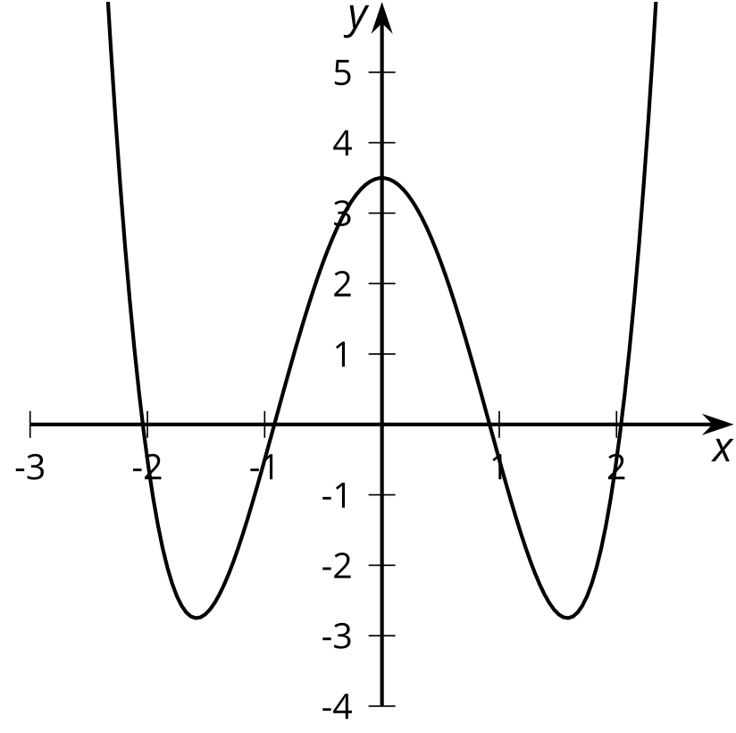
  - The degree of the polynomial is even.
  - The degree of the polynomial is odd.
  - The constant term of the polynomial is even.
  - The constant term of the polynomial is odd.
- Andre wants to make an open-top box by cutting out corners of a 22 inch by 28 inch piece of poster board and then folding up the sides. The volume $V\left(x\right)$ in cubic inches of the open-top box is a function of the side length $x$ in inches of the square cutouts.
  - Write an expression for $V\left(x\right)$.
  - What is the volume of the box when $x=6$?
  - What is a reasonable domain for $V$ in this context?
- (From Unit 2, Lesson 1.)
- For each polynomial function, rewrite the polynomial in standard form. Then state its degree and constant term.
  - $f\left(x\right)=\left(3x+1\right)\left(x+2\right)\left(x−3\right)$
  - $g\left(x\right)=\text{-}2\left(3x+1\right)\left(x+2\right)\left(x−3\right)$
- (From Unit 2, Lesson 6.)
- Kiran wrote $f\left(x\right)=\left(x−3\right)\left(x−7\right)$ as an example of a function whose graph has $x$-intercepts at $x=\text{-}3,\text{-}7$. What was his mistake?
- (From Unit 2, Lesson 7.)
- A polynomial function, $f\left(x\right)$, has $x$-intercepts at $\left(\text{-}6,0\right)$ and $\left(2,0\right)$. What is one possible factor of $f\left(x\right)$?
- (From Unit 2, Lesson 7.)
© CC BY 2019 by Illustrative Mathematics®

