Lesson 11: Pounds and Ounces
- Let’s explore measurements in pounds and ounces.

Warm-up: Notice and Wonder: A Recipe
What do you notice? What do you wonder?
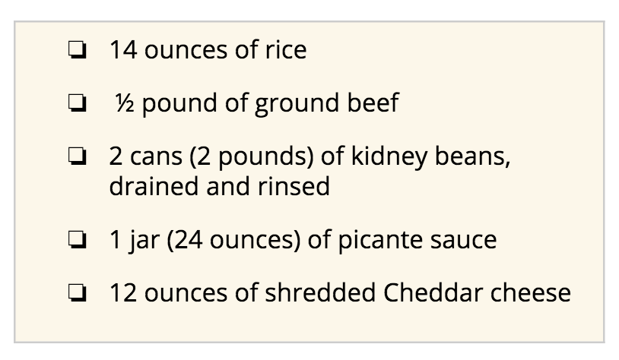

11.1: Pounds and Ounces
Your teacher will show images of some packaged food items.
- Use the information on the images to find out how pounds (lbs) and ounces (oz) are related.
  - Write a sentence to describe the relationship between the two units.
  - Use two pieces of information to show that your conclusion is right.
- Complete this table with amounts in ounces.
- pounds (lb) | - ounces (oz)
- 1
- 2
- 3
- 4
- 5
- 8
- 10

11.2: Party Prep
- A family is cooking for a party and needs to buy some ingredients for a main dish:
  - 5 pounds of rice
  - $\frac{1}{2}$ pound of almonds
  - 2 pounds 8 ounces of pinto beans
- How many ounces of each ingredient does the family need to buy? Show your reasoning.
- To make the dessert, they need 6 pounds of flour. If they already have 40 ounces of flour in the pantry, how many more ounces of flour do they need to buy?
© CC BY 2021 Illustrative Mathematics®

