Unit 7 Lesson 16: Applying Volume and Surface Area

1 You Decide (Warm up)

Student Task Statement
For each situation, decide if it requires Noah to calculate surface area or volume. Explain your reasoning.
- Noah is planning to paint the bird house he built. He is unsure if he has enough paint.
- Noah is planning to use a box with a trapezoid base to hold modeling clay. He is unsure if the clay will all fit in the box.

2 Foam Play Structure

Student Task Statement
At a daycare, Kiran sees children climbing on this foam play structure.
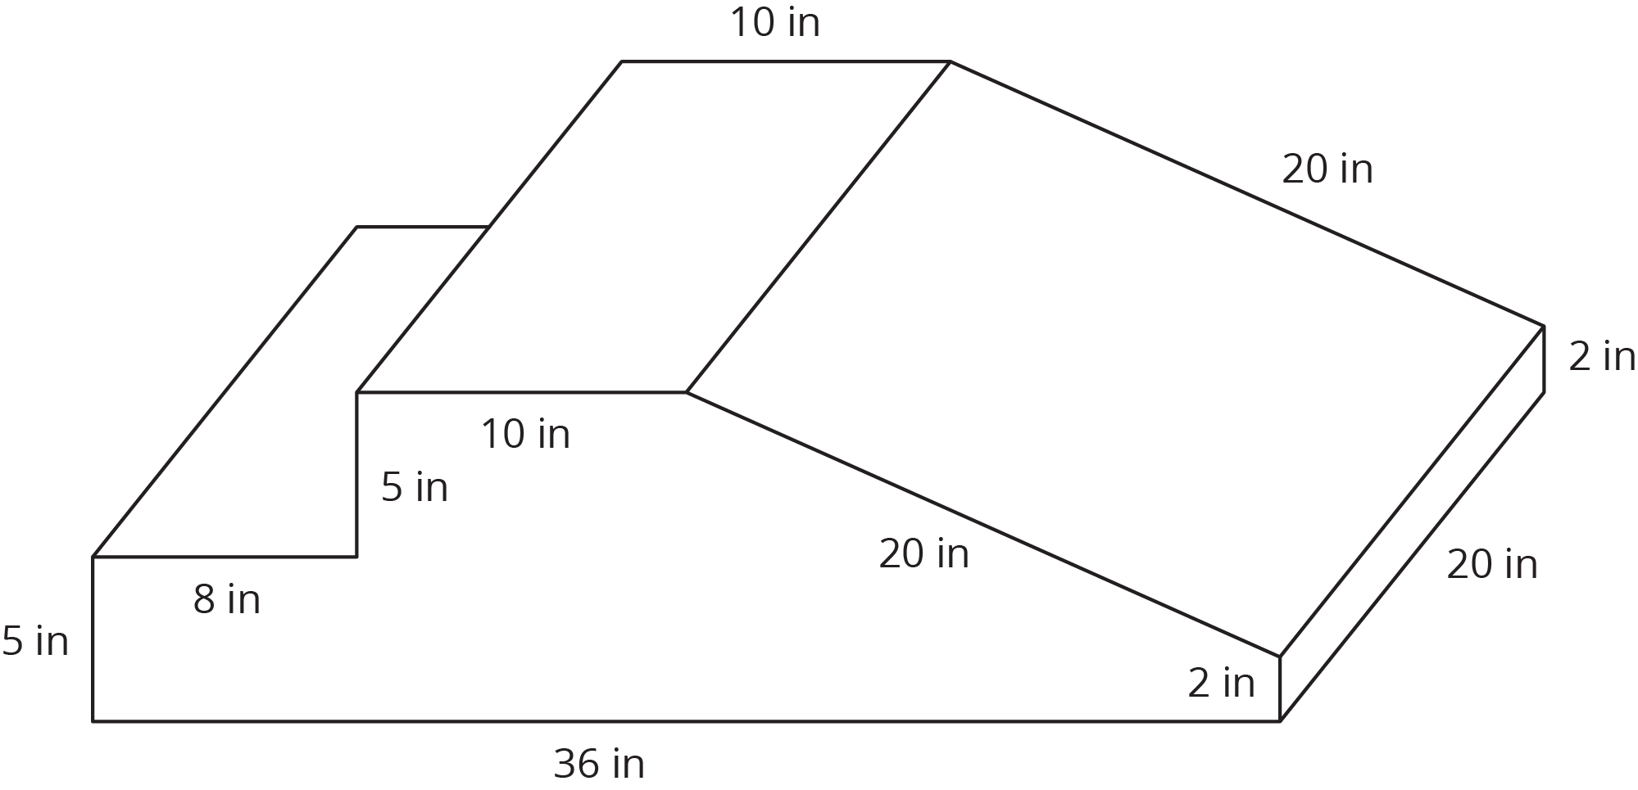
Kiran is thinking about building a structure like this for his younger cousins to play on.
- The entire structure is made out of soft foam so the children don’t hurt themselves. How much foam would Kiran need to build this play structure?
- The entire structure is covered with vinyl so it is easy to wipe clean. How much vinyl would Kiran need to build this play structure?
- The foam costs 0.8¢ per in³. Here is a table that lists the costs for different amounts of vinyl. What is the total cost for all the foam and vinyl needed to build this play structure?
- vinyl (in²)

3 Filling the Sandbox

Images for Launch
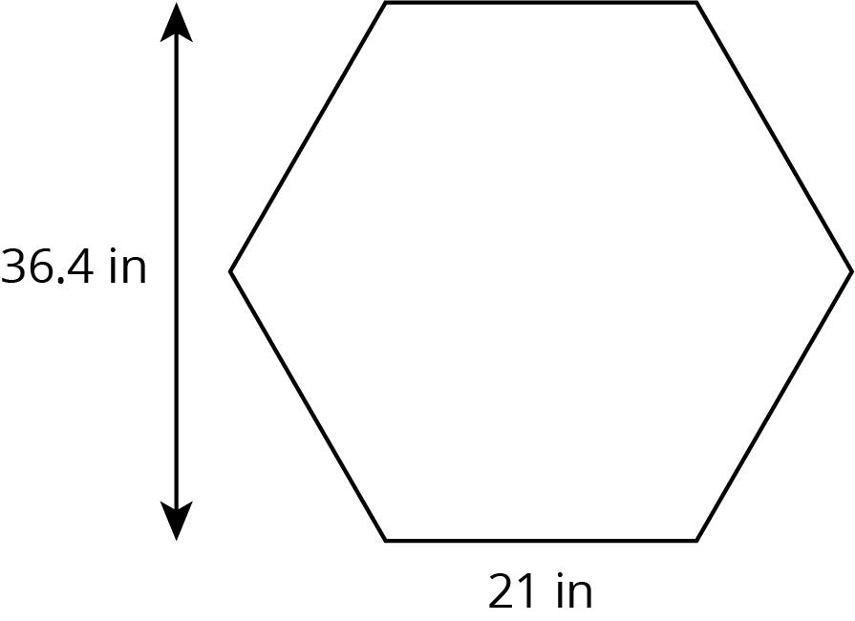

Student Task Statement
The daycare has two sandboxes that are both prisms with regular hexagons as their bases. The smaller sandbox has a base area of 1,146 in² and is filled 10 inches deep with sand.
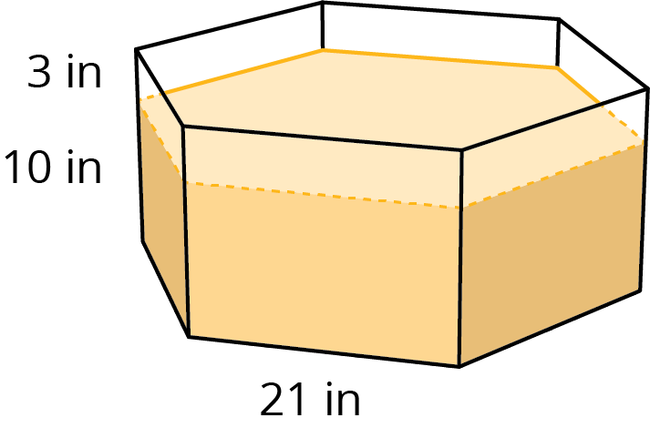
- It took 14 bags of sand to fill the small sandbox to this depth. What volume of sand comes in one bag? (Round to the nearest whole cubic inch.)
- The daycare manager wants to add 3 more inches to the depth of the sand in the small sandbox. How many bags of sand will they need to buy?
- The daycare manager also wants to add 3 more inches to the depth of the sand in the large sandbox. The base of the large sandbox is a scaled copy of the base of the small sandbox, with a scale factor of 1.5. How many bags of sand will they need to buy for the large sandbox?
- A lawn and garden store is selling 6 bags of sand for $19.50. How much will they spend to buy all the new sand for both sandboxes?
© CC BY Open Up Resources. Adaptations CC BY IM.

