Lesson 3: Interpreting Inequalities

3.1: True or False: Fractions and Decimals
Is each equation true or false? Be prepared to explain your reasoning.
- $3(12+5)=(3⋅12)⋅(3⋅5)$
- $\frac{1}{3}⋅\frac{3}{4}$ = $\frac{3}{4}⋅\frac{2}{6}$
- $2⋅(1.5)⋅12$ = $4⋅(0.75)⋅6$

3.2: Basketball Game
Noah scored $n$ points in a basketball game.
- What does $15<n$ mean in the context of the basketball game?
- What does $n<25$ mean in the context of the basketball game?
- Draw two number lines to represent the solutions to the two inequalities.
- Name a possible value for $n$ that is a solution to both inequalities.
- Name a possible value for $n$ that is a solution to $15<n$, but not a solution to $n<25$.
- Can -8 be a solution to $n$ in this context? Explain your reasoning.

3.3: Unbalanced Hangers
- Here is a diagram of an unbalanced hanger.
- 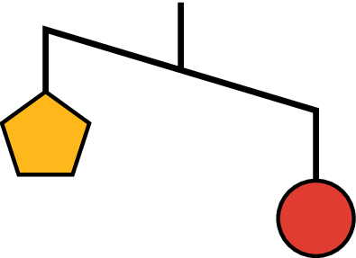
  - Jada says that the weight of one circle is greater than the weight of one pentagon. Write an inequality to represent her statement. Let $p$ be the weight of one pentagon and $c$ be the weight of one circle.
  - A circle weighs 12 ounces. Use this information to write another inequality to represent the relationship of the weights. Then, describe what this inequality means in this context.
- Here is another diagram of an unbalanced hanger.
- 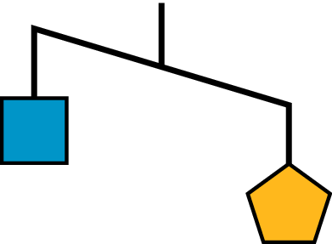
  - Write an inequality to represent the relationship of the weights. Let $p$ be the weight of one pentagon and $s$ be the weight of one square.
  - One pentagon weighs 8 ounces. Use this information to write another inequality to represent the relationship of the weights. Then, describe what this inequality means in this context.
  - Graph the solutions to this inequality on a number line.
- Based on your work so far, can you tell the relationship between the weight of a square and the weight of a circle? If so, write an inequality to represent that relationship. If not, explain your reasoning.
- This is another diagram of an unbalanced hanger.
- 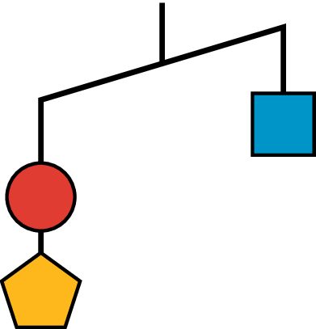
- Andre writes the following inequality: $c+p<s$. Do you agree with his inequality? Explain your reasoning.
- Jada looks at another diagram of an unbalanced hangar and writes: $s+c>2t$, where $t$ represents the weight of one triangle. Draw a sketch of the diagram.

Are you ready for more?
Here is a picture of a balanced hanger. It shows that the total weight of the three triangles is the same as the total weight of the four squares.
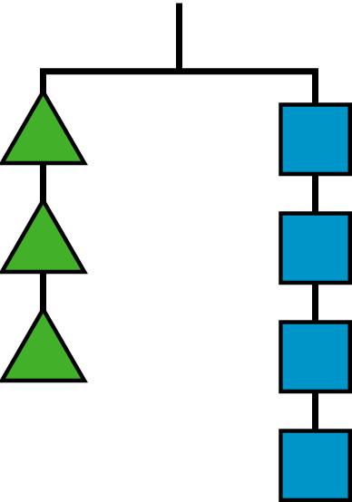
- What does this tell you about the weight of one square when compared to one triangle? Explain how you know.
- Write an equation or an inequality to describe the relationship between the weight of a square and that of a triangle. Let $s$ be the weight of a square and $t$ be the weight of a triangle.

Lesson 3 Summary
When we find the solutions to an inequality, we should think about its context carefully. A number may be a solution to an inequality outside of a context, but may not make sense when considered in context.
- Suppose a basketball player scored more than 11 points in a game, and we represent the number of points she scored, $s$, with the inequality $s>11$. By looking only at $s>11$, we can say that numbers such as 12, $14\frac{1}{2}$, and 130.25 are all solutions to the inequality because they each make the inequality true.
- $12>11$
- $14\frac{1}{2}>11$
- $130.25>11$
- In a basketball game, however, it is only possible to score a whole number of points, so fractional and decimal scores are not possible. It is also highly unlikely that one person would score more than 130 points in a single game.
- In other words, the context of an inequality may limit its solutions.
Here is another example:
- The solutions to $r<30$ can include numbers such as $27\frac{3}{4}$, 18.5, 0, and -7. But if $r$ represents the number of minutes of rain yesterday (and it did rain), then our solutions are limited to positive numbers. Zero or negative number of minutes would not make sense in this context.
- To show the upper and lower boundaries, we can write two inequalities:
- $0<r$
- $r<30$
Inequalities can also represent comparison of two unknown numbers.
- Let’s say we knew that a puppy weighs more than a kitten, but we did not know the weight of either animal. We can represent the weight of the puppy, in pounds, with $p$ and the weight of the kitten, in pounds, with $k$, and write this inequality: $p>k$
© CC BY Open Up Resources. Adaptations CC BY IM.

