Lesson 6: Completing the Square
- Let’s rewrite equations to find the center and radius of a circle.

6.1: Fill in the Box
For each expression, what value would need to be in the box in order for the expression to be a perfect square trinomial?
- x2+10x+3
- x2−16x+3
- x2+40x+3
- x2+5x+3

6.2: Complete the Process
Here is the equation of a circle: $x^{2}+y^{2}−6x−20y+105=0$
Elena wants to find the center and radius of the circle. Here is what she’s done so far.
Step 1: $x^{2}−6x+y^{2}−20y=\text{-}105$
Step 2: $x^{2}−6x+9+y^{2}−20y+100=\text{-}105+9+100$
Step 3: $x^{2}−6x+9+y^{2}−20y+100=4$
- What did Elena do in the first step?
- Why did Elena add 9 and 100 to the left side of the equation in Step 2?
- Why did Elena add 9 and 100 to the right side of the equation in Step 2?
- What should Elena do next?
- What are the center and radius of this circle?
- Draw a graph of the circle.

6.3: Your Turn
Here is the equation of a circle: $x^{2}+y^{2}−2x+4y−4=0$
- Find the center and radius of the circle. Explain or show your reasoning.
- Draw a graph of the circle.

Are you ready for more?
Triangulation is a process of using 3 distances from known landmarks to locate an exact position. Find a point that is located 5 units from the point $(3,4)$, 13 units from the point $(11,\text{-}4)$, and 17 units from the point $(21,16)$. Use the coordinate grid if it’s helpful.
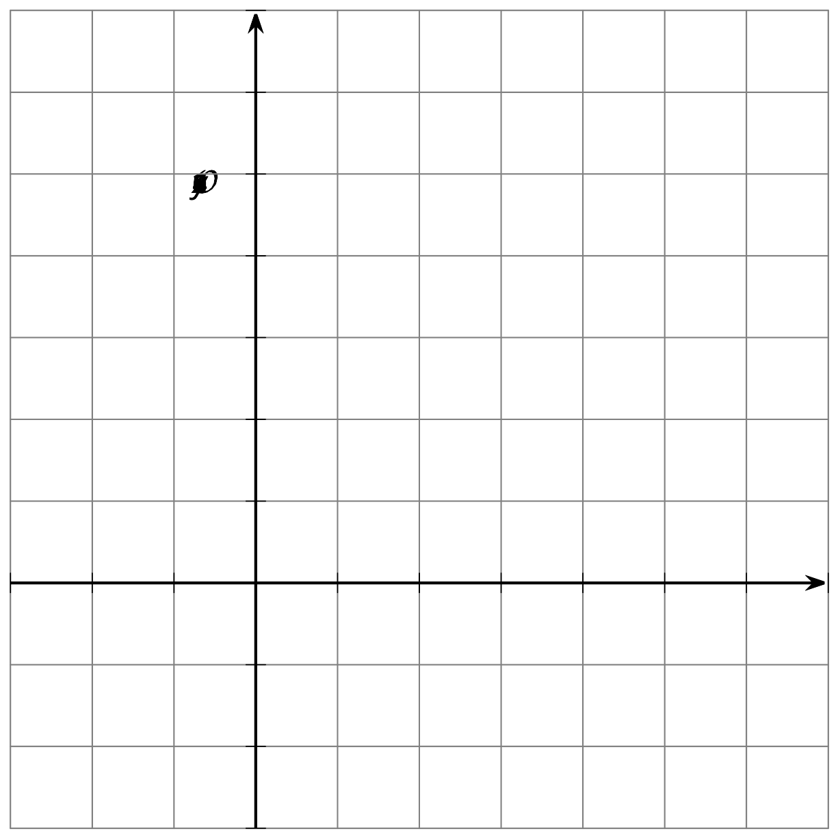

Lesson 6 Summary
Here is an equation for a circle: $x^{2}+y^{2}−4x+6y−3=0$. If we want to find the center and radius of the circle, we can rewrite the equation in the form $(x−h)^{2}+(y−k)^{2}=r^{2}$.
Start by rearranging the terms in the equation to make it easier to work with. Group terms that include the same variable and move the -3 to the right side of the equation.
$x^{2}−4x+y^{2}+6y=3$
We want the left side to include 2 perfect square trinomials—then, those trinomials can be rewritten in factored form to get the equation in the form we need. To create perfect square trinomials, we can add values to the left side. We’ll keep the equation balanced by adding those same values to the other side.
x2−4x+3+y2+6y+3=3+3+3
For the expression $x^{2}−4x$, we need to add 4 to get a perfect square trinomial. For the expression $y^{2}+6y$, we need to add 9. Add these values to both sides of the equation. Then, combine the numbers on the right side.
$x^{2}−4x+4+y^{2}+6y+9=3+4+9$
$x^{2}−4x+4+y^{2}+6y+9=16$
Now rewrite the perfect square trinomials as squared binomials, and write the 16 in the form $r^{2}$.
$(x−2)^{2}+(y+3)^{2}=4^{2}$
The circle has center $(2,\text{-}3)$ and radius 4 units.
© CC BY 2019 by Illustrative Mathematics®

