Unit 6 Lesson 15: Weighted Averages

1 Part Way: Points (Warm up)

Student Task Statement
For the questions in this activity, use the coordinate grid if it is helpful to you.
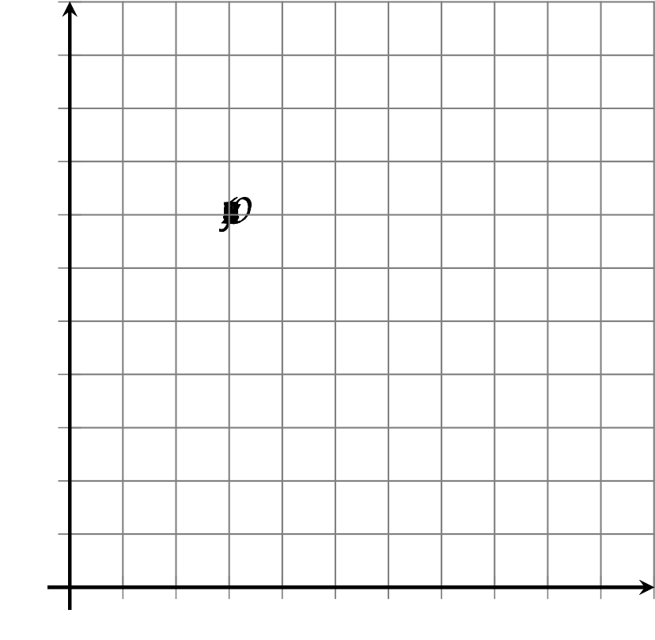
- What is the midpoint of the segment connecting $(1,2)$ and $(5,2)$?
- What is the midpoint of the segment connecting $(5,2)$ and $(5,10)$?
- What is the midpoint of the segment connecting $(1,2)$ and $(5,10)$?

Activity Synthesis

2 Part Way: Segment

Images for Launch
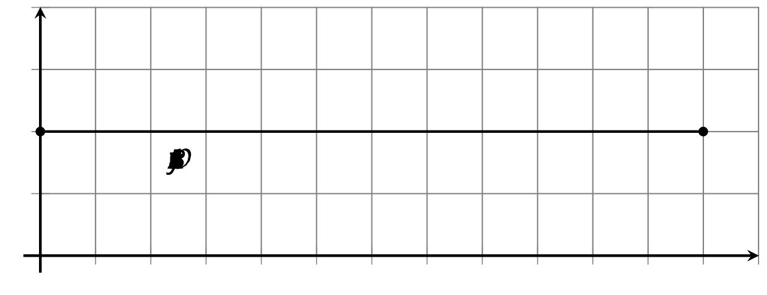

Student Task Statement
Point $A$ has coordinates $(2,4)$. Point $B$ has coordinates $(8,1)$.
- Find the point that partitions segment $AB$ in a $2:1$ ratio.
- Calculate $C=\frac{1}{3}A+\frac{2}{3}B$.
- What do you notice about your answers to the first 2 questions?
- For 2 new points $K$ and $L$, write an expression for the point that partitions segment $KL$ in a $3:1$ ratio.

Activity Synthesis

3 Part Way: Quadrilateral

Student Task Statement
Here is quadrilateral $ABCD$.
- Find the point that partitions segment $AB$ in a $1:4$ ratio. Label it $B^{′}$.
- Find the point that partitions segment $AD$ in a $1:4$ ratio. Label it $D^{′}$.
- Find the point that partitions segment $AC$ in a $1:4$ ratio. Label it $C^{′}$.
- Is $AB^{′}C^{′}D^{′}$ a dilation of $ABCD$? Justify your answer.

Images for Activity Synthesis
© CC BY 2019 by Illustrative Mathematics®

