Lesson 8: Más preguntas sobre gráficas de barras con escala

Standards Alignments
Addressing | 3.MD.B.3

Teacher-facing Learning Goals
- Solve one- and two-step “how many more” and “how many fewer” problems within 100, based on the data presented in scaled bar graphs.

Student-facing Learning Goals
- Resolvamos problemas usando datos que se muestran en gráficas de barras.

Lesson Purpose
The purpose of this lesson is for students to solve one- and two-step “how many more” and “how many fewer” problems, based on data presented in a scaled bar graph.
This lesson introduces Three Reads (MLR 6) to support students in making sense of and solving situations. In this lesson students continue to interpret graphs that represent quantities that are not exact multiples of the scale and require students to estimate values. As a result, answers may vary slightly. Accept all answers that align to reasonable estimates.
This lesson has a Student Section Summary.

Access for:

Students with Disabilities
- Engagement (Activity 2)

English Learners
- MLR8 (Activity 2)

Instructional Routines
MLR6 Three Reads (Activity 1), Number Talk (Warm-up)

Lesson Timeline
Warm-up | 10 min
Activity 1 | 20 min
Activity 2 | 15 min
Lesson Synthesis | 10 min
Cool-down | 5 min

Teacher Reflection Question
Who got to do math today in class and how do you know? Identify the norms or routines that allowed those students to engage in mathematics. How can you adjust these norms and routines so all students do math tomorrow?

Cool-down
(to be completed at the end of the lesson) 5min
Momento para leer

Student-facing Task Statement
A un grupo de estudiantes le preguntaron: “¿Cuál es tu momento favorito del día para leer?”. Sus respuestas se muestran en esta gráfica de barras:
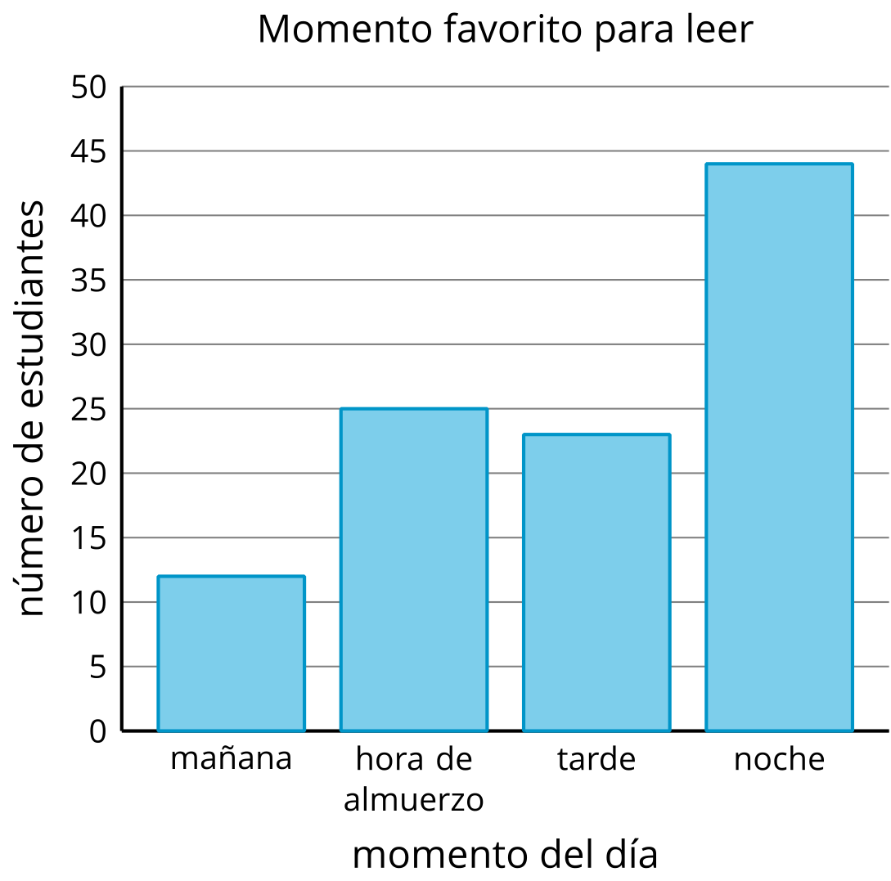
Usa la gráfica para responder las preguntas.
- ¿Cuántos estudiantes menos prefieren leer en la mañana que en la tarde? Muestra cómo pensaste. Usa expresiones o ecuaciones.
- ¿Cuántos estudiantes más prefieren leer en la noche que en la mañana o en la hora de almuerzo? Muestra cómo pensaste. Usa expresiones o ecuaciones.

Student Responses
- 12. Sample responses: $23−11=12$
- 7. Sample responses:
  - $44−\left(12+25\right)$
  - $44−10−20=14$
  - $14−2−5=7$

