Lesson 3: Associations and Relative Frequency Tables
- Let’s explore relative frequency tables

3.1: Estimation
What percentage of the graph is labeled C?
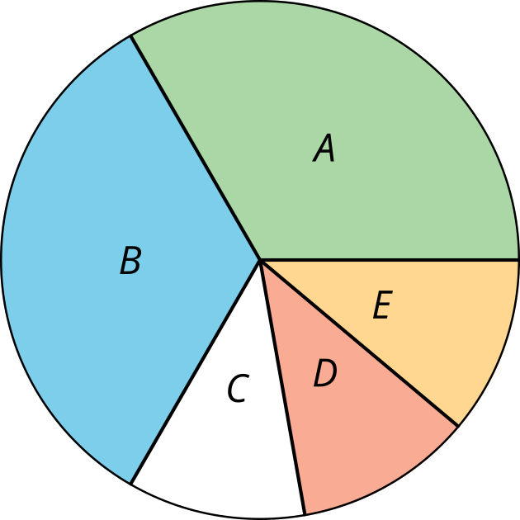
- Record an estimate that is:
- too low | - about right | - too high
- Explain your reasoning.

3.2: Relative Frequency Tables
The relative frequency tables display data collected from 230 students.
 | - participates in afterschool activity | - no afterschool activity | - total
- arrives home within 2 hours of school dismissal | - 3% | - 40% | - 43%
- arrives home 2 or more hours after school dismissal | - 42% | - 15% | - 57%
- total | - 45% | - 55% | - 100%
  - What percentage of students participate in after-school activities? How many students participate in after-school activities?
  - What percentage of students arrive home 2 or more hours after dismissal? How many students arrive home 2 or more hours after school dismissal?
 | - aspiring professional athlete | - aspiring STEM career | - total
- prefer physical education | - 77% | - 23% | - 100%
- prefer math | - 18% | - 82% | - 100%
  - What percentage of students who prefer math aspire to have a career in STEM?
  - What percentage of students who prefer physical education aspire to have a career in STEM?
  - Are these two percentages close?
  - Is there evidence of an association between students’ career aspirations and subject preference? Explain your reasoning.
 | - 9th grade | - 12th grade
- curfew | - 95% | - 90%
- no curfew | - 5% | - 10%
- total | - 100% | - 100%
  - Of the students in 12th grade, what percentage have a curfew?
  - Of the students in 9th grade, what percentage have a curfew?
  - Is there evidence of an association between students’ grade level and whether they have a curfew? Explain your reasoning.

3.3: Associate Your Variables
- Invent a pair of variables that you think will have an association. Explain your reasoning.
- Invent a pair of variables that you think will not have an association. Explain your reasoning.
© CC BY 2019 by Illustrative Mathematics®

