Unit 1 Lesson 16: More Symmetry

1 Which One Doesn't Belong: Symmetry (Warm up)

Student Task Statement
Which one doesn’t belong?

A
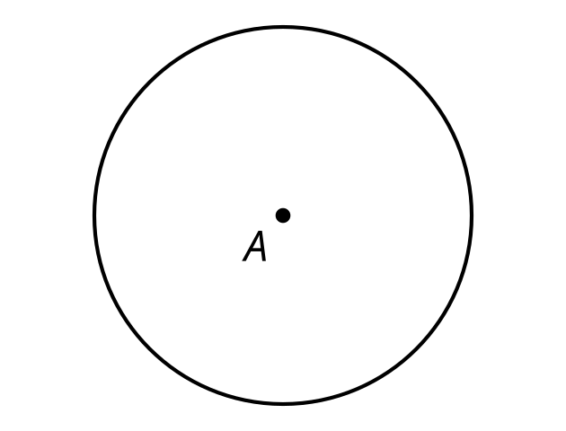

B
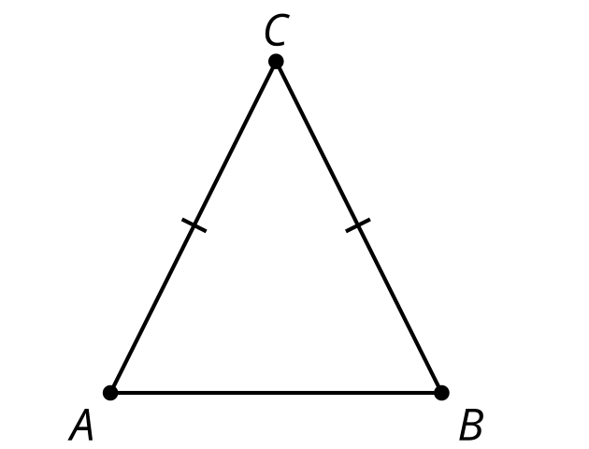

C
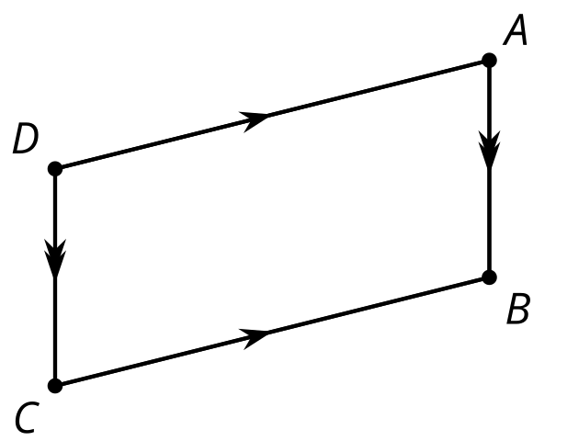

D
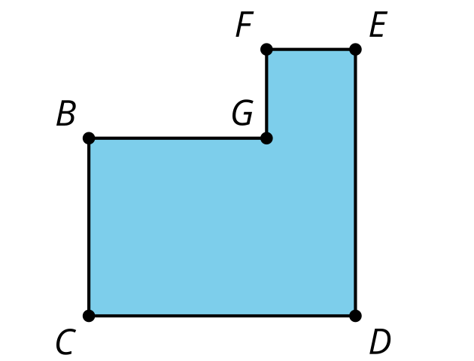

2 Self Rotation

Student Task Statement
Determine all the angles of rotation that create symmetry for the shape your teacher assigns you. Create a visual display about your shape. Include these parts in your display:
- the name of your shape
- the definition of your shape
- drawings of each rotation that creates symmetry
- a description in words of each rotation that creates symmetry, including the center, angle, and direction of rotation
- one non-example (a description and drawing of a rotation that does not result in symmetry)

3 Parallelogram Symmetry

Student Task Statement
Clare says, "Last class I thought the parallelogram would have reflection symmetry. I tried using a diagonal as the line of symmetry but it didn’t work. So now I’m doubting that it has rotation symmetry."
Lin says, "I thought that too at first, but now I think that a parallelogram does have rotation symmetry. Here, look at this."
How could Lin describe to Clare the symmetry she sees?

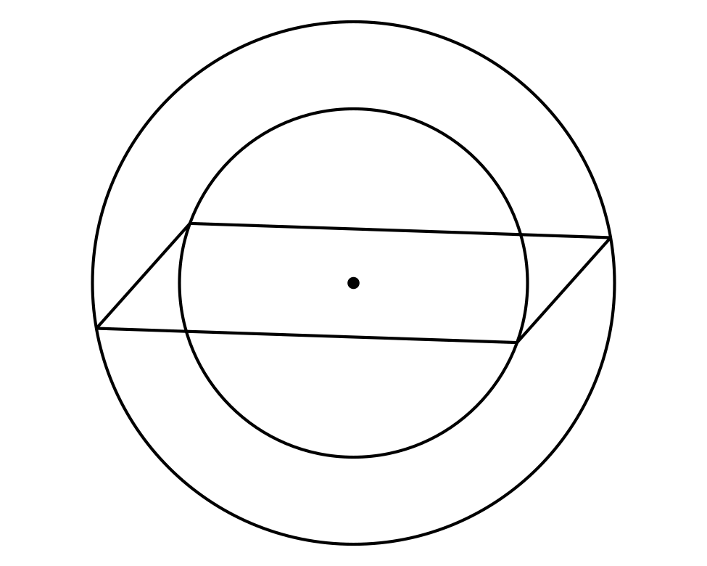
© CC BY 2019 by Illustrative Mathematics®

