Lesson 13 Practice Problems
- In right triangle $ABC$, altitude $CD$ is drawn to its hypotenuse. Select all triangles which must be similar to triangle $ABC$.
- 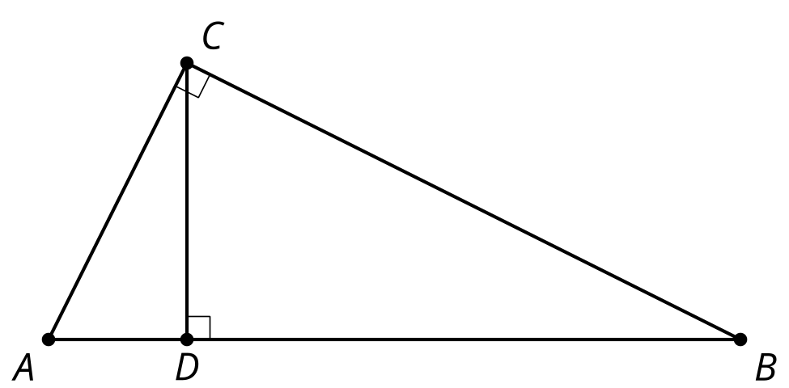
  - $ABC$
  - $ACD$
  - $BCD$
  - $BDC$
  - $CAD$
  - $CBD$
- In right triangle $ABC$, altitude $CD$ with length $h$ is drawn to its hypotenuse. We also know $AD=12$ and $DB=3$. What is the value of $h$?
- 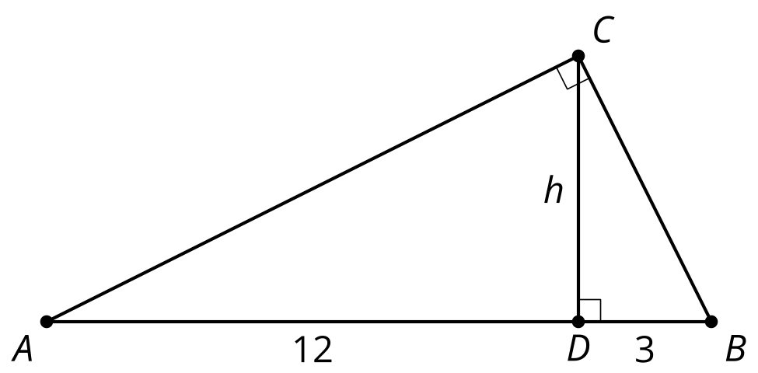
- In triangle $ABC$ (not a right triangle), altitude $CD$ is drawn to side $AB$. The length of $AB$ is $c$. Which of the following statements must be true?
- 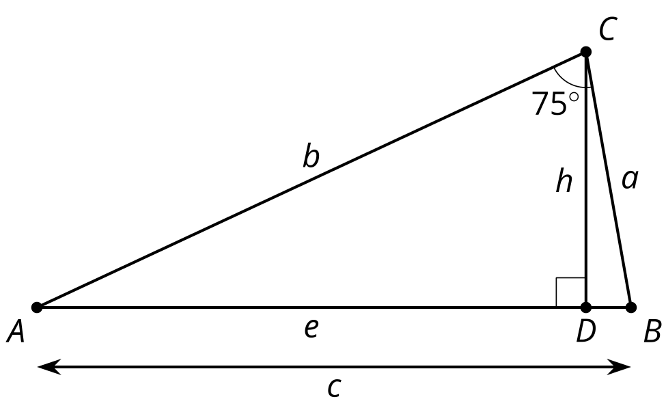
  - The measure of angle $ACB$ is the same measure as angle $B$.
  - $b^{2}=c^{2}+a^{2}$.
  - Triangle $ADC$ is similar to triangle $ACB$.
  - The area of triangle $ABC$ equals $\frac{1}{2}h⋅c$.
- Quadrilateral $ABCD$ is similar to quadrilateral $A^{′}B^{′}C^{′}D^{′}$. Write 2 equations that could be used to solve for missing lengths.
- (From Unit 3, Lesson 12.)
- Segment $A^{′}B^{′}$ is parallel to segment $AB$.
  - What is the length of segment $A^{′}A$?
  - What is the length of segment $B^{′}B$?
- 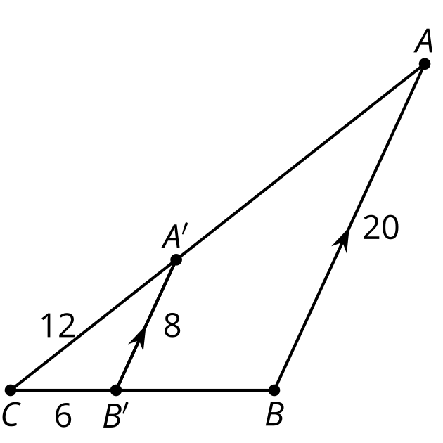
- (From Unit 3, Lesson 11.)
- Lines $BC$ and $DE$ are both vertical. What is the length of $AD$?
- 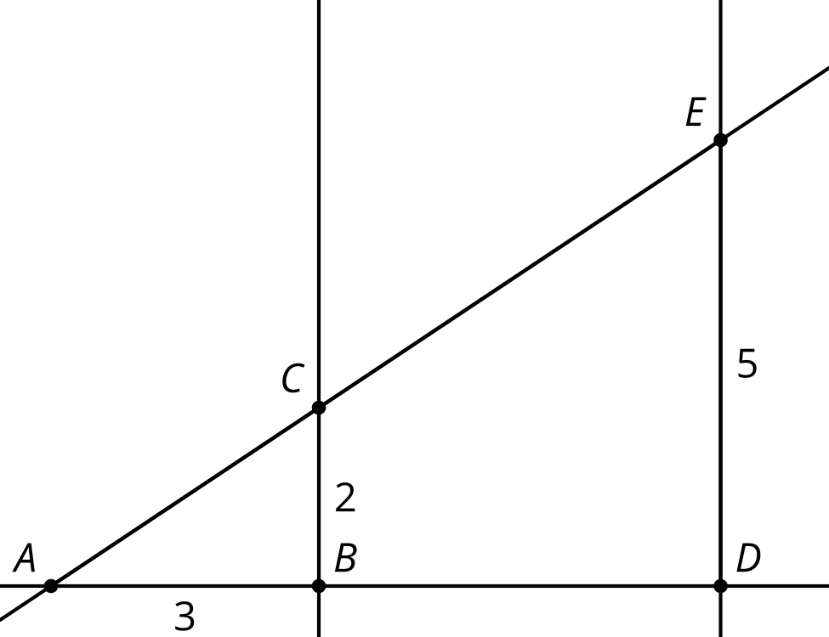
  - 4.5
  - 5
  - 7.5
  - 10
- (From Unit 3, Lesson 12.)
- Triangle $DEF$ is formed by connecting the midpoints of the sides of triangle $ABC$. Select all true statements.
- 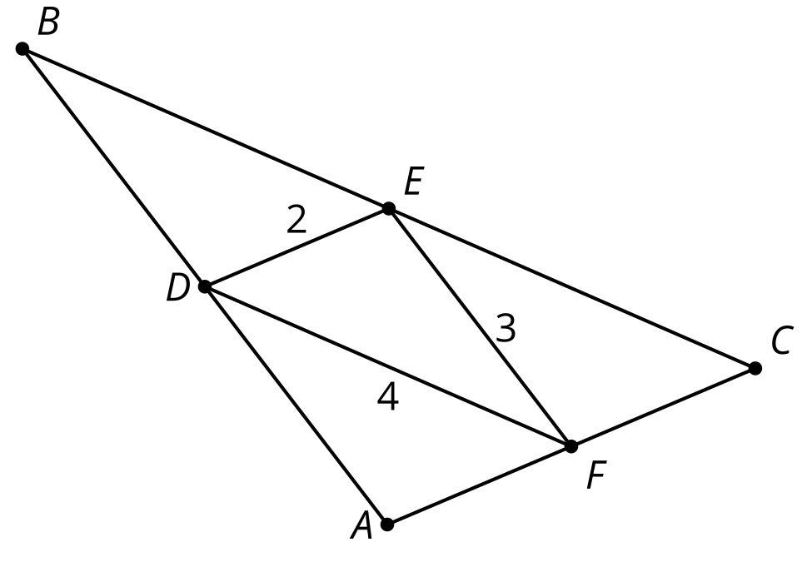
  - Triangle $BDE$ is congruent to triangle $EFC$
  - Triangle $BDE$ is congruent to triangle $DAF$
  - $BD$ is congruent to $FE$
  - The length of $BC$ is 8
  - The length of $BC$ is 6
- (From Unit 3, Lesson 5.)
© CC BY 2019 by Illustrative Mathematics®

