Lesson 9 Practice Problems
- Match the polynomial with its end behavior.
  - $f\left(x\right)=\text{-}2x+3$
  - $f\left(x\right)=x^{2}−6x+3$
  - $f\left(x\right)=1−x^{2}+2x^{3}$
  - $f\left(x\right)=7−x^{4}$
  - As $x$ gets larger and larger in either the positive or negative direction, $f\left(x\right)$ gets larger and larger in the positive direction.
  - As $x$ gets larger and larger in the positive direction, $f\left(x\right)$ gets larger and larger in the positive direction. As $x$ gets larger and larger in the negative direction, $f\left(x\right)$ gets larger and larger in the negative direction.
  - As $x$ gets larger and larger in the positive direction, $f\left(x\right)$ gets larger and larger in the negative direction. As $x$ gets larger and larger in the negative direction, $f\left(x\right)$ gets larger and larger in the positive direction.
  - As $x$ gets larger and larger in either the positive or negative direction, $f\left(x\right)$ gets larger and larger in the negative direction.
- State the degree and end behavior of $f\left(x\right)=\text{-}x^{3}+5x^{2}+6x+1$. Explain or show your reasoning.
- The graph of a polynomial function $f$ is shown. Select all the true statements about the polynomial.
- 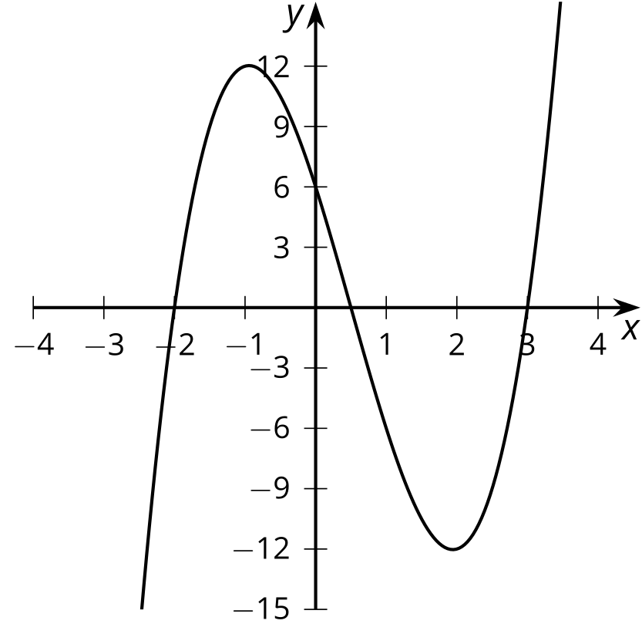
  - The degree of the polynomial is even.
  - The degree of the polynomial is odd.
  - The leading coefficient is positive.
  - The leading coefficient is negative.
  - The constant term of the polynomial is positive.
  - The constant term of the polynomial is negative.
- Write the sum of $5x^{2}+2x−10$ and $2x^{2}+6$ as a polynomial in standard form.
- (From Unit 2, Lesson 4.)
- State the degree and end behavior of $f\left(x\right)=4x^{3}+3x^{5}−x^{2}−2$. Explain or show your reasoning.
- (From Unit 2, Lesson 8.)
- Select all the polynomial functions whose graphs have $x$-intercepts at $x=4,\text{-}\frac{1}{4},\text{-}2$.
  - $\left(x+4\right)\left(4x−1\right)\left(x−2\right)$
  - $\left(x−4\right)\left(4x+1\right)\left(x+2\right)$
  - $\left(x−4\right)\left(4x−1\right)\left(x−2\right)$
  - $\left(x+4\right)\left(4x+1\right)\left(x+2\right)$
  - $\left(2x+4\right)\left(4x−1\right)\left(x−2\right)$
  - $\left(4x−16\right)\left(4x+1\right)\left(x+2\right)$
- (From Unit 2, Lesson 7.)
© CC BY 2019 by Illustrative Mathematics®

