Lesson 1: Inputs and Outputs

1.1: Dividing by 0
Study the statements carefully.
- $12÷3=4$ because $12=4⋅3$
- $6÷0=x$ because $6=x⋅0$
What value can be used in place of $x$ to create true statements? Explain your reasoning.

1.2: Guess My Rule
Keep the rule cards face down. Decide who will go first.
- Player 1 picks up a card and silently reads the rule without showing it to Player 2.
- Player 2 chooses an integer and asks Player 1 for the result of applying the rule to that number.
- Player 1 gives the result, without saying how they got it.
- Keep going until Player 2 correctly guesses the rule.
After each round, the players switch roles.

Are you ready for more?
If you have a rule, you can apply it several times in a row and look for patterns. For example, if your rule was "add 1" and you started with the number 5, then by applying that rule over and over again you would get 6, then 7, then 8, etc., forming an obvious pattern.
Try this for the rules in this activity. That is, start with the number 5 and apply each of the rules a few times. Do you notice any patterns? What if you start with a different starting number?

1.3: Making Tables
For each input-output rule, fill in the table with the outputs that go with a given input. Add two more input-output pairs to the table.
- 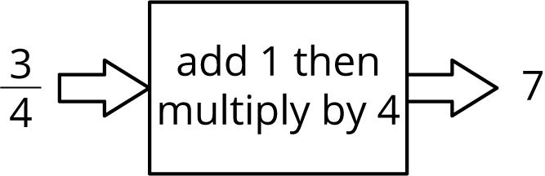
- input | - output
- $\frac{3}{4}$ | - 7
- 2.35
- 42
- 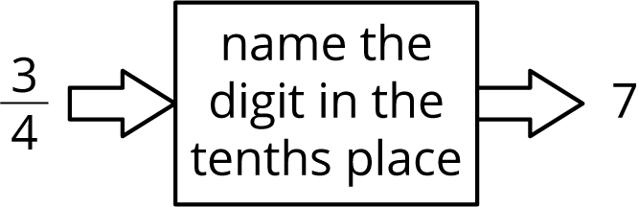
- input | - output
- $\frac{3}{4}$ | - 7
- 2.35
- 42
- 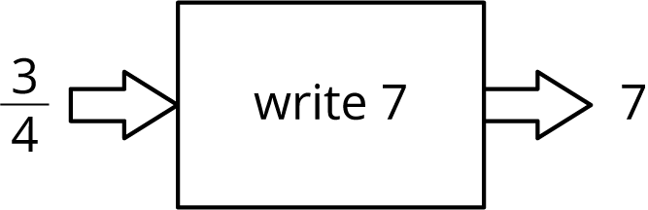
- input | - output
- $\frac{3}{4}$ | - 7
- 2.35
- 42
- Pause here until your teacher directs you to the last rule.
- 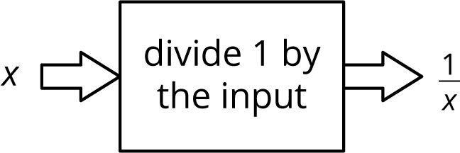
- input | - output
- $\frac{3}{7}$ | - $\frac{7}{3}$
- 1
- 0

Lesson 1 Summary
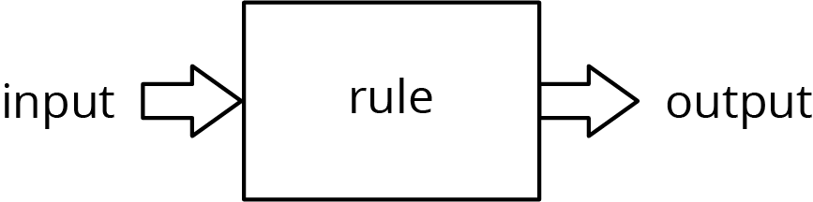
An input-output rule is a rule that takes an allowable input and uses it to determine an output. For example, the following diagram represents the rule that takes any number as an input, then adds 1, multiplies by 4, and gives the resulting number as an output.
In some cases, not all inputs are allowable, and the rule must specify which inputs will work. For example, this rule is fine when the input is 2:
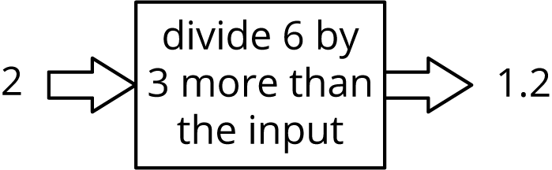
But if the input is -3, we would need to evaluate $6÷0$ to get the output.
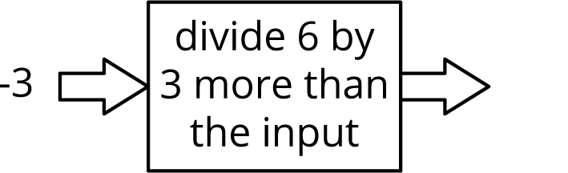
So, when we say that the rule is “divide 6 by 3 more than the input,” we also have to say that -3 is not allowed as an input.
© CC BY Open Up Resources. Adaptations CC BY IM.

