Lesson 13: Find the Area of Figures
- Let’s find the area of figures.

Warm-up: Number Talk: Extend Make a Ten
Find the value of each expression mentally.
- $109+4$
- $109+14$
- $209+34$
- $219+34$

13.1: Bye-Bye Squares
What do you notice? What do you wonder?
Find the area of each figure. Explain or show your reasoning.

- 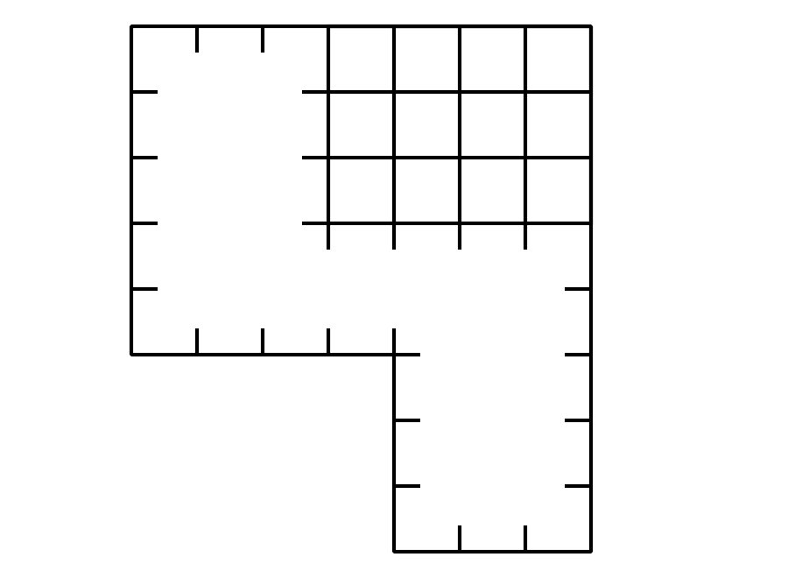

- 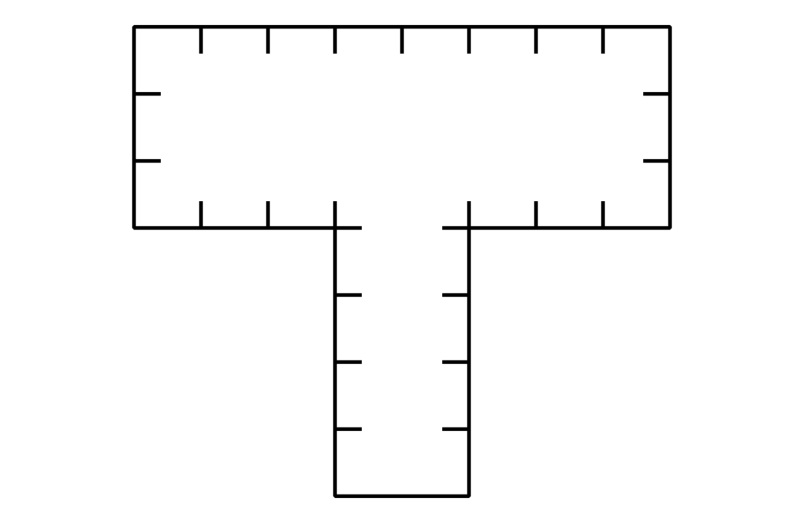

13.2: How Many Pavers Do We Need?
Noah wants to use square pavers that are 1 square foot each to create a small patio in the community garden. A diagram of the patio is shown.
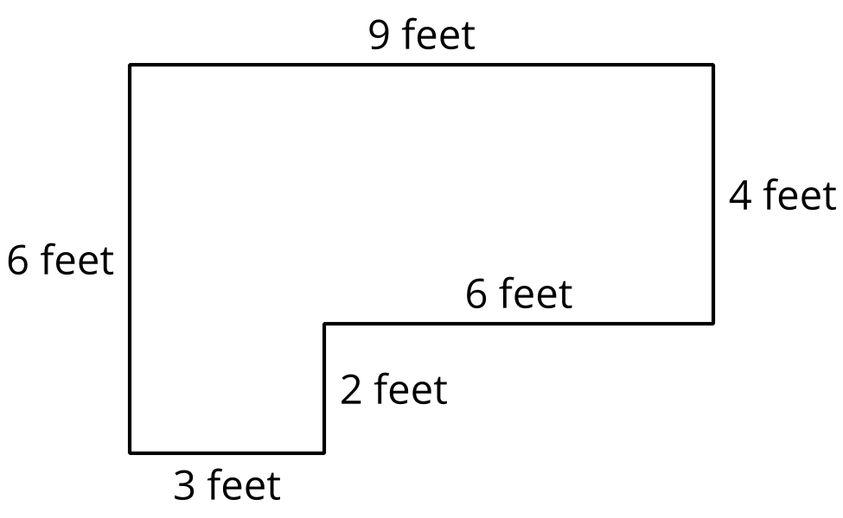
- How many 1 square foot pavers will Noah need to cover the whole patio?
- What is the area of the patio? Explain or show your reasoning.
- 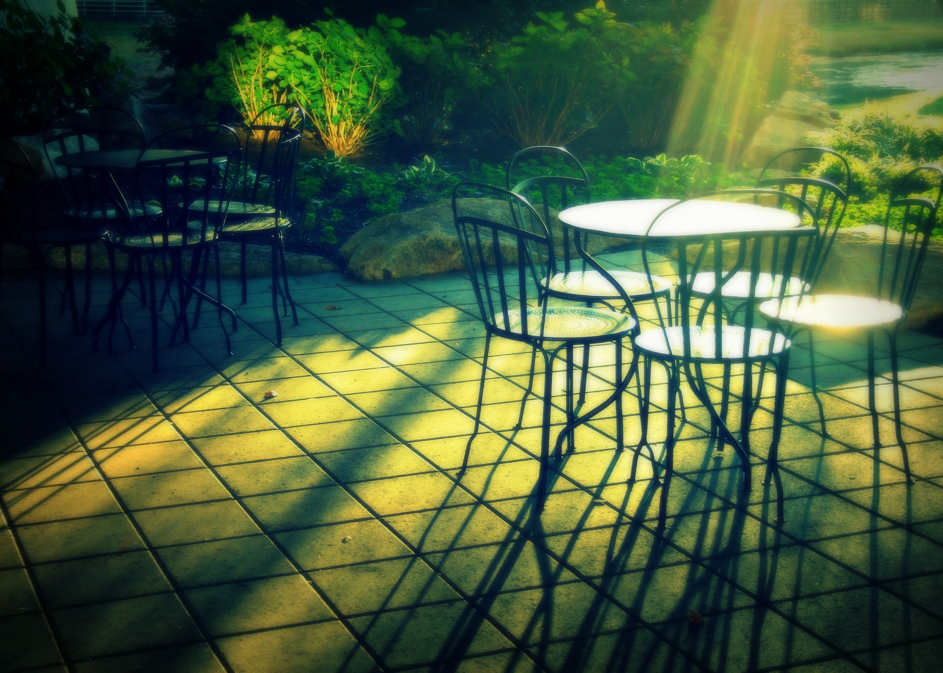
© CC BY 2021 Illustrative Mathematics®

