Lesson 8: Addition of Fractions

Standards Alignments
Addressing | 4.NF.B.3.a, 4.NF.B.3.b
Building Towards | 4.NF.B.3.a, 4.NF.B.3.b, 4.NF.B.3.c

Teacher-facing Learning Goals
- Decompose fractions greater than 1 into a sum of a whole number and a fraction less than 1.
- Reason about addition of fractions with the same denominator using a number line.

Student-facing Learning Goals
- Let’s explore sums of fractions on a number line.

Lesson Purpose
The purpose of this lesson is for students to use a number line to reason about addition of fractions with the same denominator, and to decompose fractions greater than 1 into a whole number and a fraction less than 1.
Previously, students decomposed non-unit fractions into smaller unit and non-unit fractions. Here they continue to think about decomposing fractions, but they now use number line diagrams to support their reasoning.
A number line can illustrate the number of unit fractions that make a whole number. This in turn allows students to see that a fraction greater than 1 can be decomposed into a whole number and a fraction less than 1, preparing them to work with mixed numbers. For instance, on a number line partitioned into fifths, the fraction $\frac{7}{5}$ is 7 fifths away from 0 and 2 fifths away from 1, so we can express $\frac{7}{5}$ as 1 and $\frac{2}{5}$. One way to illustrate that sum is by drawing “jumps” on the number line.
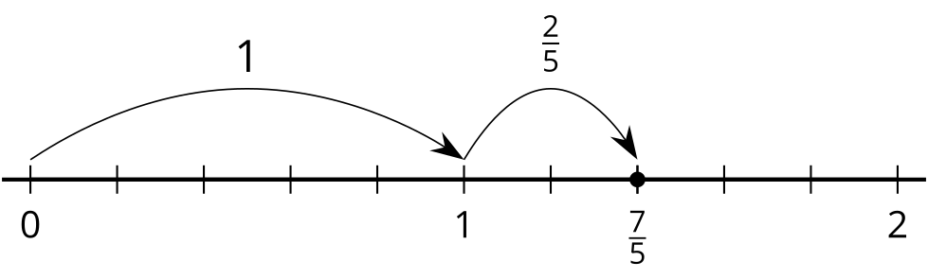
Note that in grade 3, students came across mixed numbers in the context of measurement. For instance, they use inch rulers to measure lengths greater than 1 inch to the nearest halves and fourths, express them using numbers such as $2\frac{1}{4}$ and $5\frac{1}{2}$. They did not, however, reason about mixed numbers as sums of smaller fractions or sums of a fraction and a whole number.

Access for:

Students with Disabilities
- Action and Expression (Activity 1)

English Learners
- MLR8 (Activity 2)

Instructional Routines
Notice and Wonder (Warm-up)

Materials to Copy
- Make Two Jumps (groups of 2): Activity 3

Lesson Timeline
Warm-up | 10 min
Activity 1 | 20 min
Activity 2 | 15 min
Activity 3 | 20 min
Lesson Synthesis | 10 min
Cool-down | 5 min

Teacher Reflection Question
Students have previously represented whole numbers and fractions on the number line. How did you leverage that experience to help them reason about addition of fractions on the number line?

Cool-down
(to be completed at the end of the lesson) 5min
Lucky Thirteen-tenths

Standards Alignments
Addressing | 4.NF.B.3.b

Student-facing Task Statement
- On each number line, draw two “jumps” to show how to use tenths to make a sum of $\frac{13}{10}$.
  - Represent each combination of jumps as an equation.
  - Write $\frac{13}{10}$ as a sum of a whole number and a fraction.
- Find the value of $\frac{8}{5}+\frac{6}{5}$. Use the number line if you find it helpful.

Student Responses
- Sample response:
- 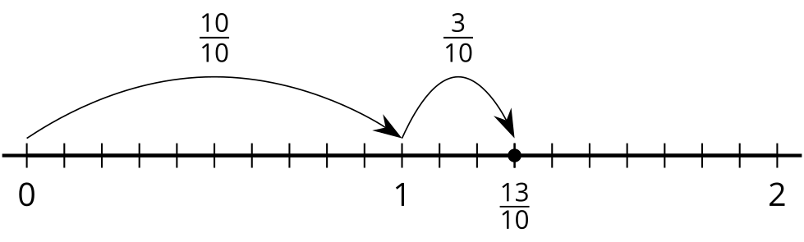
- 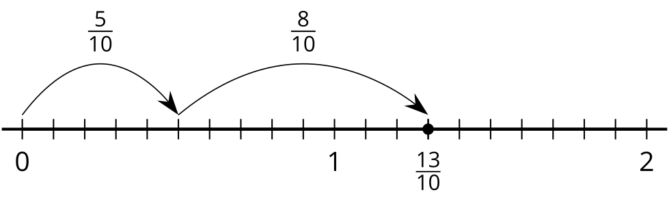
  - $\frac{10}{10}+\frac{3}{10}=\frac{13}{10}$ and $\frac{5}{10}+\frac{8}{10}=\frac{13}{10}$
  - $1+\frac{3}{10}=\frac{13}{10}$
- $\frac{14}{5}$ or $2\frac{4}{5}$
- 