Unit 7 Lesson 6: Areas in Histograms

1 Find the Area (Warm up)

Student Task Statement
- Find the shaded area between the function, the $x$-axis, and the boundaries $x=1$ and $x=2$. Explain or show your reasoning.
- What proportion of the area between the function, the $x$-axis, and the boundaries $x=0$ and $x=7$ is shaded? Explain or show your reasoning.

2 Story Submissions

Student Task Statement
A publisher takes submissions for short stories to include in a book. 200 stories are submitted, but the publisher needs to be aware of how long each story is. The way the publisher will put together the collection of stories, a page typically contains 200 words. The mean number of words for each story is 2,600 and the standard deviation is 400 words.
- If a histogram is created using intervals of 200 words, what would be the area of the bar representing the number of stories that contain between 2,000 and 2,200 words? Explain or show your reasoning.
- What proportion of the total area is represented by the bar for stories that contain between 2,000 and 2,200 words? Explain or show your reasoning.
- What proportion of stories in this group contain between 2,000 and 2,200 words? Explain or show your reasoning.
- How does the proportion of the area you calculated relate to the proportion of stories in the group that contain between 2,000 and 2,200 words?
- What proportion of stories in this group are within 1 standard deviation of the mean number of words?
- What proportion of stories in this group are within 2 standard deviations of the mean number of words?
- What proportion of stories in this group are within 1 standard deviation of 2,400 words?

Activity Synthesis

3 Website Load Times

Student Task Statement
A company collects data from 10,000 websites about how long it takes to load the site. The number of seconds it takes to fully load the website is summarized in the relative frequency table.
seconds to load | relative frequency
1.4–1.6 | 0.0003
1.6–1.8 | 0.0012
1.8–2.0 | 0.0053
2.0–2.2 | 0.0181
2.2–2.4 | 0.0442
2.4–2.6 | 0.0910
2.6–2.8 | 0.1555
2.8–3.0 | 0.1861
3.0–3.2 | 0.1938
3.2–3.4 | 0.1447
3.4–3.6 | 0.0923
3.6–3.8 | 0.0447
3.8–4.0 | 0.0166
4.0–4.2 | 0.0048
4.2–4.4 | 0.0012
4.4–4.6 | 0.0002
The relative frequency histogram summarizes the same data.
The mean time to load a website is 3 seconds and the standard deviation is 0.4 seconds.
- Would a normal distribution be a good model for this distribution? Explain your reasoning.
- What proportion of websites loaded within 1 standard deviation of the mean?
- What proportion of websites loaded within 2 standard deviations of the mean?
- What proportion of websites loaded within 1 standard deviation of 2.8 seconds?
- Compare the proportion of websites within 1 standard deviation of the mean to the proportion of stories in the submissions that are within 1 standard deviation of the mean number of words from the previous task. Do the same for the proportion within 2 standard deviations.

Activity Synthesis

Images for Activity Synthesis
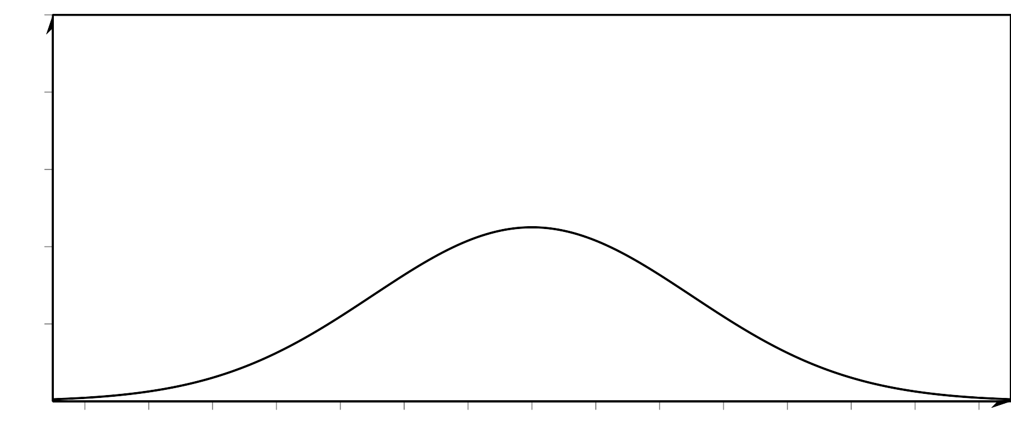
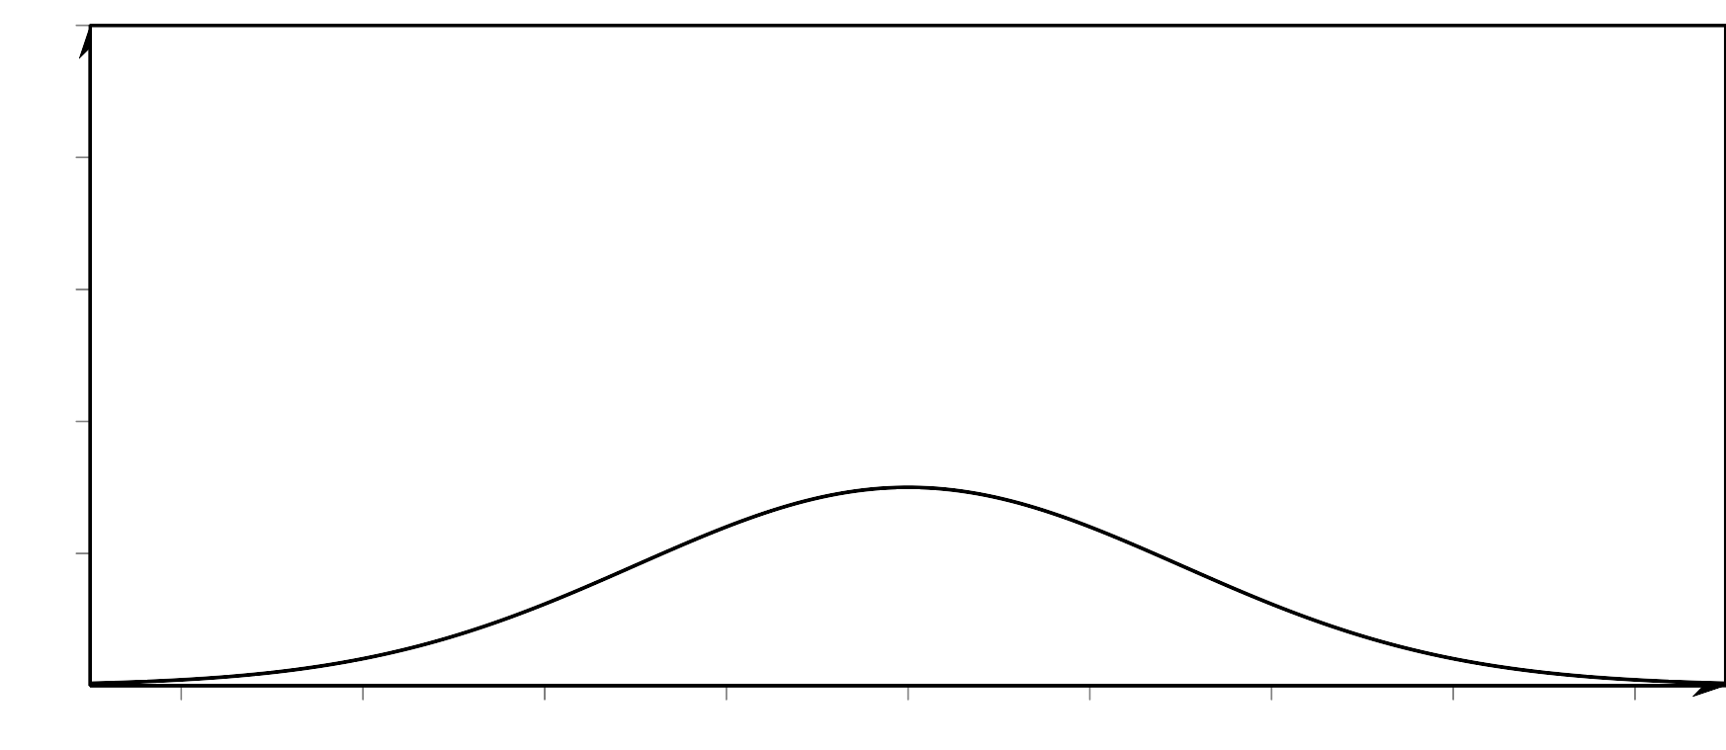
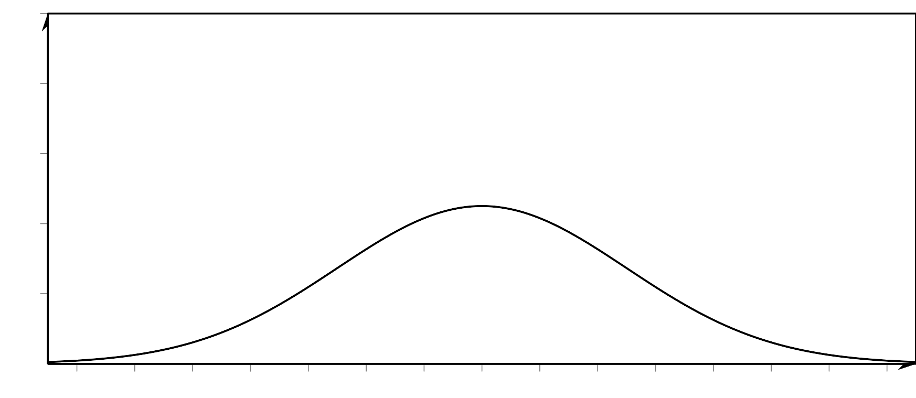
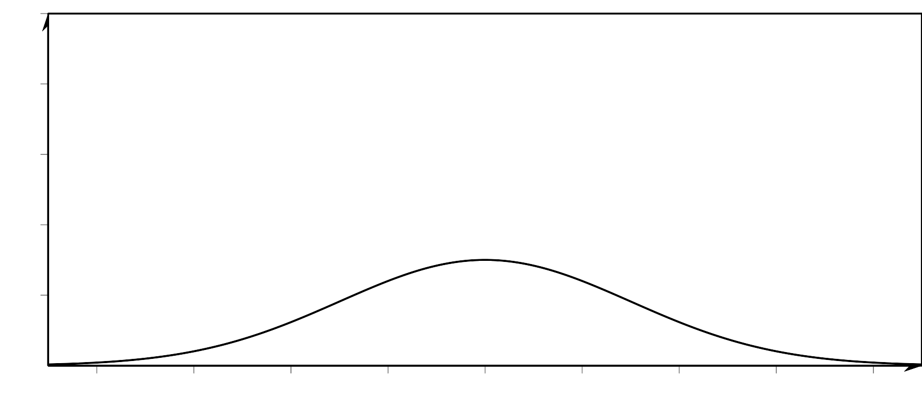
© CC BY 2019 by Illustrative Mathematics®

