Lesson 12: Dividing Decimals by Whole Numbers
Let’s divide decimals by whole numbers.

12.1: Number Talk: Dividing by 4
Find each quotient mentally.
$80÷4$
$12÷4$
$1.2÷4$
$81.2÷4$

12.2: Using Diagrams to Represent Division
To find $53.8÷4$ using diagrams, Elena began by representing 53.8.
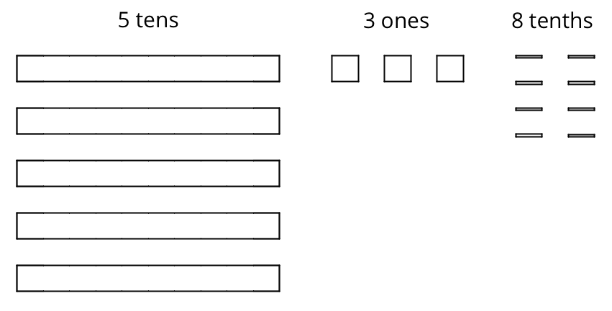
She placed 1 ten into each group, unbundled the remaining 1 ten into 10 ones, and went on distributing the units.
This diagram shows Elena’s initial placement of the units and the unbundling of 1 ten.
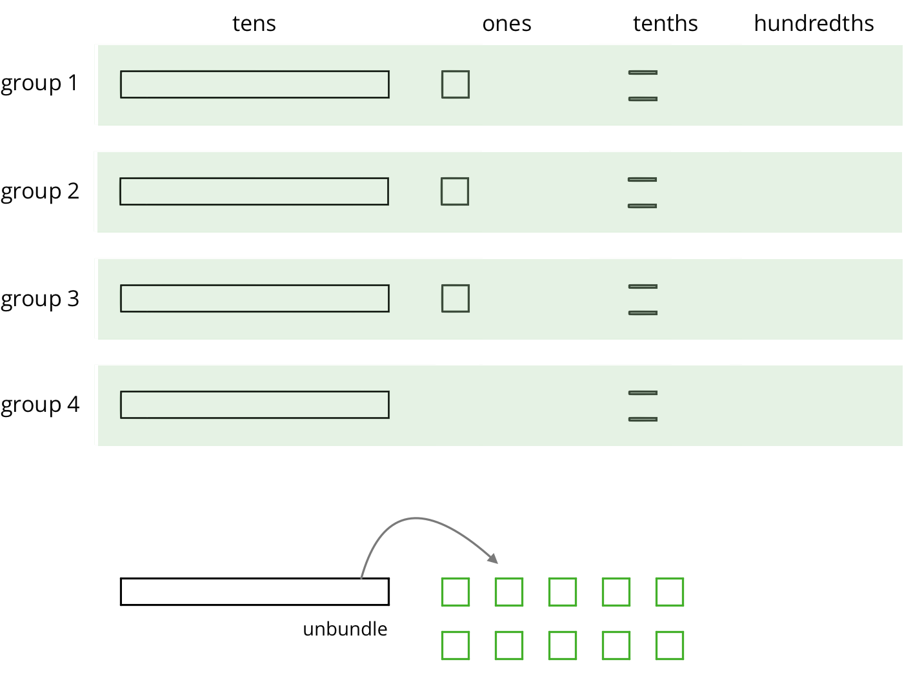
- Complete the diagram by continuing the division process. How would you use the available units to make 4 equal groups?
- As the units get placed into groups, show them accordingly and cross out those pieces from the bottom. If you unbundle a unit, draw the resulting pieces.
- What value did you find for $53.8÷4$? Be prepared to explain your reasoning.
- Use long division to find $53.8÷4$. Check your answer by multiplying it by the divisor 4.
- Use long division to find $77.4÷5$. If you get stuck, you can draw diagrams or use another method.

Are you ready for more?
A distant, magical land uses jewels for their bartering system. The jewels are valued and ranked in order of their rarity. Each jewel is worth 3 times the jewel immediately below it in the ranking. The ranking is red, orange, yellow, green, blue, indigo, and violet. So a red jewel is worth 3 orange jewels, a green jewel is worth 3 blue jewels, and so on.
A group of 4 craftsmen are paid 1 of each jewel. If they split the jewels evenly amongst themselves, which jewels does each craftsman get?

12.3: Dividends and Divisors
Analyze the dividends, divisors, and quotients in the calculations, and then answer the questions.
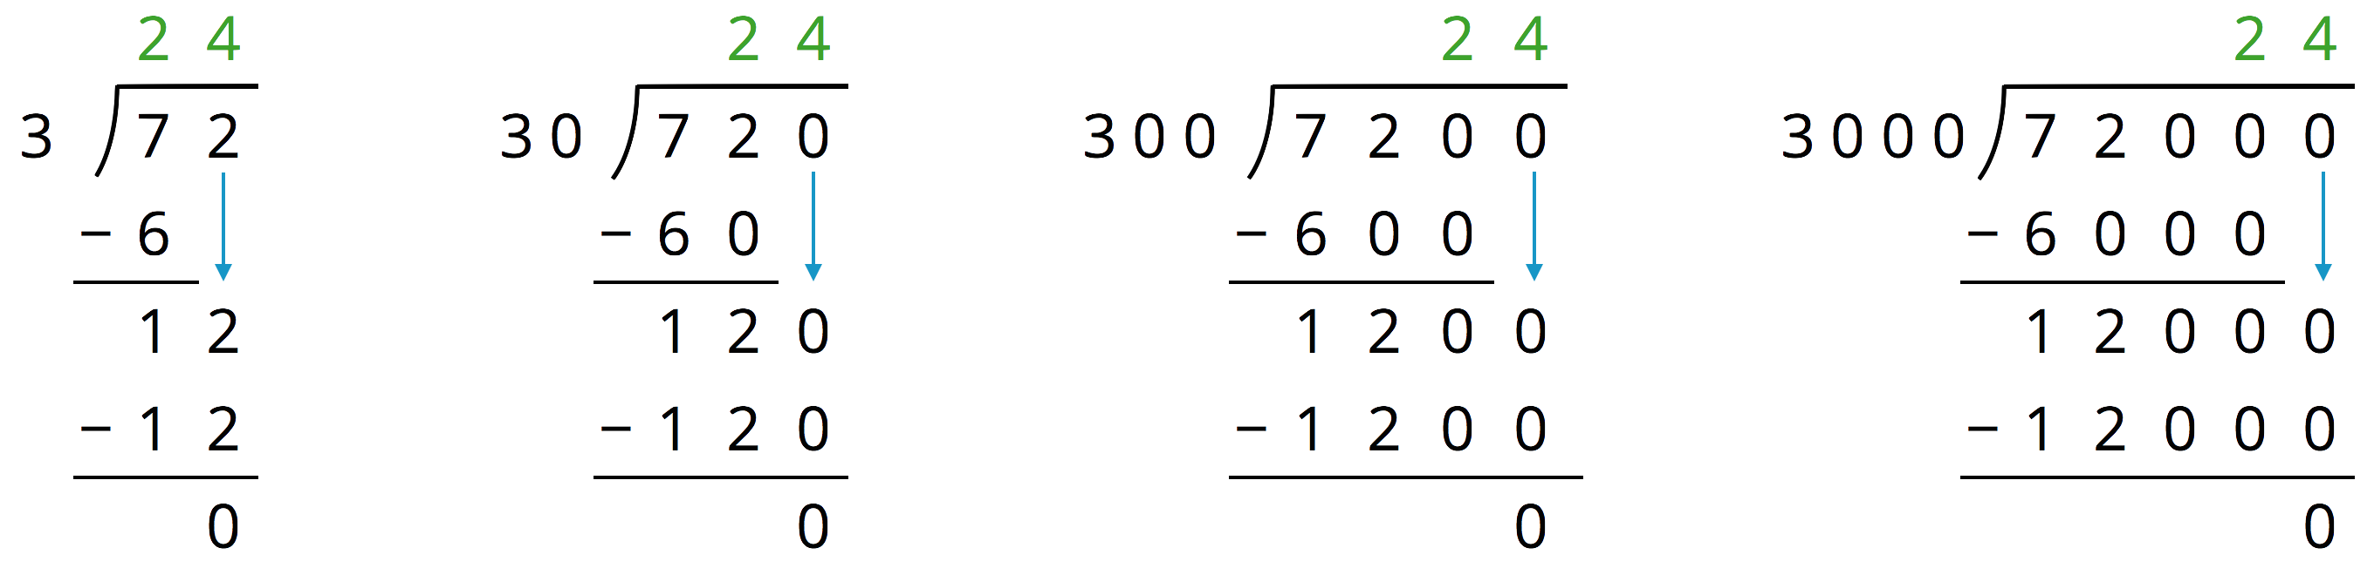
- Complete each sentence. In the calculations shown:
  - Each dividend is ______ times the dividend to the left of it.
  - Each divisor is ______ times the divisor to the left of it.
  - Each quotient is _____________________ the quotient to the left of it.
- Suppose we are writing a calculation to the right of $72,​000÷3,​000$. Which expression has a quotient of 24? Be prepared to explain your reasoning.
  - $72,​000÷30,​000$
  - $720,​000÷300,​000$
  - $720,​000÷30,​000$
  - $720,​000÷3,​000$
- Suppose we are writing a calculation to the left of $72÷3$. Write an expression that would also give a quotient of 24. Be prepared to explain your reasoning.
- Decide which of the following expressions would have the same value as $250÷10$. Be prepared to share your reasoning.
  - $250÷0.1$
  - $25÷1$
  - $2.5÷1$
  - $2.5÷0.1$
  - $2,500÷100$
  - $0.25÷0.01$

Lesson 12 Summary
We know that fractions such as $\frac{6}{4}$ and $\frac{60}{40}$ are equivalent because:
- The numerator and denominator of $\frac{60}{40}$ are each 10 times those of $\frac{6}{4}$.
- Both fractions can be simplified to $\frac{3}{2}$.
- 600 divided by 400 is 1.5, and 60 divided by 40 is also 1.5.
Just like fractions, division expressions can be equivalent. For example, the expressions $540÷90$ and $5,​400÷900$ are both equivalent to $54÷9$ because:
- They all have a quotient of 6.
- The dividend and the divisor in $540÷90$ are each 10 times the dividend and divisor in $54÷9$. Those in $5,​400÷900$ are each 100 times the dividend and divisor in $54÷9$. In both cases, the quotient does not change.
This means that an expression such as $5.4÷0.9$ also has the same value as $54÷9$. Both the dividend and divisor of $5.4÷0.9$ are $\frac{1}{10}$ of those in $54÷9$.
In general, multiplying a dividend and a divisor by the same number does not change the quotient. Multiplying by powers of 10 (e.g., 10, 100, 1,000, etc.) can be particularly useful for dividing decimals, as we will see in an upcoming lesson.
© CC BY Open Up Resources. Adaptations CC BY IM.

