Unit 3 Lesson 5: Introduction to Linear Relationships

1 Number Talk: Fraction Division (Warm up)

Student Task Statement
Find the value of $2\frac{5}{8}÷\frac{1}{2}$.

2 Stacking Cups

Images for Launch
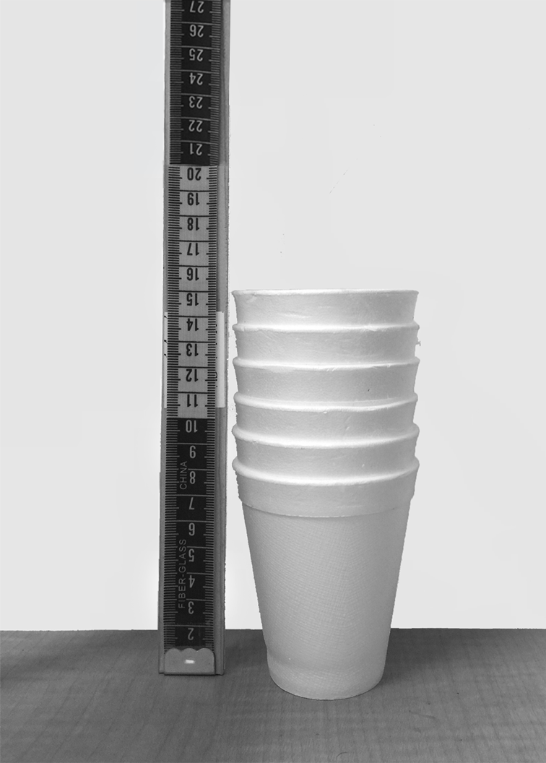

Student Task Statement
We have two stacks of styrofoam cups.
- One stack has 6 cups, and its height is 15 cm.
- The other stack has 12 cups, and its height is 23 cm.
How many cups are needed for a stack with a height of 50 cm?

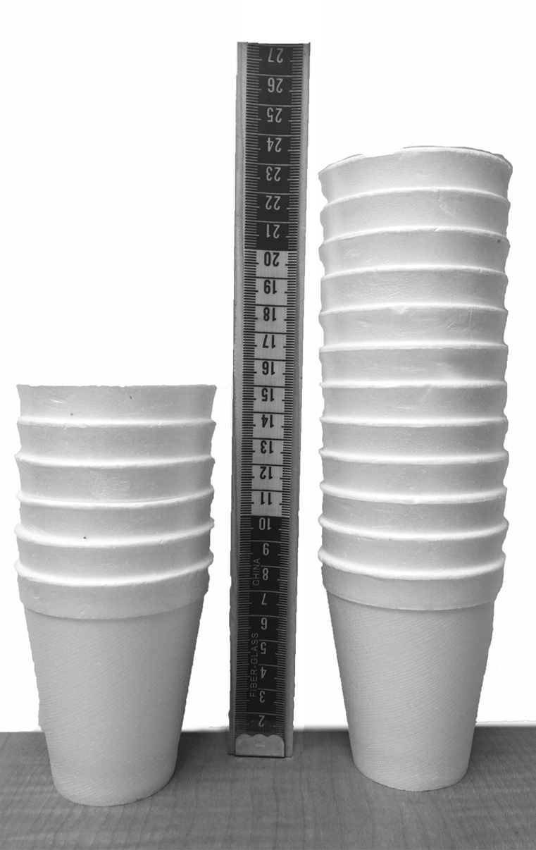

Activity Synthesis
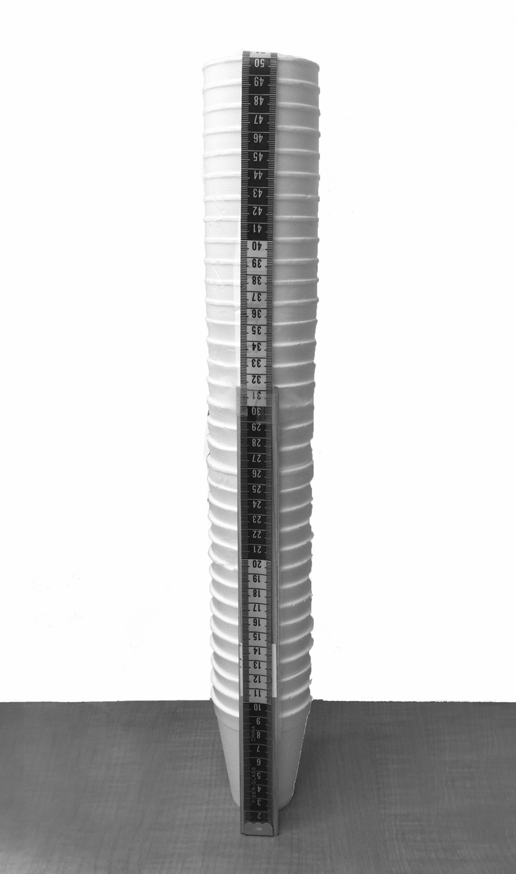

3 Connecting Slope to Rate of Change

Student Task Statement
- If you didn’t create your own graph of the situation before, do so now.
- 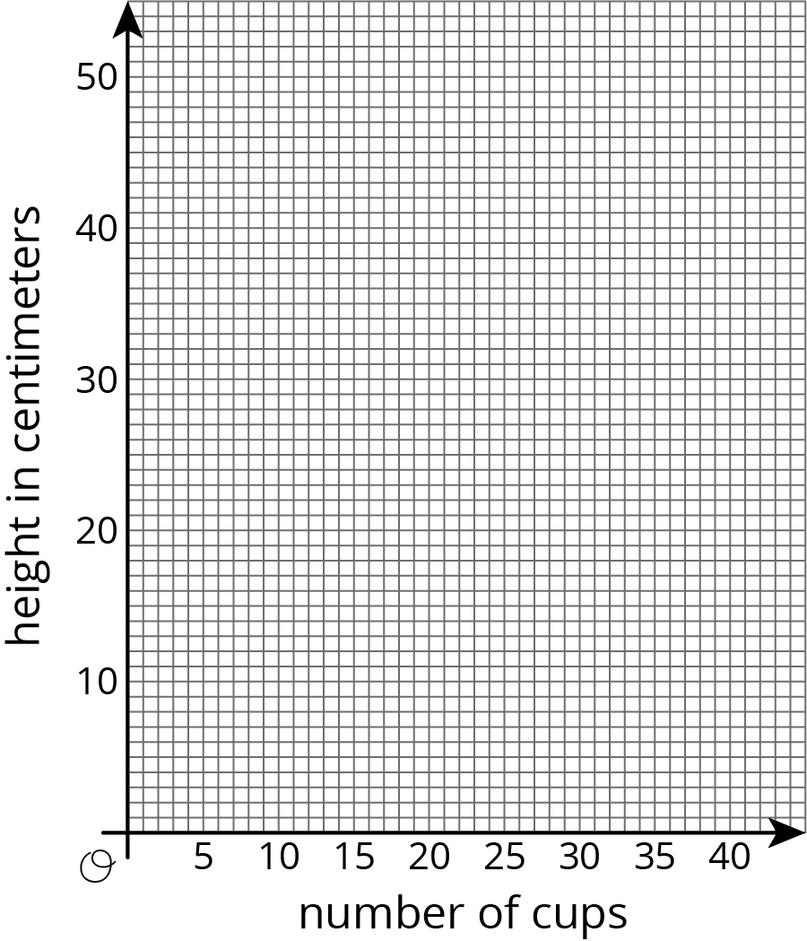
- What are some ways you can tell that the number of cups is not proportional to the height of the stack?
- What is the slope of the line in your graph? What does the slope mean in this situation?
- At what point does your line intersect the vertical axis? What do the coordinates of this point tell you about the cups?
- How much height does each cup after the first add to the stack?

Activity Synthesis
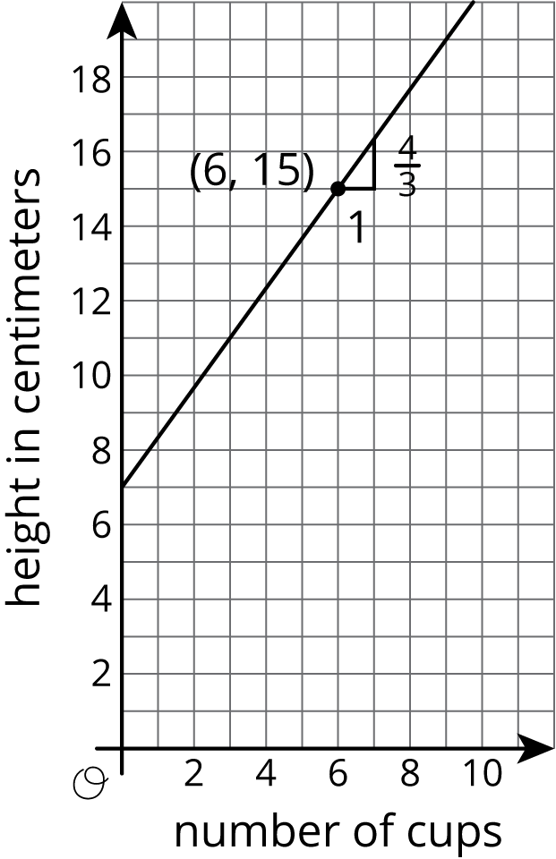
© CC BY Open Up Resources. Adaptations CC BY IM.

