Unit 6 Lesson 12: Graphing the Standard Form (Part 1)

1 Matching Graphs to Linear Equations (Warm up)

Student Task Statement
Graphs A, B, and C represent 3 linear equations: $y=2x+4$, $y=3−x$, and $y=3x−2$. Which graph corresponds to which equation? Explain your reasoning.
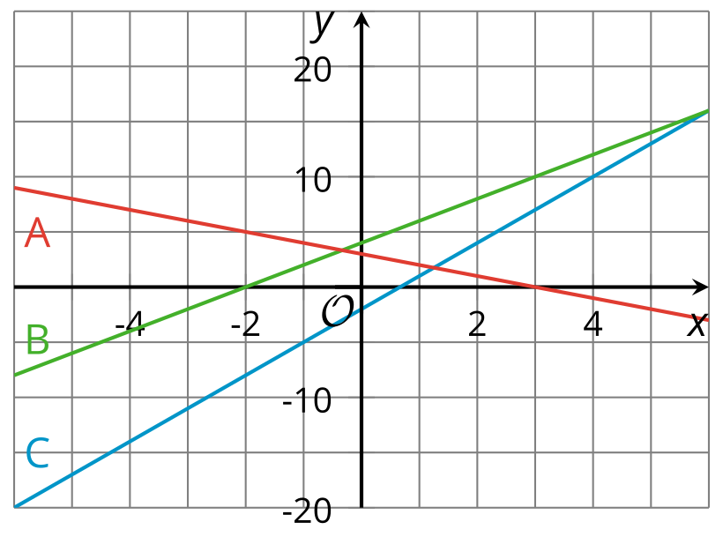

2 Quadratic Graphs Galore

Student Task Statement
Using graphing technology, graph $y=x^{2}$, and then experiment with each of the following changes to the function. Record your observations (include sketches, if helpful).
1. Adding different constant terms to $x^{2}$ (for example: $x^{2}+5$, $x^{2}+10$, $x^{2}−3$, etc.)
2. Multiplying $x^{2}$ by different positive coefficients greater than 1 (for example: $3x^{2}$, $7.5x^{2}$, etc.)
3. Multiplying $x^{2}$ by different negative coefficients less than or equal to -1 (for example: $\text{-}x^{2}$, $\text{-}4x^{2}$, etc.)
4. Multiplying $x^{2}$ by different coefficients between -1 and 1 (for example: $\frac{1}{2}x^{2}$, $\text{-}0.25x^{2}$, etc.)

3 What Do These Tables Reveal? (Optional)

Student Task Statement

  - Complete the table with values of $x^{2}+10$ and $x^{2}−3$ at different values of $x$. (You may also use a spreadsheet tool, if available.)
- $x$ | - -3 | - -2 | - -1 | - 0 | - 1 | - 2 | - 3
- $x^{2}$ | - 9 | - 4 | - 1 | - 0 | - 1 | - 4 | - 9
  - $x^{2}+10$
  - $x^{2}−3$
  - Earlier, you observed the effects on the graph of adding or subtracting a constant term from $x^{2}$. Study the values in the table. Use them to explain why the graphs changed they way they did when a constant term is added or subtracted.

  - Complete the table with values of $2x^{2}$, $\frac{1}{2}x^{2}$, and $\text{-}2x^{2}$ at different values of $x$. (You may also use a spreadsheet tool, if available.)
- $x$ | - -3 | - -2 | - -1 | - 0 | - 1 | - 2 | - 3
- $x^{2}$ | - 9 | - 4 | - 1 | - 0 | - 1 | - 4 | - 9
  - $2x^{2}$
  - $\frac{1}{2}x^{2}$
  - $\text{-}2x^{2}$
  - You also observed the effects on the graph of multiplying $x^{2}$ by different coefficients. Study the values in the table. Use them to explain why the graphs changed they way they did when $x^{2}$ is multiplied by a number greater than 1, by a negative number less than or equal to -1, and by numbers between -1 and 1.

Activity Synthesis
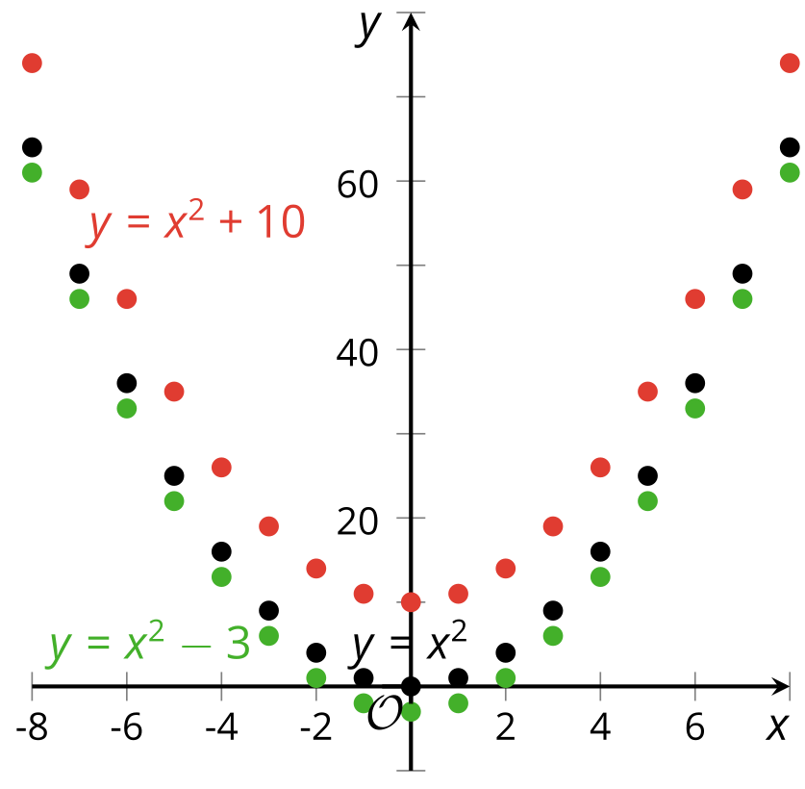

4 Card Sort: Representations of Quadratic Functions

Student Task Statement
Your teacher will give your group a set of cards. Each card contains a graph or an equation.
- Take turns with your partner to sort the cards into sets so that each set contains two equations and a graph that all represent the same quadratic function.
- For each set of cards that you put together, explain to your partner how you know they belong together.
- For each set that your partner puts together, listen carefully to their explanation. If you disagree, discuss your thinking and work to reach an agreement.
- Once all the cards are sorted and discussed, record the equivalent equations, sketch the corresponding graph, and write a brief note or explanation about why the representations were grouped together.
Standard form:
Factored form:
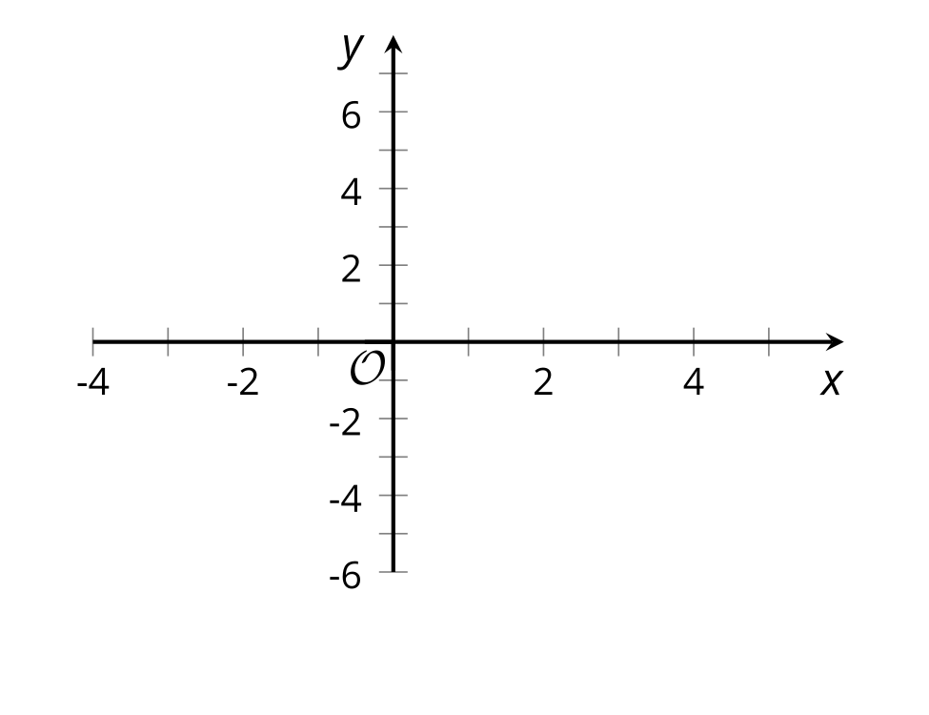
Explanation:
Standard form:
Factored form:
Explanation:
Standard form:
Factored form:
Explanation:
Standard form:
Factored form:
Explanation:

© CC BY 2019 by Illustrative Mathematics®

