Unit 1 Lesson 18: Practicing Point by Point Transformations

1 Notice and Wonder: Obstacles (Warm up)

Student Task Statement
What do you notice? What do you wonder?
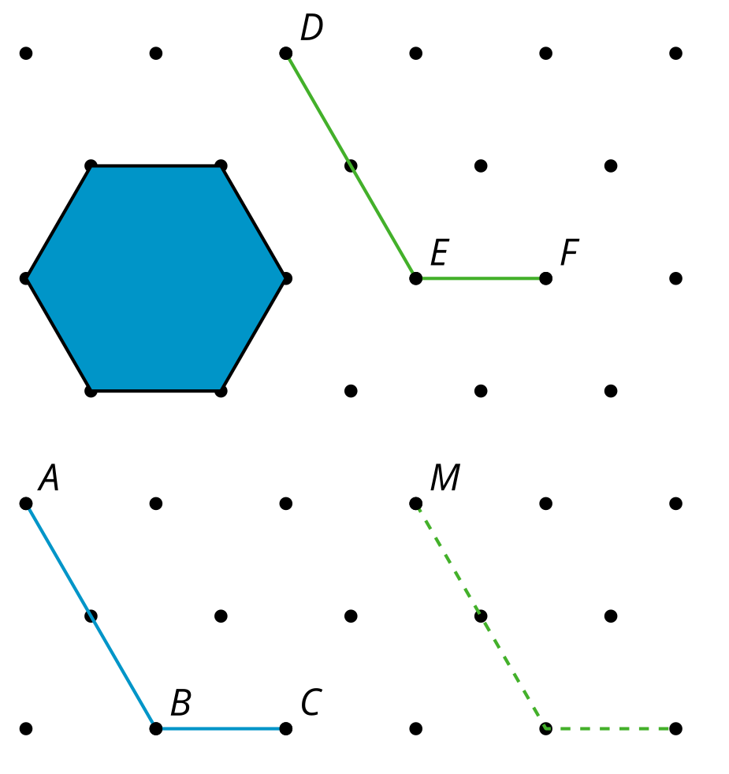

2 Obstacle Course (Optional)

Student Task Statement
For each diagram, find a sequence of translations and rotations that take the original figure to the image, so that if done physically, the figure would not touch any of the solid obstacles and would not leave the diagram. Test your sequence by drawing the image of each step.
1. Take $ABC$ to $DEF$.
2. Take $GHI$ to $JKL$.
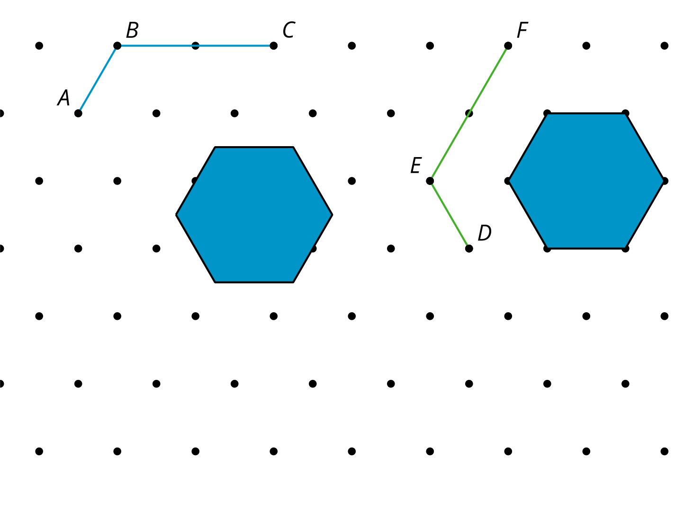
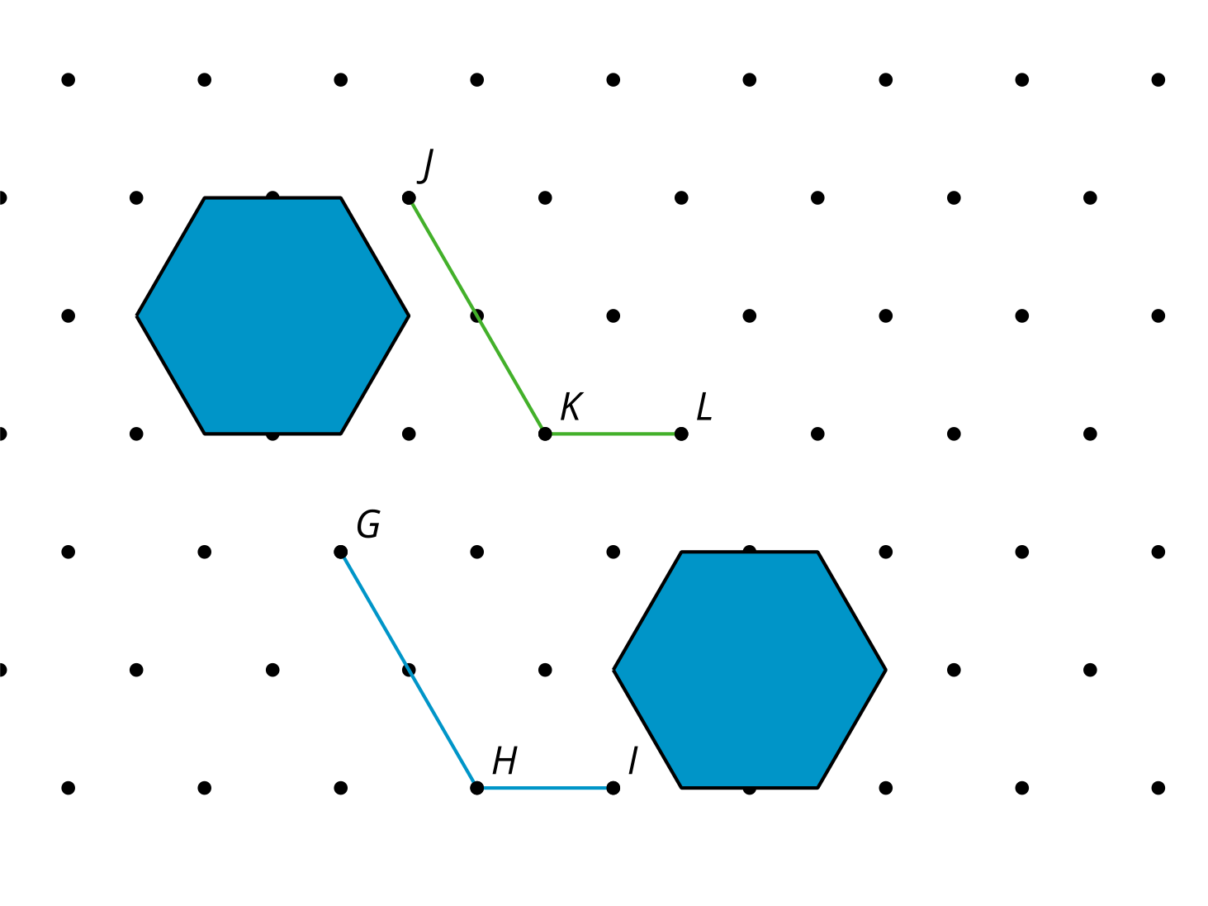

3 Point by Point (Optional)

Student Task Statement
For each question, describe a sequence of translations, rotations, and reflections that will take parallelogram $ABCD$ to parallelogram $A^{′}B^{′}C^{′}D^{′}$.
- 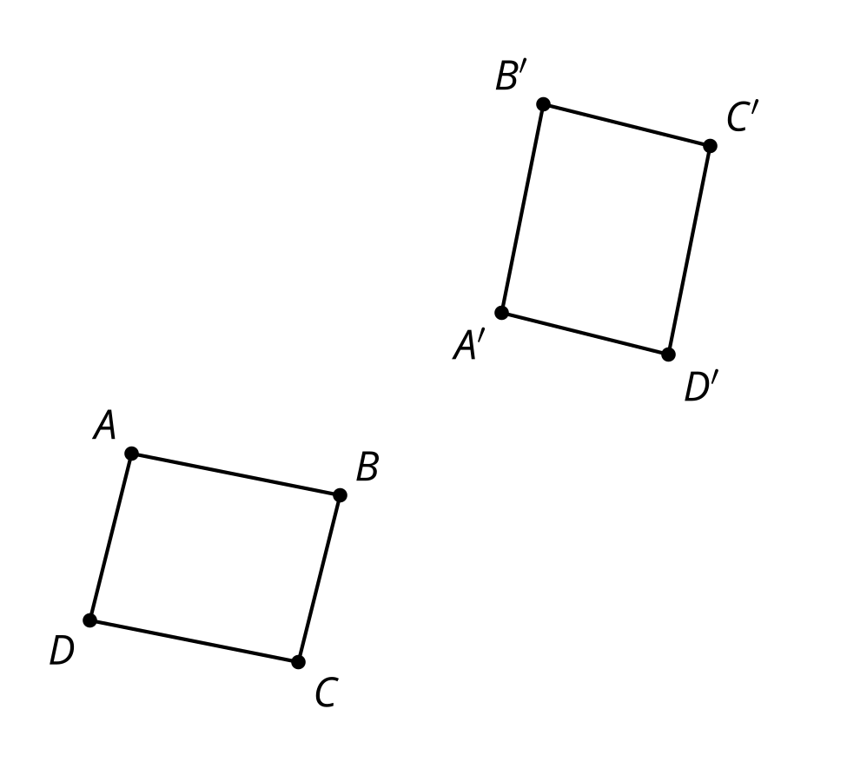
- 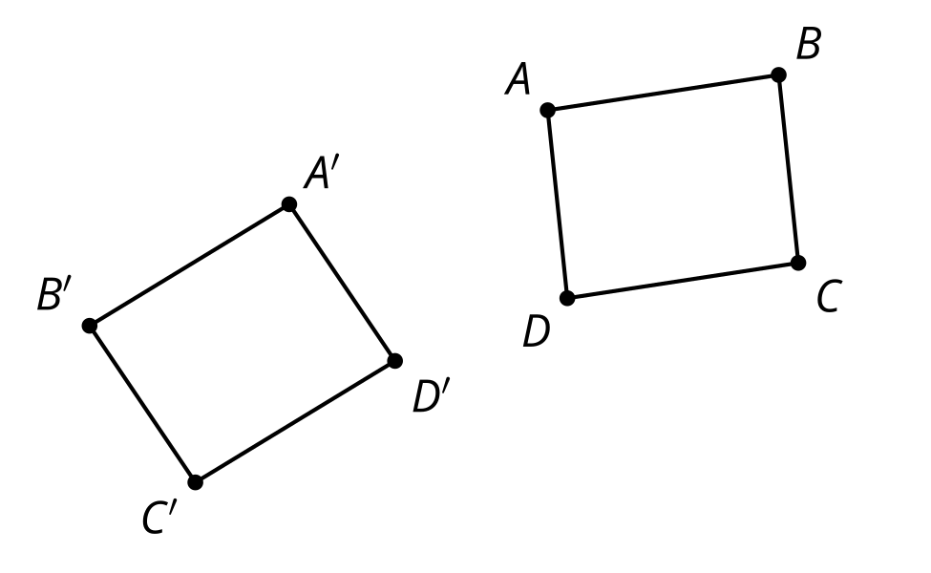
© CC BY 2019 by Illustrative Mathematics®

