Lesson 3: Thousandths in Expanded Form

Standards Alignments
Addressing | 5.NBT.A.1, 5.NBT.A.3.a, 5.OA.A

Teacher-facing Learning Goals
- Relate different representations of the same number.
- Write decimals in expanded form.

Student-facing Learning Goals
- Let's represent thousandths.

Lesson Purpose
The purpose of this lesson is for students to represent decimals to the thousandths place in expanded form.
The previous lesson introduced students to different ways of thinking about a decimal number, including by place value. The goal of this lesson is for students to make connections between familiar representations of decimals, such as grids or numerical form, and expanded form. Students have seen expanded form of whole numbers in a previous course and apply the same idea here to write expressions showing how many of each decimal place value is in a number. This sets students up for work in a future unit considering the relationship between place values.

Instructional Routines
Which One Doesn’t Belong? (Warm-up)

Lesson Timeline
Warm-up | 10 min
Activity 1 | 20 min
Activity 2 | 15 min
Lesson Synthesis | 10 min
Cool-down | 5 min

Teacher Reflection Question
What unfinished learning or misunderstandings do your students have about the relationship between place values? How did you leverage those misconceptions in a positive way to further the understanding of the class?

Cool-down
(to be completed at the end of the lesson) 5min
Different Ways to Write a Decimal Number

Standards Alignments
Addressing | 5.NBT.A.3.a

Student-facing Task Statement
The shaded region of the diagram shows a number.
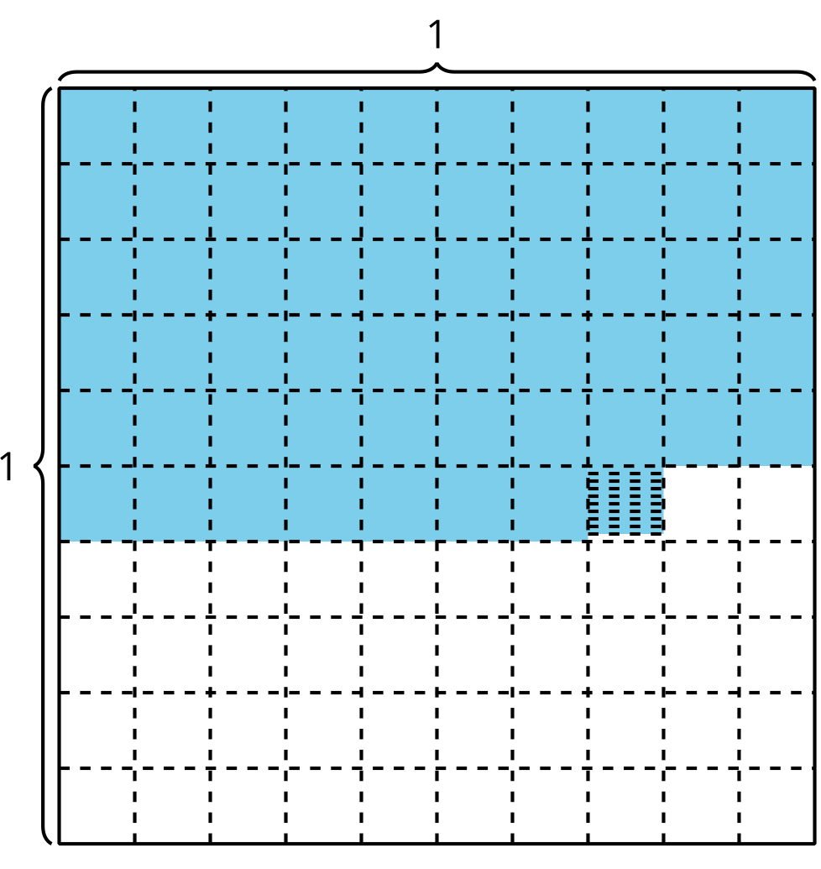
- Write the number as a decimal.
- Write the number as a fraction.
- Write the number in expanded form.
- Write the number in word form.

Student Responses
- 0.579
- $\frac{579}{1,​000}$
- $\left(5×0.1\right)+\left(7×0.01\right)+\left(9×0.001\right)$
- five hundred seventy-nine thousandths

