Lesson 17: Parameters and Graphs

17.1: Which One Doesn’t Belong: Triangles
Each figure shows triangle $PQR$, and its image after a transformation, $P^{′}Q^{′}R^{′}$. Which one doesn’t belong?

A
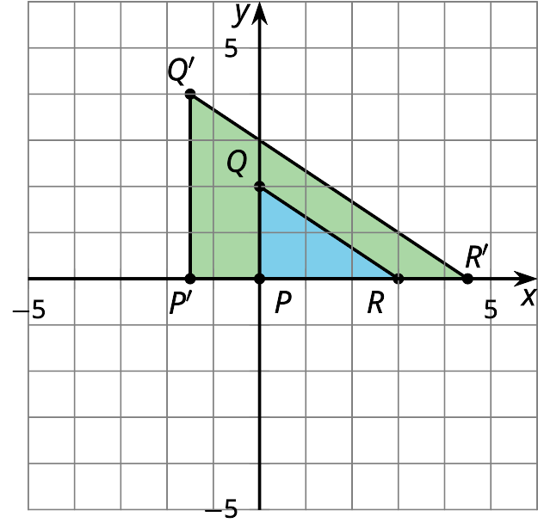

B
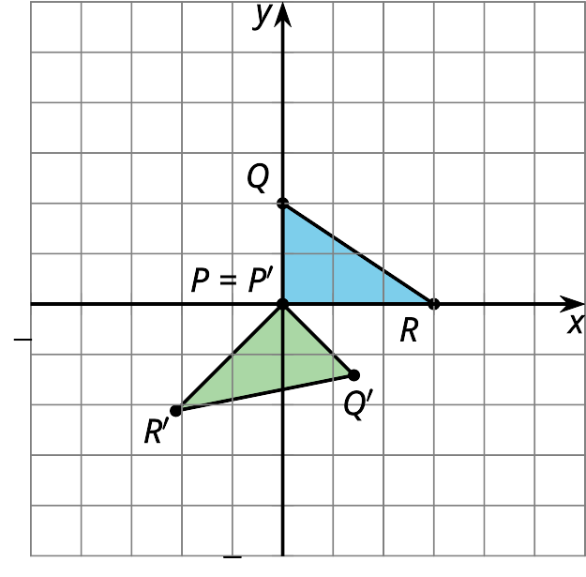

C
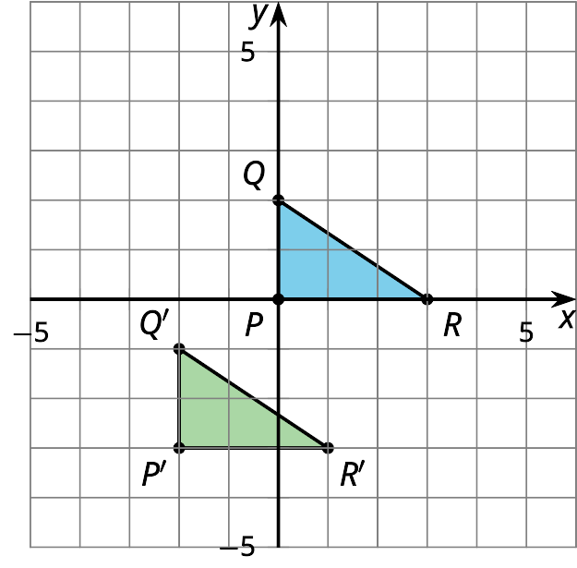

D
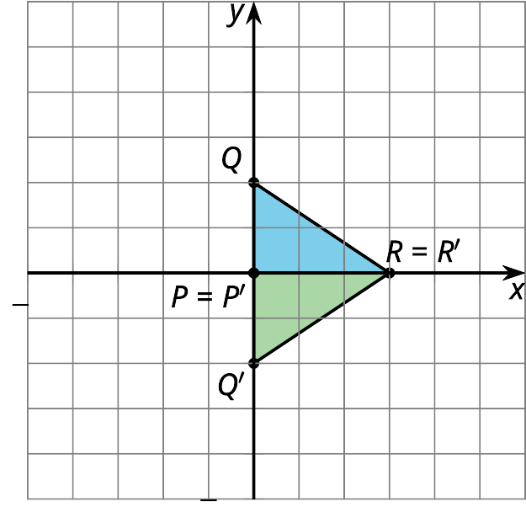

17.2: Describe the Change
- Use graphing technology to graph each equation. Describe how each graph changes from the previous graph and draw a sketch of the change.
- equation | - description of change | - sketch of graph
- $y=x^{2}$ | - original graph | - 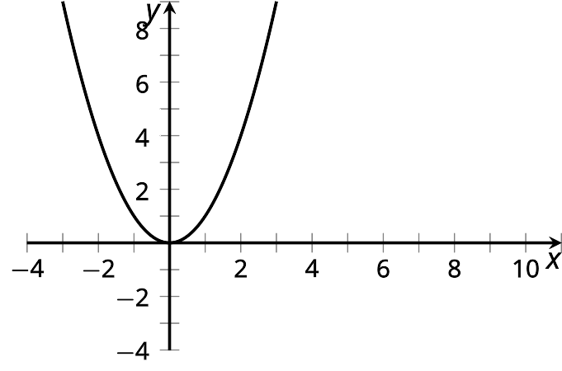
- $y=(x−5)^{2}$
- $y=(x−5)^{2}+4$
- Describe the change in the given sketch and write an equation that you think would generate that change.
- equation | - description of change | - sketch of graph
- $y=x^{2}$ | - original graph | - 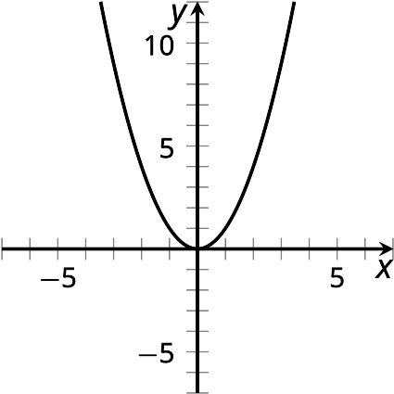
 |  | - 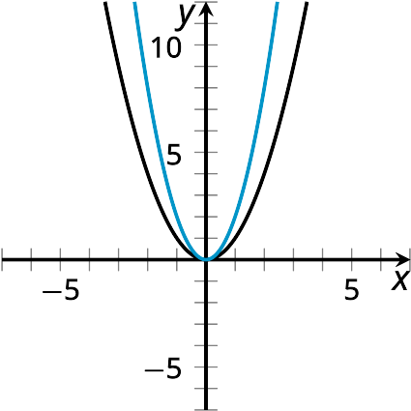
 |  | - 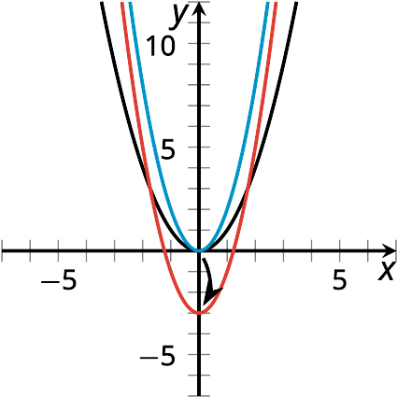
- How would the graph of $y=\text{-}2x^{2}−3$ compare to the graph of $y=2x^{2}−3$?

17.3: Select a Function
Let’s call the graph of $y=x^{2}$ “the original graph.”
Select the function that will affect the original graph in the way described.
- Shift the vertex of the graph left 1 unit.
- Shift the vertex of the graph up 1 unit.
- Shift the vertex of the graph right 1 unit and up 1 unit.
- Make the original graph narrower.
- Make the original graph narrower, and shift the vertex 1 unit to the right.
- $y=x^{2}+1$
- $y=(x+1)^{2}$
- $y=3x^{2}$
- $y=(x−1)^{2}+1$
- $y=3(x−1)^{2}$
© CC BY 2019 by Illustrative Mathematics

