Lesson 18: Practicing Point by Point Transformations

18.1: Notice and Wonder: Obstacles
What do you notice? What do you wonder?
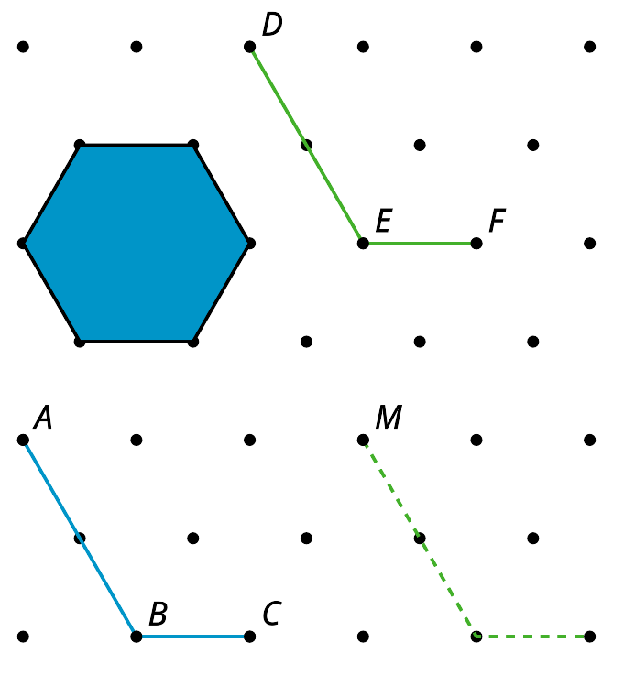

18.2: Obstacle Course
For each diagram, find a sequence of translations and rotations that take the original figure to the image, so that if done physically, the figure would not touch any of the solid obstacles and would not leave the diagram. Test your sequence by drawing the image of each step.
1. Take $ABC$ to $DEF$.
2. Take $GHI$ to $JKL$.
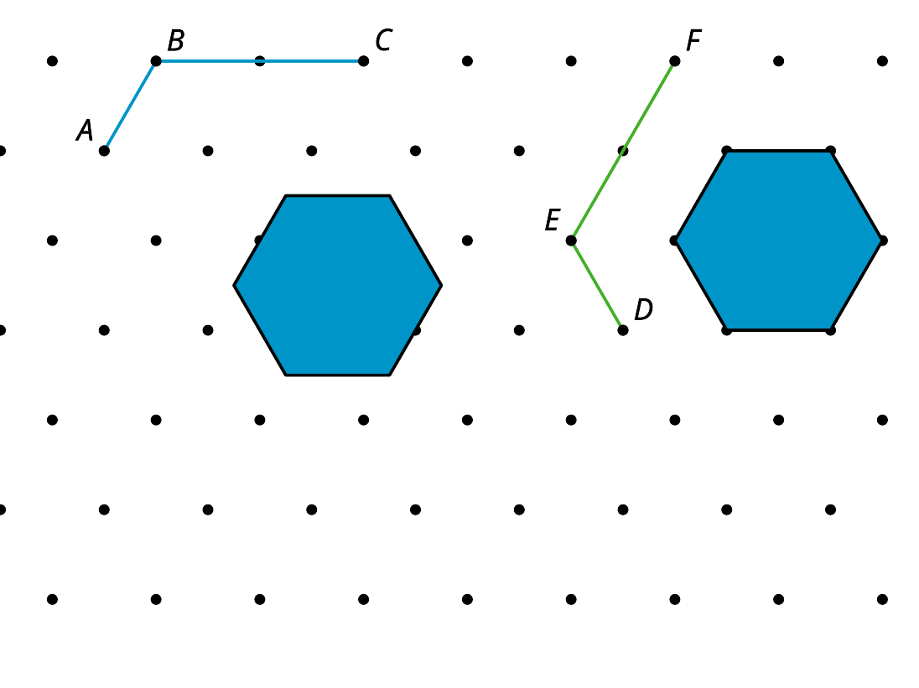
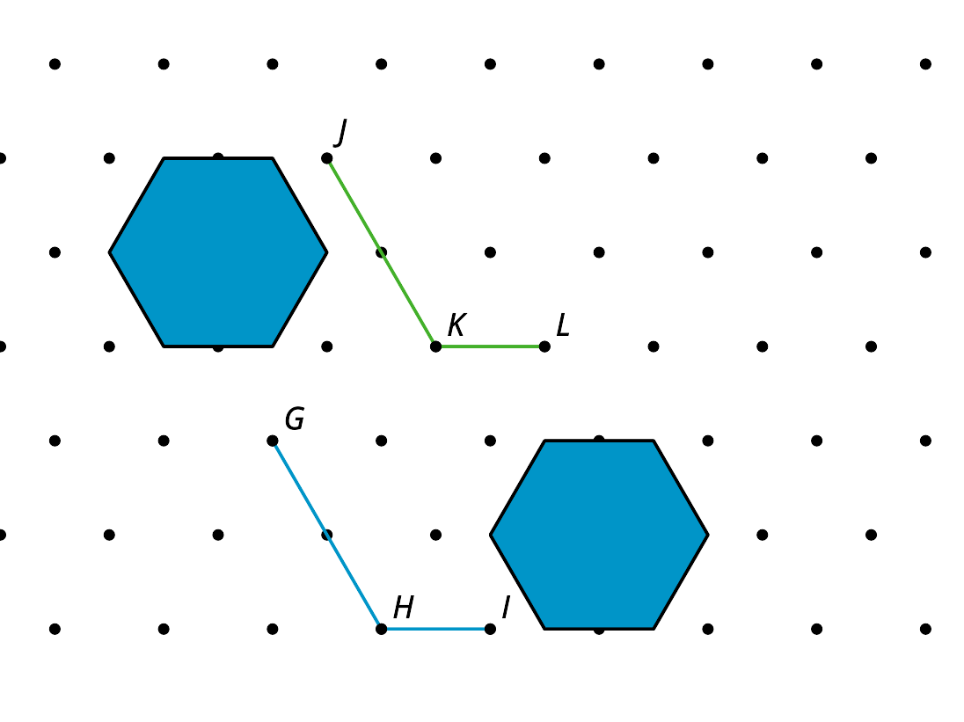

Are you ready for more?
Create your own obstacle course with an original figure, an image, and at least one obstacle. Make sure it is possible to solve. Challenge a partner to solve your obstacle course.

18.3: Point by Point
For each question, describe a sequence of translations, rotations, and reflections that will take parallelogram $ABCD$ to parallelogram $A^{′}B^{′}C^{′}D^{′}$.
- 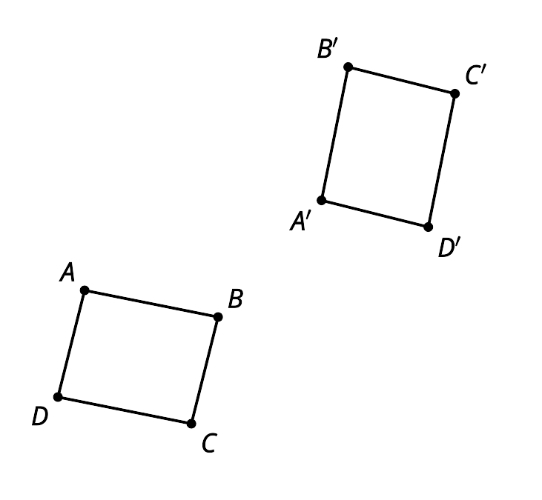
- 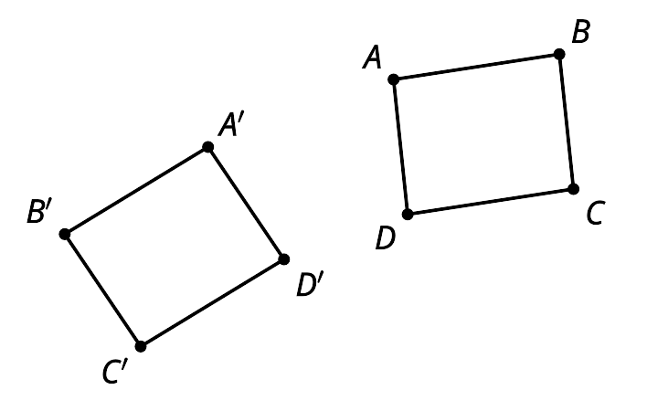

Are you ready for more?
In this unit, we have been focusing on rigid transformations in two dimensions. By thinking carefully about precise definitions, we can extend many of these ideas into three dimensions. How could you define rotations, reflections, and translations in three dimensions?

Lesson 18 Summary
Sometimes it's not hard to figure out a transformation that takes all the points of one figure directly to all the points of its image. Here, it looks like there is a 90 degree rotation that will take figure $ABCD$ to figure $EFGH$. It is not obvious where the center of rotation would be, though.
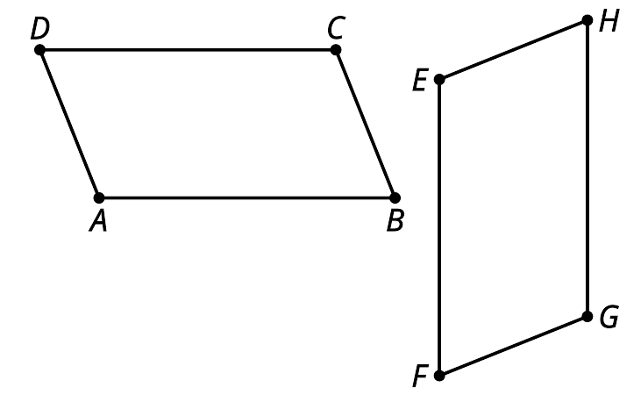
Instead, we could describe the transformation in 2 steps. First, translate figure $ABCD$ by the directed line segment $AE$. Next, rotate the image of $ABCD$ clockwise by angle $B^{′}EF$ using center $E$. It looks like this is a 90 degree rotation, but we can be sure the rotation will work if we use the labels to define the rotation instead of an angle measure. This method of matching up 1 point at a time until the whole figure has been taken to the image will work for any transformation, including ones in which it's hard to see a single transformation from one figure to the other.
© CC BY 2019 by Illustrative Mathematics

