Lesson 15: New Room
- Let’s fit furniture into a room.

Warm-up: Notice and Wonder: Floor Plan
What do you notice? What do you wonder?
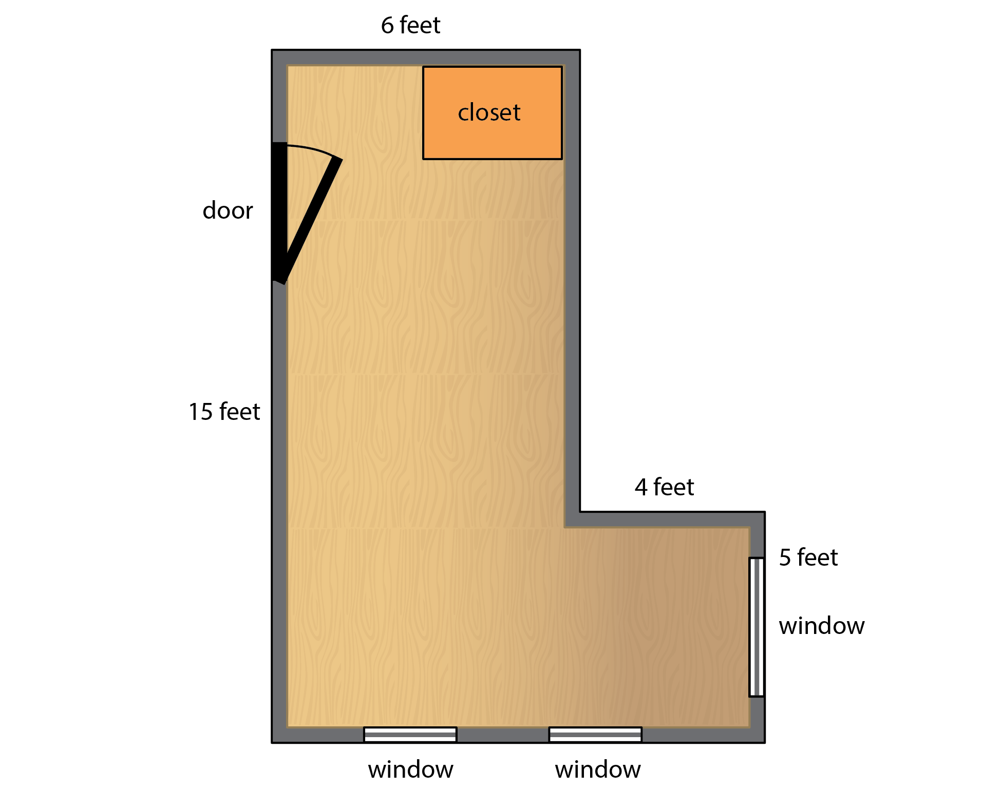

15.1: Floor Plans
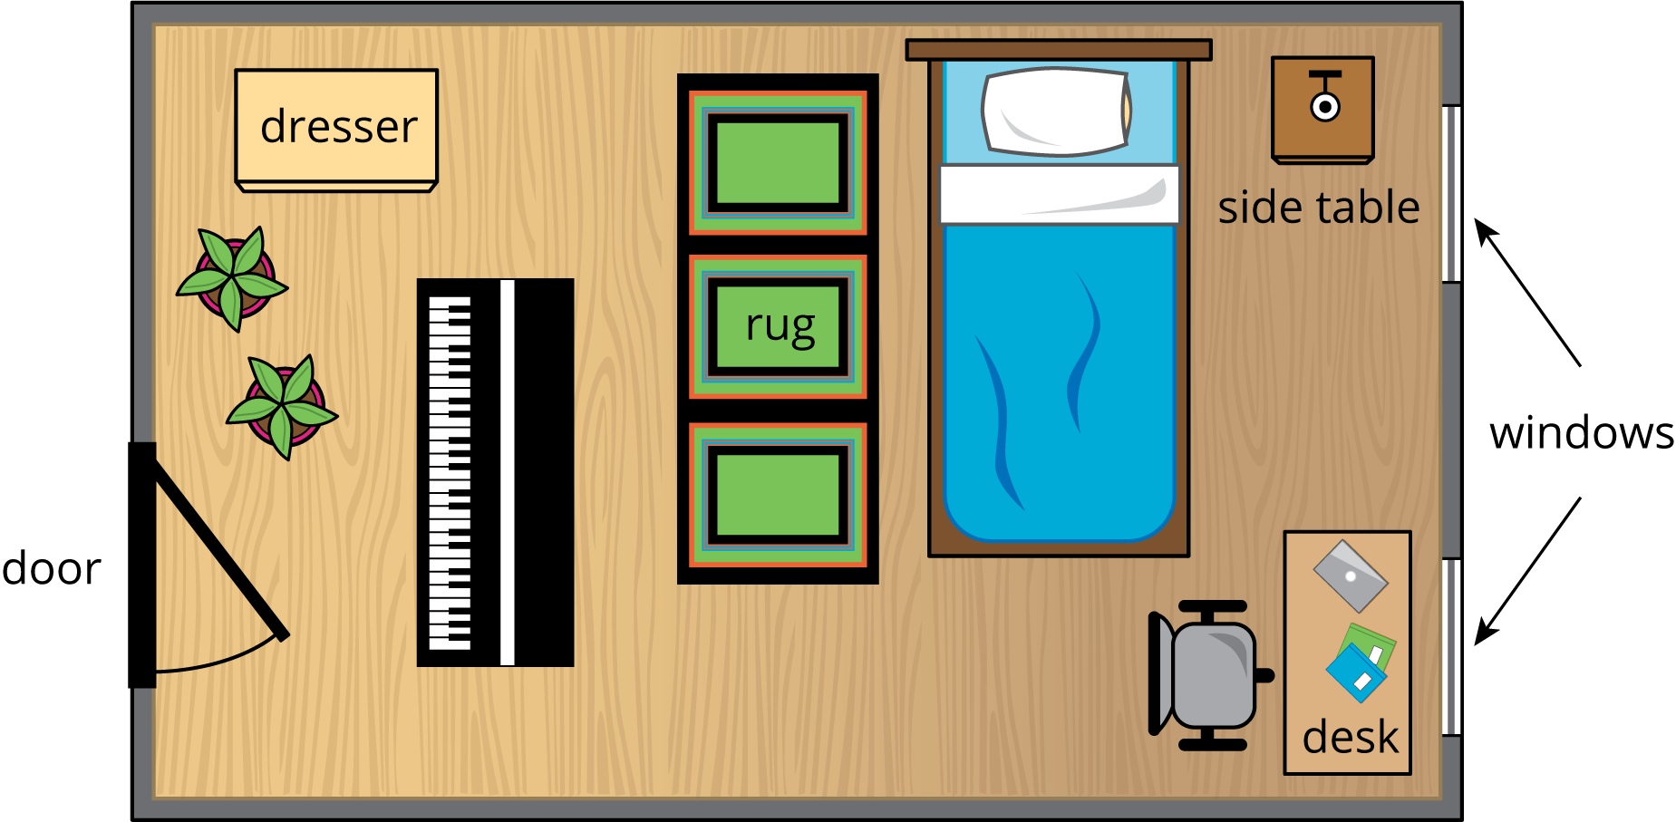
The image shows a design of a floor plan for a bedroom. Discuss with your partners:
- What is one thing you like about the given design?
- What is one thing you would change and why?

15.2: New Bed and Desk
This is a diagram of Tyler's new room, his desk, and his bed.
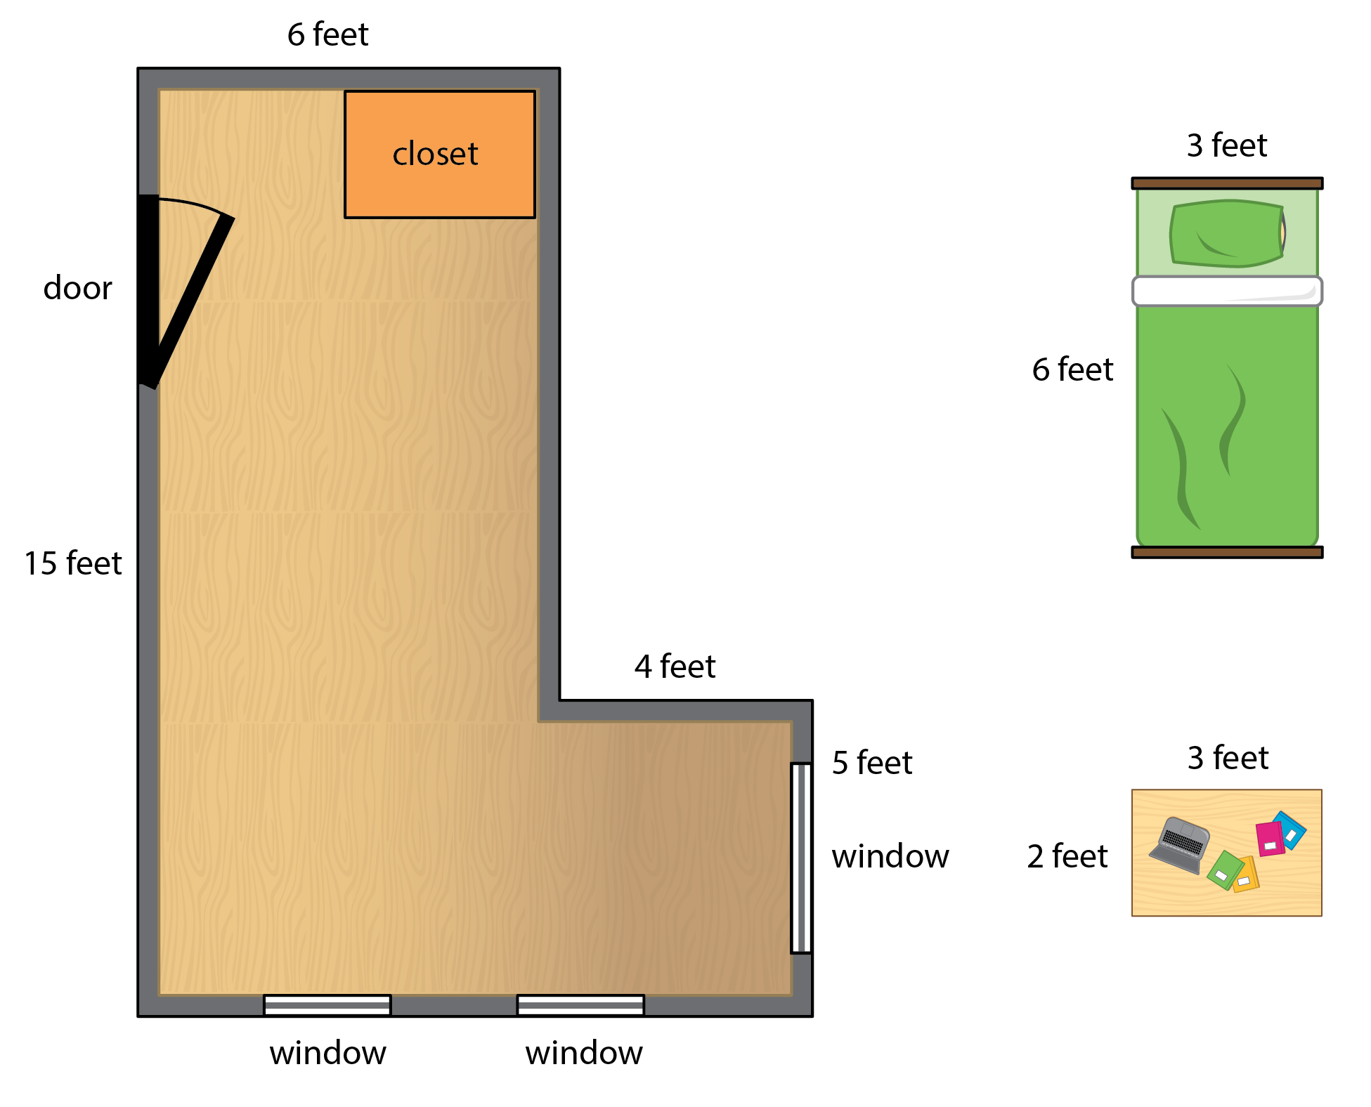
- How should Tyler arrange his bed and desk in his new room?
- What is the area of the room that is not covered with furniture?
Create a poster to show your thinking. Organize it so it can be followed by others.
© CC BY 2021 Illustrative Mathematics®

