Lesson 14: Weight and Capacity Measurements
- Let’s solve problems about weight and capacity.

Warm-up: Number Talk: Lots of Thousands
Find the value of each expression mentally.
- $1,​200+900$
- $12,​500+9,​000$
- $13,​000+9,​900$
- $130,​000+99,​000$

14.1: Milk and Mango Lassi
- Here are three true statements about this jug of milk.
  - This jug contains 1 gallon of milk.
  - This jug contains 4 quarts of milk.
  - This jug contains 16 cups of milk.
- Complete each statement so that it is true:
- 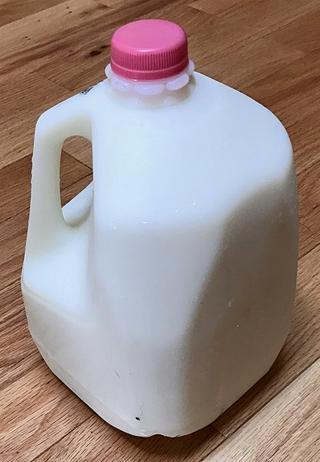
  - One gallon is __________ times as much as 1 quart.
  - One gallon is __________ times as much as 1 cup.
  - One quart is __________ times as much as 1 cup.
- For a potluck party, Priya and three other relatives are bringing mango lassi.
- 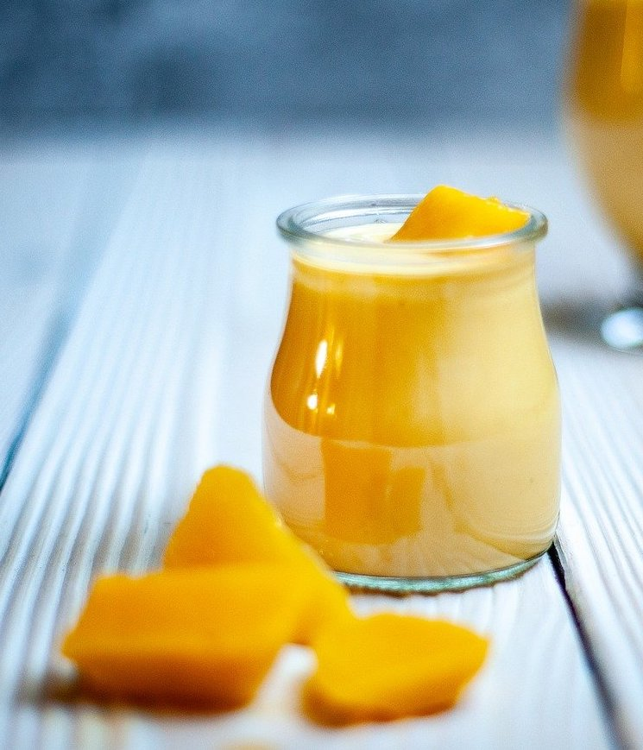
- guest | - amount of lassi
- Priya | - 10 cups
- Uncle | - 3 quarts
- Cousin | - 8 cups
- Grandma | - 2 gallons
  - Who prepared the most mango lassi? Explain or show your reasoning.
  - How many cups of lassi did all the guests bring?
  - Complete this sentence: Priya’s grandma made __________ times as much lassi as Priya’s cousin. Show how you know.

14.2: Clay for Art Class
At a craft store, clay is sold in packs of different sizes: 1 pound, 24 ounces, 3 pounds, and 5 pounds.
An art teacher needs 120 ounces of clay for her class.
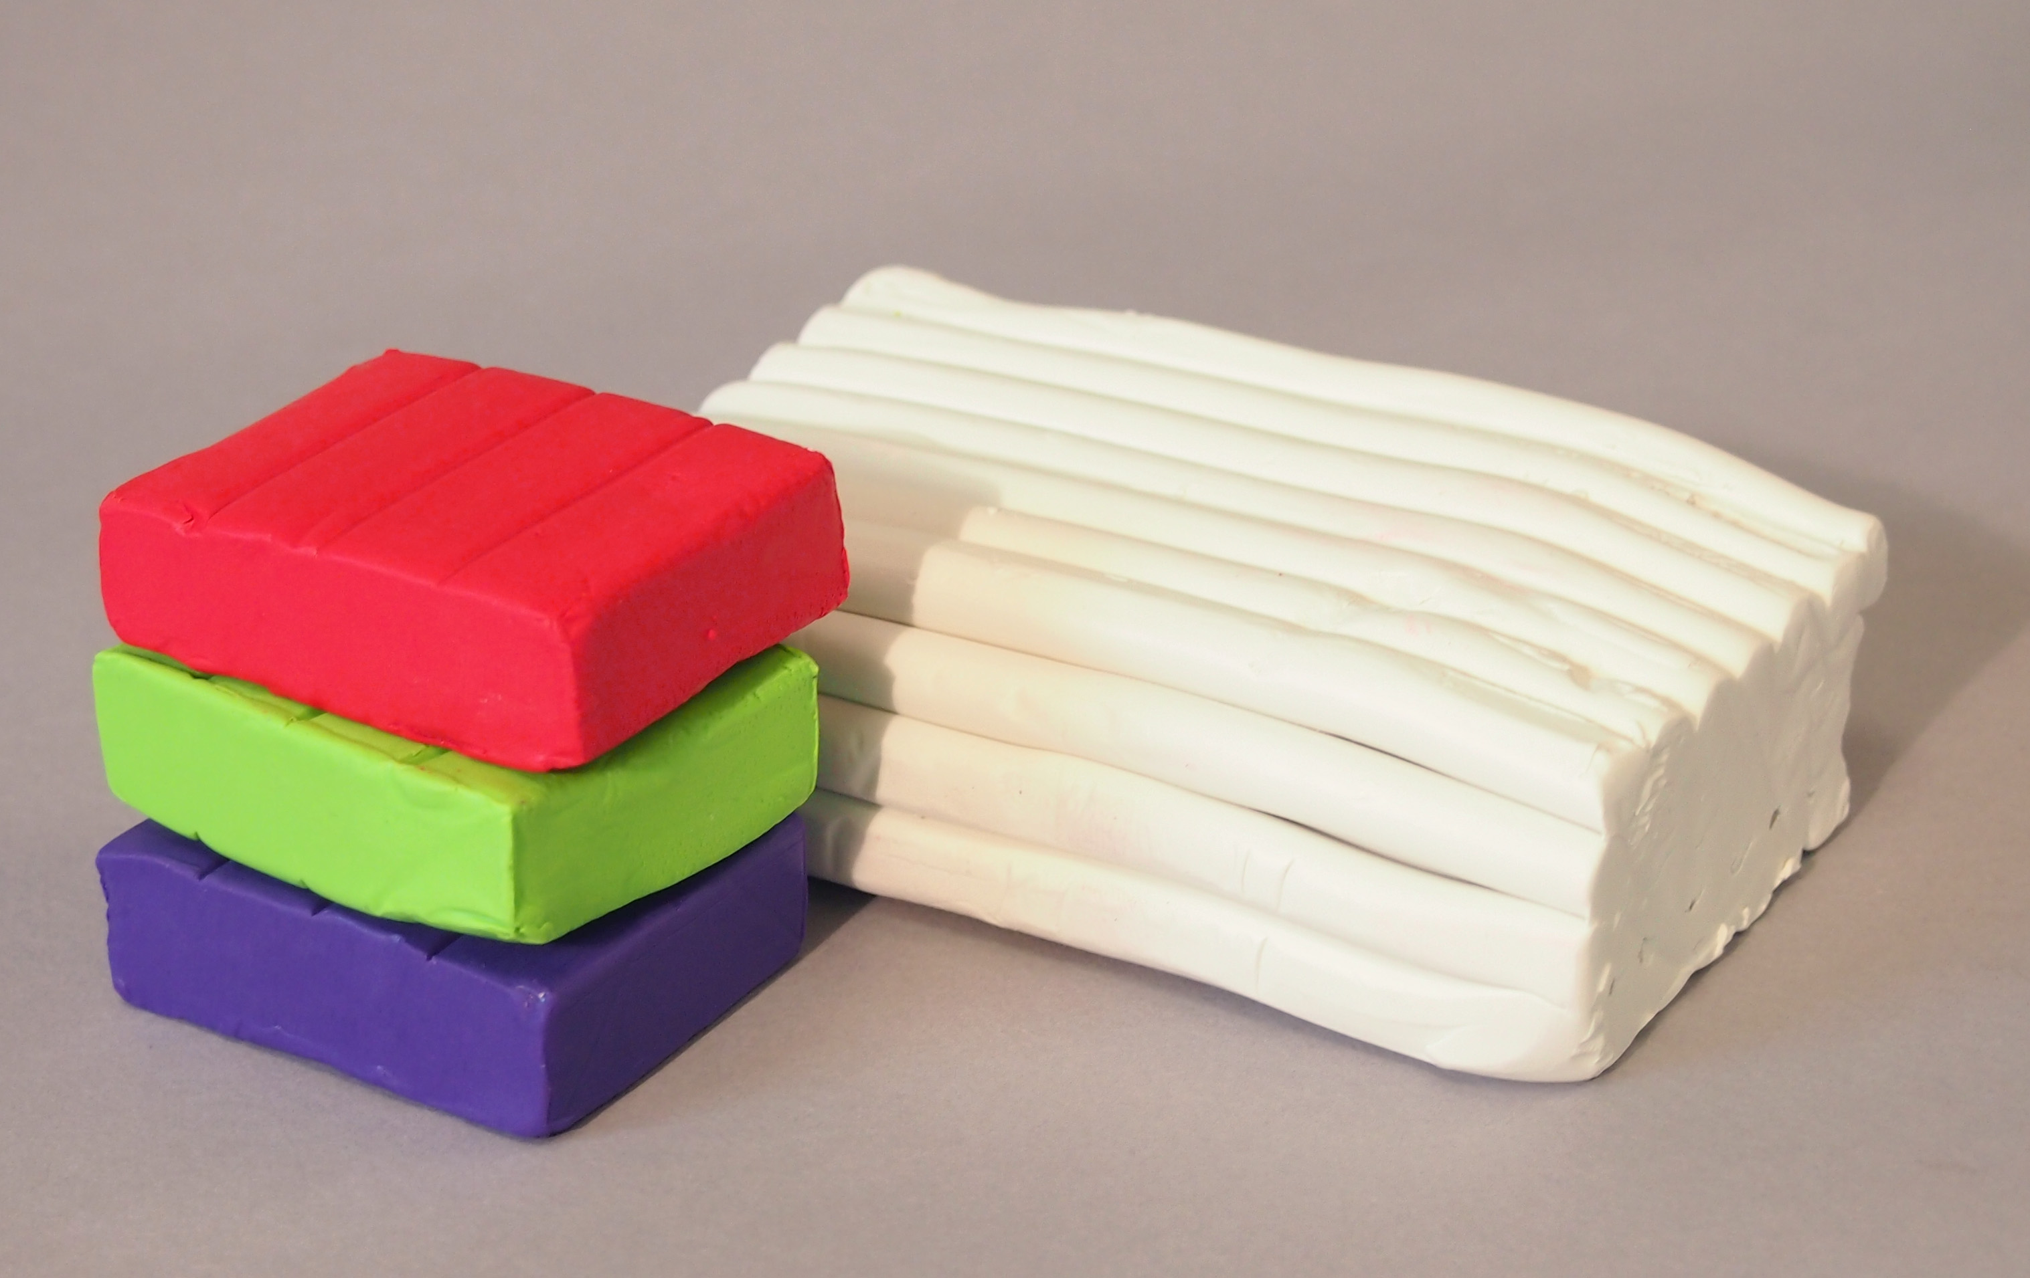
- Would she have enough clay if she bought each of the following combinations? Explain or show your reasoning.
 | - 1-pound pack | - 24-ounce pack | - 3-pound pack | - 5-pound pack
- Combo A | - 1 |  | - 1
- Combo B | - 1 | - 1 | - 1 | - 1
- Combo C |  | - 1 | - 2
- Decide if each statement is true or false. Be prepared to explain or show your reasoning.
  - A 3-pound pack weighs 2 times as much as a 24-ounce pack.
  - If we combine a 1-pound pack, a 3-pound pack, and a 5-pound pack, we’d have 6 times as much clay as what’s in a 24-ounce pack.
© CC BY 2021 Illustrative Mathematics®

