Lesson 5: ¿Cuántos dedos? ¿Cuántos puntos?

Standards Alignments
Addressing | K.CC.A.3, K.CC.B.5
Building Towards | K.NBT.A.1

Teacher-facing Learning Goals
- Answer “how many” questions about groups of up to 19 images.

Student-facing Learning Goals
- Descifremos cuántas cosas hay.

Lesson Purpose
The purpose of this lesson is for students to count to answer “how many” questions about groups of up to 19 images.
In this lesson students see 11–19 images displayed on fingers and 10-frames. Both representations highlight a group of 10 ones in teen numbers. Students begin to understand that each of these numbers have 10 ones and some more ones (MP7). Although some students may begin to recognize the group of 10 ones and determine how many there are by counting on from 10, this is not an expectation of students in kindergarten. Make sure that numbers 1–20 are posted in the classroom so that students can count from 1 to find the number 17 if they are unsure what the written number 17 looks like. Throughout the section, students have access to a reference sheet that shows numbers 11–20 with dots in 10-frames that they can use to identify written numbers.

Access for:

Students with Disabilities
- Action and Expression (Activity 3)

English Learners
- MLR8 (Activity 1)

Instructional Routines
Estimation Exploration (Warm-up)

Materials to Gather
- 10-frames: Activity 3
- Counting mats: Activity 3
- Materials from previous centers: Activity 3
- Pattern blocks: Activity 3

Materials to Copy
- Grab and Count Stage 1 Recording Sheet, Spanish (groups of 1): Activity 3

Lesson Timeline
Warm-up | 10 min
Activity 1 | 10 min
Activity 2 | 10 min
Activity 3 | 20 min
Lesson Synthesis | 5 min
Cool-down | 5 min

Teacher Reflection Question
In upcoming lessons, students will compose and decompose numbers 11–19 using 10 ones and some more ones. How does the work of this lesson help build students’ understanding numbers 11–19 as 10 ones and some more ones?

Cool-down
(to be completed at the end of the lesson) 5min
¿Cuántos hay?

Standards Alignments
Addressing | K.CC.B.5

Student-facing Task Statement
Marca el número que muestra cuántos puntos hay.
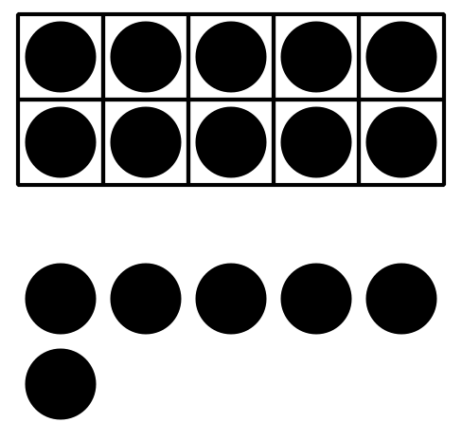
12 18 16

Student Responses
16

