Lesson 5: Efficiently Solving Inequalities

5.1: Lots of Negatives
Here is an inequality: $\text{-}x≥\text{-}4$.
- Predict what you think the solutions on the number line will look like.
- Select all the values that are solutions to $\text{-}x≥\text{-}4$:
  - 3
  - -3
  - 4
  - -4
  - 4.001
  - -4.001
- Graph the solutions to the inequality on the number line:
- 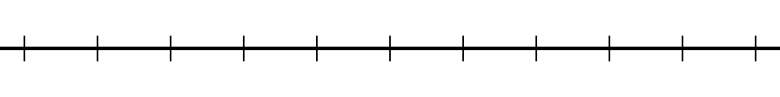

5.2: Inequalities with Tables
- Let's investigate the inequality $x−3>\text{-}2$.
- $x$ | - -4 | - -3 | - -2 | - -1 | - 0 | - 1 | - 2 | - 3 | - 4
- $x−3$ | - -7 |  | - -5 |  |  |  | - -1 |  | - 1
  - Complete the table.
  - For which values of $x$ is it true that $x−3=\text{-}2$?
  - For which values of $x$ is it true that $x−3>\text{-}2$?
  - Graph the solutions to $x−3>\text{-}2$ on the number line:
- Here is an inequality: $2x<6$.
  - Predict which values of $x$ will make the inequality $2x<6$ true.
  - Complete the table. Does it match your prediction?
- $x$ | - -4 | - -3 | - -2 | - -1 | - 0 | - 1 | - 2 | - 3 | - 4
  - $2x$
  - Graph the solutions to $2x<6$ on the number line:
- Here is an inequality: $\text{-}2x<6$.
  - Predict which values of $x$ will make the inequality $\text{-}2x<6$ true.
  - Complete the table. Does it match your prediction?
- $x$ | - -4 | - -3 | - -2 | - -1 | - 0 | - 1 | - 2 | - 3 | - 4
  - $\text{-}2x$
  - Graph the solutions to $\text{-}2x<6$ on the number line:
  - How are the solutions to $2x<6$ different from the solutions to $\text{-}2x<6$?

5.3: Which Side are the Solutions?
- Let’s investigate $\text{-}4x+5≥25$.
  - Solve $\text{-}4x+5=25$.
  - Is $\text{-}4x+5≥25$ true when $x$ is 0? What about when $x$ is 7? What about when $x$ is -7?
  - Graph the solutions to $\text{-}4x+5≥25$ on the number line.
- Let's investigate $\frac{4}{3}x+3<\frac{23}{3}$.
  - Solve $\frac{4}{3}x+3=\frac{23}{3}$.
  - Is $\frac{4}{3}x+3<\frac{23}{3}$ true when $x$ is 0?
  - Graph the solutions to $\frac{4}{3}x+3<\frac{23}{3}$ on the number line.
- Solve the inequality $3(x+4)>17.4$ and graph the solutions on the number line.
- Solve the inequality $\text{-}3\left(x−\frac{4}{3}\right)≤6$ and graph the solutions on the number line.

Are you ready for more?
Write at least three different inequalities whose solution is $x>\text{-}10$. Find one with $x$ on the left side that uses a $<$.

Lesson 5 Summary
Here is an inequality: $3(10−2x)<18$. The solution to this inequality is all the values you could use in place of $x$ to make the inequality true.
In order to solve this, we can first solve the related equation $3(10−2x)=18$ to get the solution $x=2$. That means 2 is the boundary between values of $x$ that make the inequality true and values that make the inequality false.
To solve the inequality, we can check numbers greater than 2 and less than 2 and see which ones make the inequality true.
Let’s check a number that is greater than 2: $x=5$. Replacing $x$ with 5 in the inequality, we get $3(10−2⋅5)<18$ or just $0<18$. This is true, so $x=5$ is a solution. This means that all values greater than 2 make the inequality true. We can write the solutions as $x>2$ and also represent the solutions on a number line:
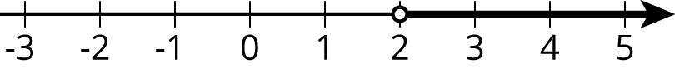
Notice that 2 itself is not a solution because it's the value of $x$ that makes $3(10−2x)$ ​equal to 18, and so it does not make $3(10−2x)<18$ true.
For confirmation that we found the correct solution, we can also test a value that is less than 2. If we test $x=0$, we get $3(10−2⋅0)<18$ or just $30<18$. This is false, so $x=0$ and all values of $x$ that are less than 2 are not solutions.
© CC BY Open Up Resources. Adaptations CC BY IM.

