Lesson 9: Equations of Lines
- Let’s investigate equations of lines.

9.1: Remembering Slope
The slope of the line in the image is $\frac{8}{15}$. Explain how you know this is true.

9.2: Building an Equation for a Line
- The image shows a line.
  - Write an equation that says the slope between the points $(1,3)$ and $(x,y)$ is 2.
  - Look at this equation: $y−3=2(x−1)$
How does it relate to the equation you wrote?
- Here is an equation for another line: $y−7=\frac{1}{2}(x−5)$
  - What point do you know this line passes through?
  - What is the slope of this line?
- Next, let’s write a general equation that we can use for any line. Suppose we know a line passes through a particular point $(h,k)$.
  - Write an equation that says the slope between point $(x,y)$ and $(h,k)$ is $m$.
  - Look at this equation: $y−k=m(x−h)$. How does it relate to the equation you wrote?

9.3: Using Point-Slope Form
- Write an equation that describes each line.
  - the line passing through point $(\text{-}2,8)$ with slope $\frac{4}{5}$
  - the line passing through point $(0,7)$ with slope $\text{-}\frac{7}{3}$
  - the line passing through point $(\frac{1}{2},0)$ with slope -1
  - the line in the image
- Using the structure of the equation, what point do you know each line passes through? What’s the line’s slope?
  - $y−5=\frac{3}{2}(x+4)$
  - $y+2=5x$
  - $y=\text{-}2(x−\frac{5}{8})$

Are you ready for more?
Another way to describe a line, or other graphs, is to think about the coordinates as changing over time. This is especially helpful if we’re thinking tracing an object’s movement. This example describes the $x$- and $y$-coordinates separately, each in terms of time, $t$.
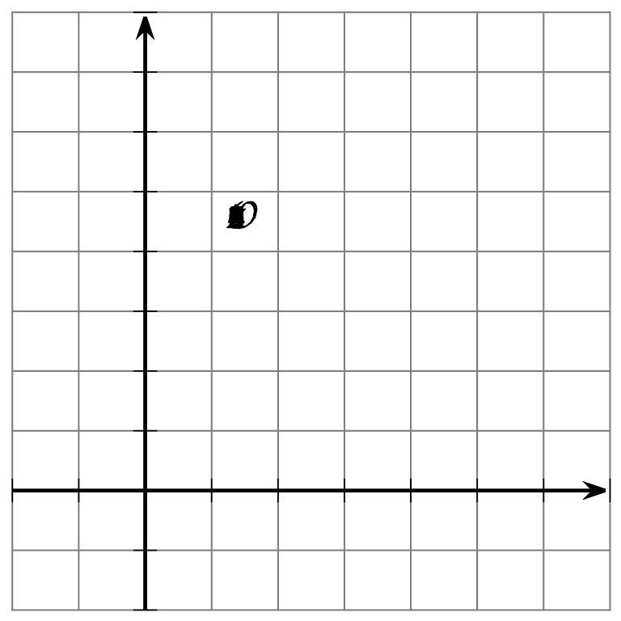
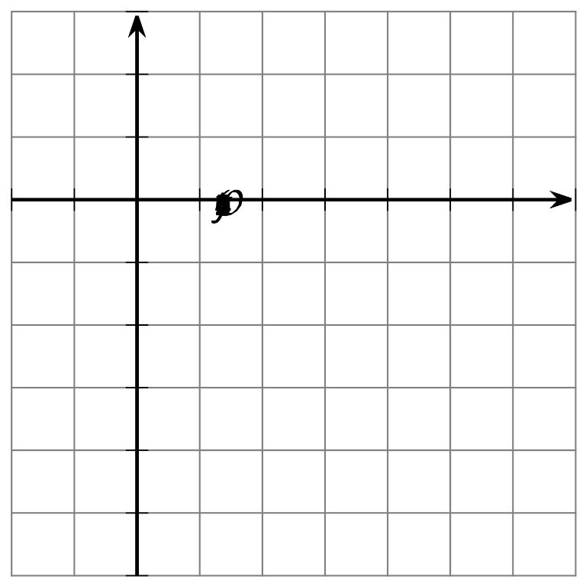
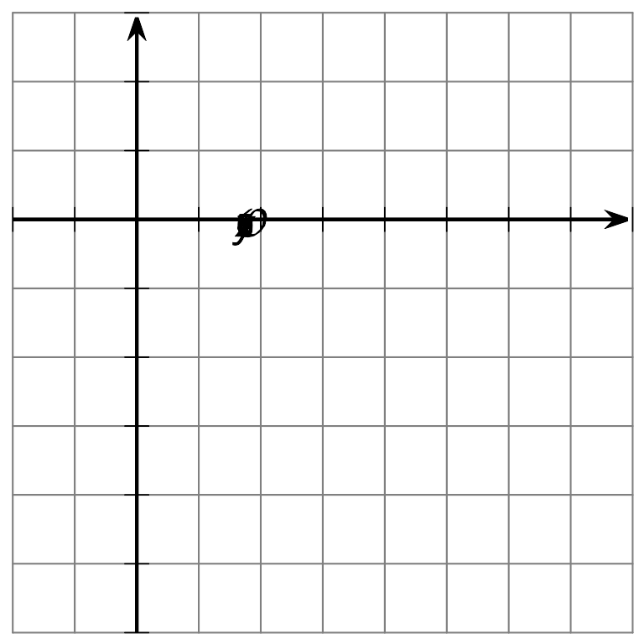
- On the first grid, create a graph of $x=2+5t$ for $\text{-}2≤t≤7$ with $x$ on the vertical axis and $t$ on the horizontal axis.
- On the second grid, create a graph of $y=3−4t$ for $\text{-}2≤t≤7$ with $y$ on the vertical axis and $t$ on the horizontal axis.
- On the third grid, create a graph of the set of points $(2+5t,3−4t)$ for $\text{-}2≤t≤7$ on the $xy$-plane.

Lesson 9 Summary
The line in the image can be defined as the set of points that have a slope of 2 with the point $(3,4)$. An equation that says point $(x,y)$ has slope 2 with $(3,4)$ is $\frac{y−4}{x−3}=2$. This equation can be rearranged to look like $y−4=2(x−3)$.
The equation is now in point-slope form, or $y−k=m(x−h)$, where:
- $(x,y)$ is any point on the line
- $(h,k)$ is a particular point on the line that we choose to substitute into the equation
- $m$ is the slope of the line
Other ways to write the equation of a line include slope-intercept form, $y=mx+b$, and standard form, $Ax+By=C$.
To write the equation of a line passing through $(3,1)$ and $(0,5)$, start by finding the slope of the line. The slope is $\text{-}\frac{4}{3}$ because $\frac{5−1}{0−3}=\text{-}\frac{4}{3}$. Substitute this value for $m$ to get $y−k=\text{-}\frac{4}{3}(x−h)$. Now we can choose any point on the line to substitute for $(h,k)$. If we choose $(3,1)$, we can write the equation of the line as $y−1=\text{-}\frac{4}{3}(x−3)$.
We could also use $(0,5)$ as the point, giving $y−5=\text{-}\frac{4}{3}(x−0)$. We can rearrange the equation to see how point-slope and slope-intercept forms relate, getting $y=\text{-}\frac{4}{3}x+5$. Notice $(0,5)$ is the $y$-intercept of the line. The graphs of all 3 of these equations look the same.
© CC BY 2019 by Illustrative Mathematics®

