Lesson 3: How Many Groups?

3.1: How Many of These in That?
- We can think of the division expression $10÷2\frac{1}{2}$ as the question: “How many groups of $2\frac{1}{2}$ are in 10?” Complete the tape diagram to represent this question. Then find the answer.
- 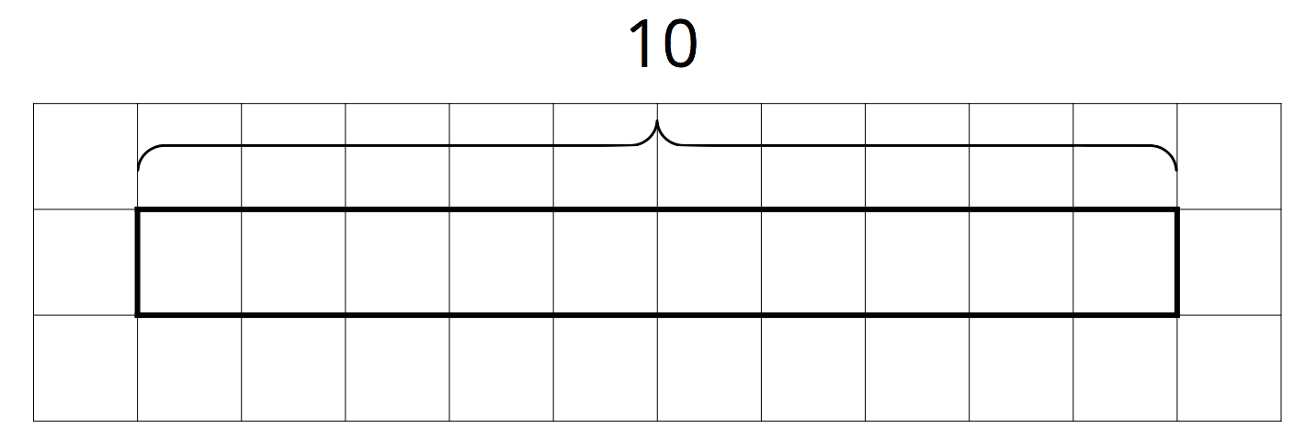
- Complete the tape diagram to represent the question: “How many groups of 2 are in 7?” Then find the answer.
- 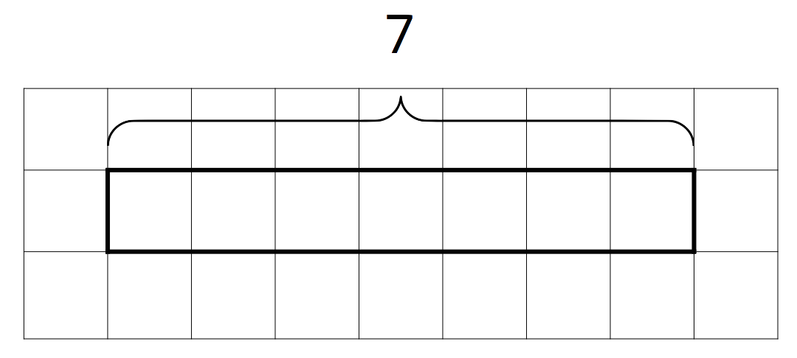

3.2: Representing Groups of Fractions with Tape Diagrams
To make sense of the question “How many $\frac{2}{3}$s are in 1?,” Andre wrote equations and drew a tape diagram.
$?⋅\frac{2}{3}=1$
$1÷\frac{2}{3}=?$
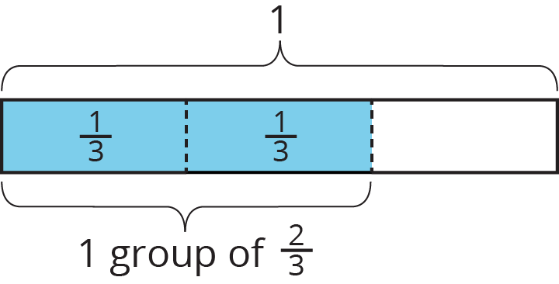
- Andre wasn’t sure how to deal with the remainder.
  - Diego says, “The answer is $1\frac{1}{3}$, because the remainder is $\frac{1}{3}$ of the rectangle.”
  - Jada says, “I think the answer is $1\frac{1}{2}$. Since we want to find out ‘how many $\frac{2}{3}$s there are,’ we should compare the leftover part to a group of $\frac{2}{3}$. The remainder is $\frac{1}{2}$ of a group.”
- Do you agree with either of them? Explain or show your reasoning.
- Write a multiplication equation and a division equation for each question. Then, draw a tape diagram and find the answer.
  - How many $\frac{3}{4}$s are in 1?
  - How many $\frac{2}{3}$s are in 3?
  - How many $\frac{3}{2}$s are in 5?

3.3: Finding Number of Groups
- Write a multiplication equation or a division equation for each question. Then, find the answer and explain or show your reasoning.
  - How many $\frac{3}{8}$-inch thick books make a stack that is 6 inches tall?
  - How many groups of $\frac{1}{2}$ pound are in $2\frac{3}{4}$ pounds?
- Write a question that can be represented by the division equation $5÷1\frac{1}{2}=?$. Then, find the answer and explain or show your reasoning.

Lesson 3 Summary
A baker used 2 kilograms of flour to make several batches of a pastry recipe. The recipe called for $\frac{2}{5}$ kilogram of flour per batch. How many batches did she make?
We can think of the question as: “How many groups of $\frac{2}{5}$ kilogram make 2 kilograms?” and represent that question with the equations:
$?⋅\frac{2}{5}=2$
$2÷\frac{2}{5}=?$
To help us make sense of the question, we can draw a tape diagram. This diagram shows 2 whole kilograms, with each kilogram partitioned into fifths.
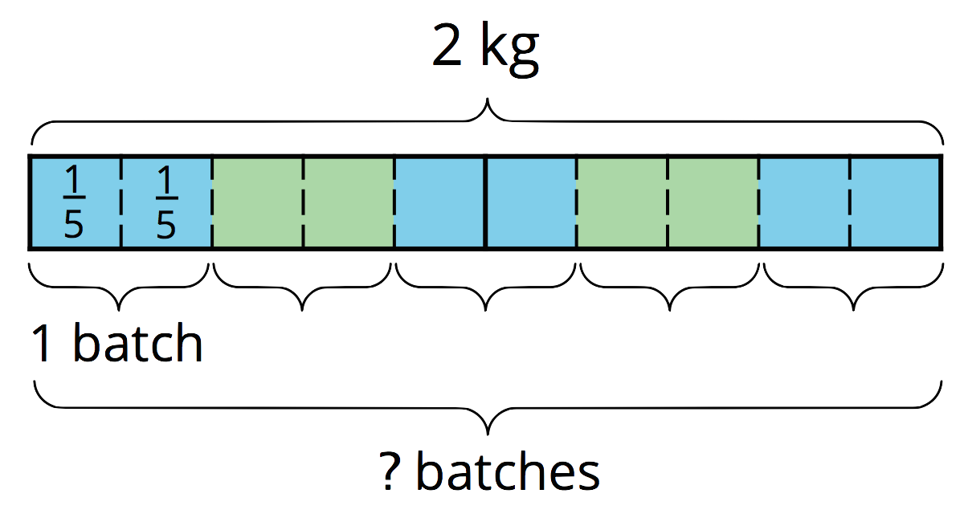
We can see there are 5 groups of $\frac{2}{5}$ in 2. Multiplying 5 and $\frac{2}{5}$ allows us to check this answer: $5⋅\frac{2}{5}=\frac{10}{5}$ and $\frac{10}{5}=2$, so the answer is correct.
Notice the number of groups that result from $2÷\frac{2}{5}$ is a whole number. Sometimes the number of groups we find from dividing may not be a whole number. Here is an example:
Suppose one serving of rice is $\frac{3}{4}$ cup. How many servings are there in $3\frac{1}{2}$ cups?
$?⋅\frac{3}{4}=3\frac{1}{2}$
$3\frac{1}{2}÷\frac{3}{4}=?$
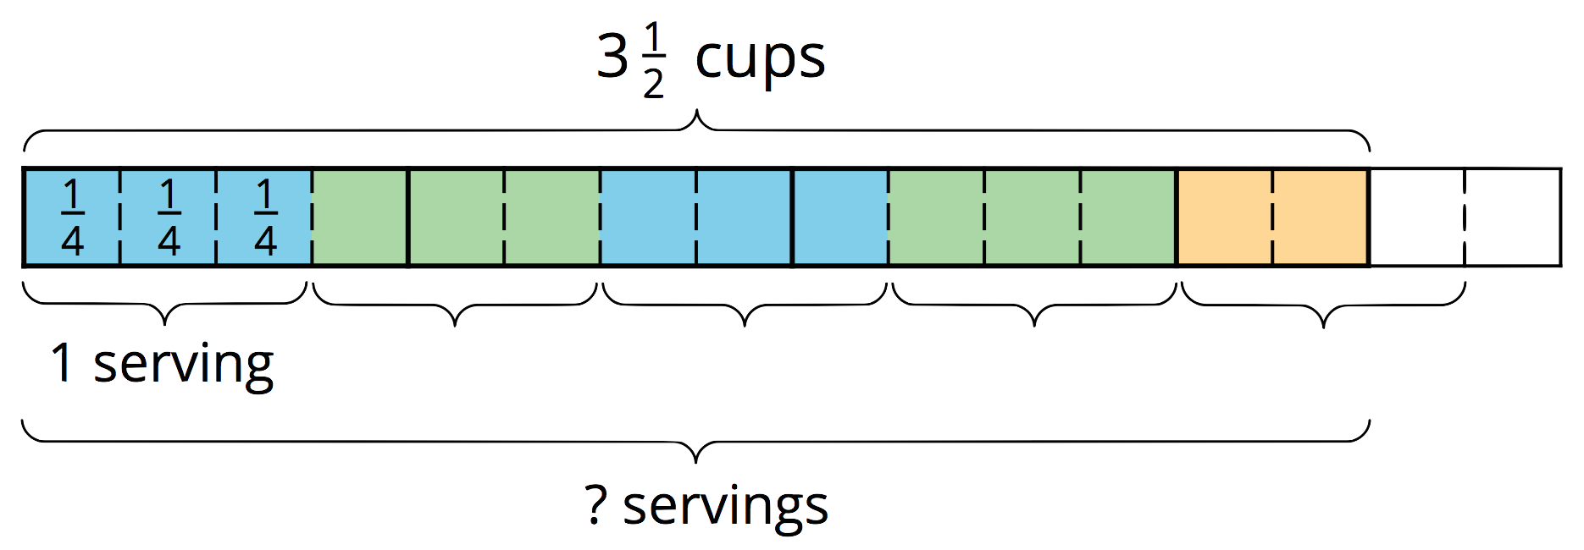
Looking at the diagram, we can see there are 4 full groups of $\frac{3}{4}$, plus 2 fourths. If 3 fourths make a whole group, then 2 fourths make $\frac{2}{3}$ of a group. So the number of servings (the “?” in each equation) is $4\frac{2}{3}$. We can check this by multiplying $4\frac{2}{3}$ and $\frac{3}{4}$.
$4\frac{2}{3}⋅\frac{3}{4}=\frac{14}{3}⋅\frac{3}{4}$, and $\frac{14}{3}⋅\frac{3}{4}=\frac{14}{4}$, which is indeed equivalent to $3\frac{1}{2}$.
© CC BY Open Up Resources. Adaptations CC BY IM.

