Lesson 15: Hagamos diagramas de puntos

Standards Alignments
Addressing | 2.MD.A.1, 2.MD.D.9, 2.NBT.B.5

Teacher-facing Learning Goals
- Represent numerical data in a line plot.

Student-facing Learning Goals
- Representemos datos en diagramas de puntos.

Lesson Purpose
The purpose of this lesson is for students to create line plots to represent numerical data.
In an earlier lesson, students learned about the features of a line plot. They interpreted a line plot that represented data from measurements they made in inches.
In this lesson, students measure the lengths of pencils in centimeters and represent the data on their own in a line plot. In Activity 2, students make sense of line plots that do not start at 0. They choose an appropriate starting and ending number based on the data (MP6). In the lesson synthesis, students interpret the data presented in a line plot with a scale that does not start at 0.

Access for:

Students with Disabilities
- Action and Expression (Activity 1)

Instructional Routines
MLR8 Discussion Supports (Activity 2), Number Talk (Warm-up)

Materials to Gather
- Objects of various lengths: Activity 1
- Rulers (centimeters): Activity 1

Materials to Copy
- Line Plot Template (groups of 1): Activity 1

Lesson Timeline
Warm-up | 10 min
Activity 1 | 15 min
Activity 2 | 20 min
Lesson Synthesis | 10 min
Cool-down | 5 min

Teacher Reflection Question
What did you say, do, or ask to support students in creating a line plot based on an understanding of the representation, rather than following a procedure?

Cool-down
(to be completed at the end of the lesson) 5min
Palmos del grupo de Mai

Standards Alignments
Addressing | 2.MD.D.9

Student-facing Task Statement
- Mai hizo estas afirmaciones sobre las longitudes de los palmos de los estudiantes de su grupo.
  - Cuatro estudiantes tienen un palmo de 18 cm.
  - Dos estudiantes tienen un palmo de 16 cm.
  - Dos estudiantes tienen un palmo de 19 cm.
  - Un estudiante tiene un palmo de 20 cm.
- Completa el diagrama de puntos para que corresponda con los datos de Mai.
- 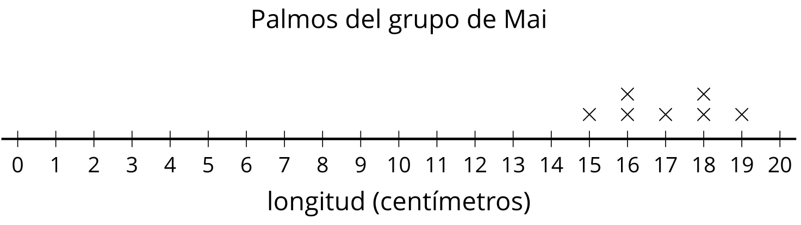

Student Responses

- 