Lesson 4: Comparing Quadratic and Exponential Functions

4.1: From Least to Greatest
List these quantities in order, from least to greatest, without evaluating each expression. Be prepared to explain your reasoning.
A. $2^{10}$
B. ${10}^{2}$
C. $2^{9}$
D. $9^{2}$

4.2: Which One Grows Faster?
- In Pattern A, the length and width of the rectangle grow by one small square from each step to the next.
- In Pattern B, the number of small squares doubles from each step to the next.
- In each pattern, the number of small squares is a function of the step number, $n$.

Pattern A
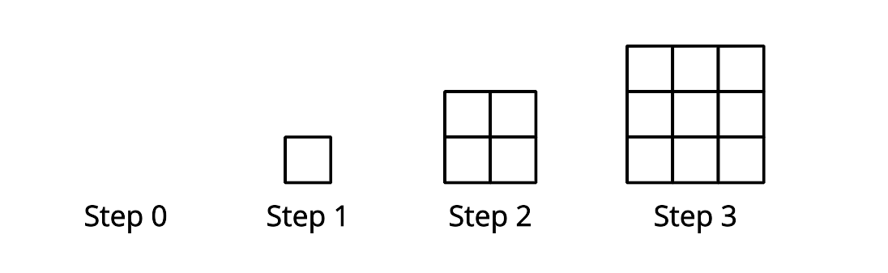

Pattern B
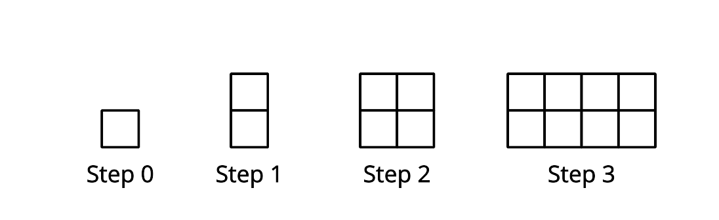
- Write an equation to represent the number of small squares at Step $n$ in Pattern A.
- Is the function linear, quadratic, or exponential?
- Complete the table:
- $n$, step number | - $f(n)$, number of small squares
- 0
- 1
- 2
- 3
- 4
- 5
- 6
- 7
- 8
- Write an equation to represent the number of small squares at Step $n$ in Pattern B.
- Is the function linear, quadratic, or exponential?
- Complete the table:
- $n$, step number | - $g(n)$, number of small squares
- 0
- 1
- 2
- 3
- 4
- 5
- 6
- 7
- 8
How would the two patterns compare if they continue to grow? Make 1–2 observations.

4.3: Comparing Two More Functions
Here are two functions: $p(x)=6x^{2}$ and $q(x)=3^{x}$.
Investigate the output of $p$ and $q$ for different values of $x$. For large enough values of $x$, one function will have a greater value than the other. Which function will have a greater value as $x$ increases?
Support your answer with tables, graphs, or other representations.

Are you ready for more?
- Jada says that some exponential functions grow more slowly than the quadratic function as $x$ increases. Do you agree with Jada? Explain your reasoning.
- Could you have an exponential function $g(x)=b^{x}$ so that $g(x)<f(x)$ for all values of $x$?

Lesson 4 Summary
We have seen that the graphs of quadratic functions can curve upward. Graphs of exponential functions, with base larger than 1, also curve upward. To compare the two, let’s look at the quadratic expression $3n^{2}$ and the exponential expression $2^{n}$.
A table of values shows that $3n^{2}$ is initially greater than $2^{n}$ but $2^{n}$ eventually becomes greater.
$n$
$3n^{2}$
$2^{n}$
1
3
2
2
12
4
3
27
8
4
48
16
5
75
32
6
108
64
7
147
128
8
192
256
We also saw an explanation for why exponential growth eventually overtakes quadratic growth.
- When $n$ increases by 1, the exponential expression $2^{n}$ always increases by a factor of 2.
- The quadratic expression $3n^{2}$ increases by different factors, depending on $n$, but these factors get smaller. For example, when $n$ increases from 2 to 3, the factor is $\frac{27}{12}$ or 2.25. When $n$ increases from 6 to 7, the factor is $\frac{147}{108}$ or about 1.36. As $n$ increases to larger and larger values, $3n^{2}$ grows by a factor that gets closer and closer to 1.
A quantity that always doubles will eventually overtake a quantity growing by this smaller factor at each step.
© CC BY 2019 by Illustrative Mathematics

