Unit 1 Lesson 20: Transformations, Transversals, and Proof

1 Math Talk: Angle Relationships (Warm up)

Student Task Statement
Lines $ℓ$ and $m$ are parallel. Mentally evaluate the measure $x$ in each figure.

Figure A
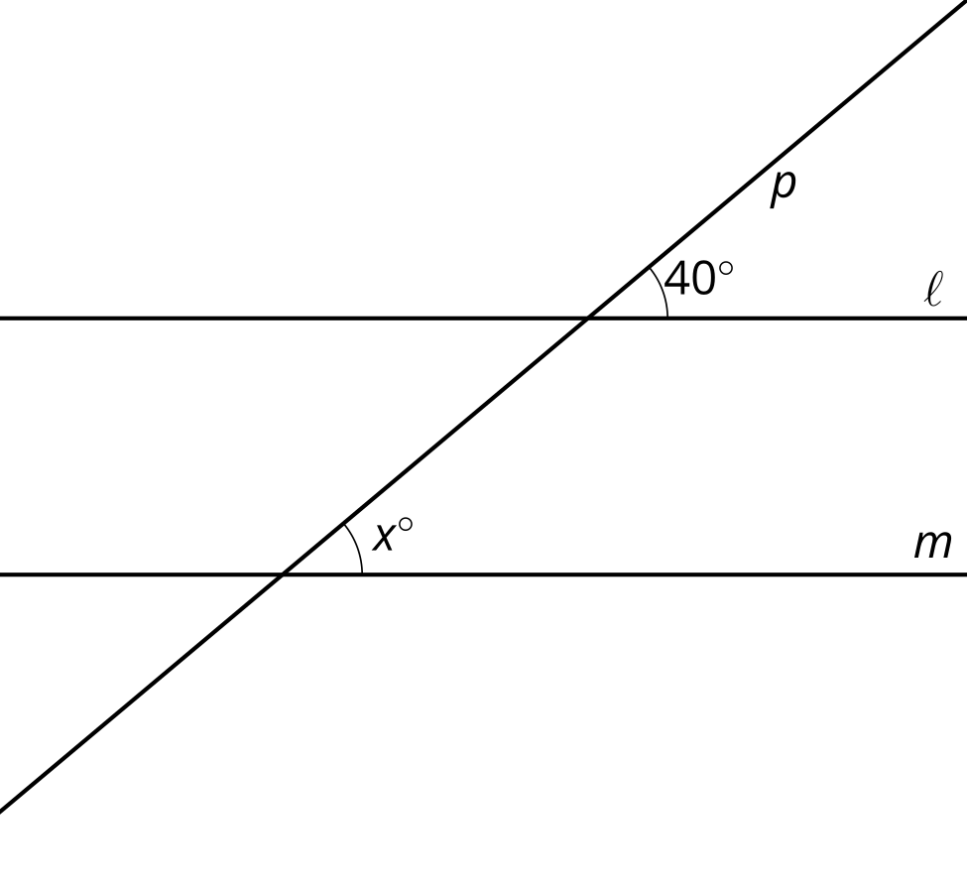

Figure B
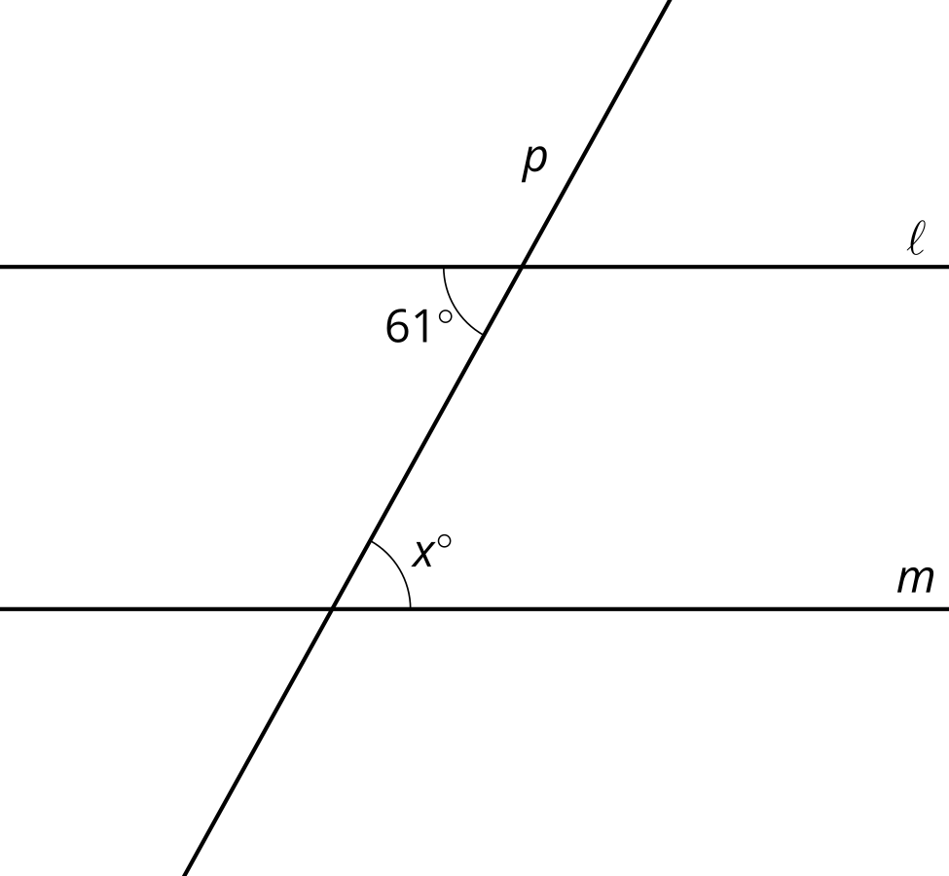

Figure C
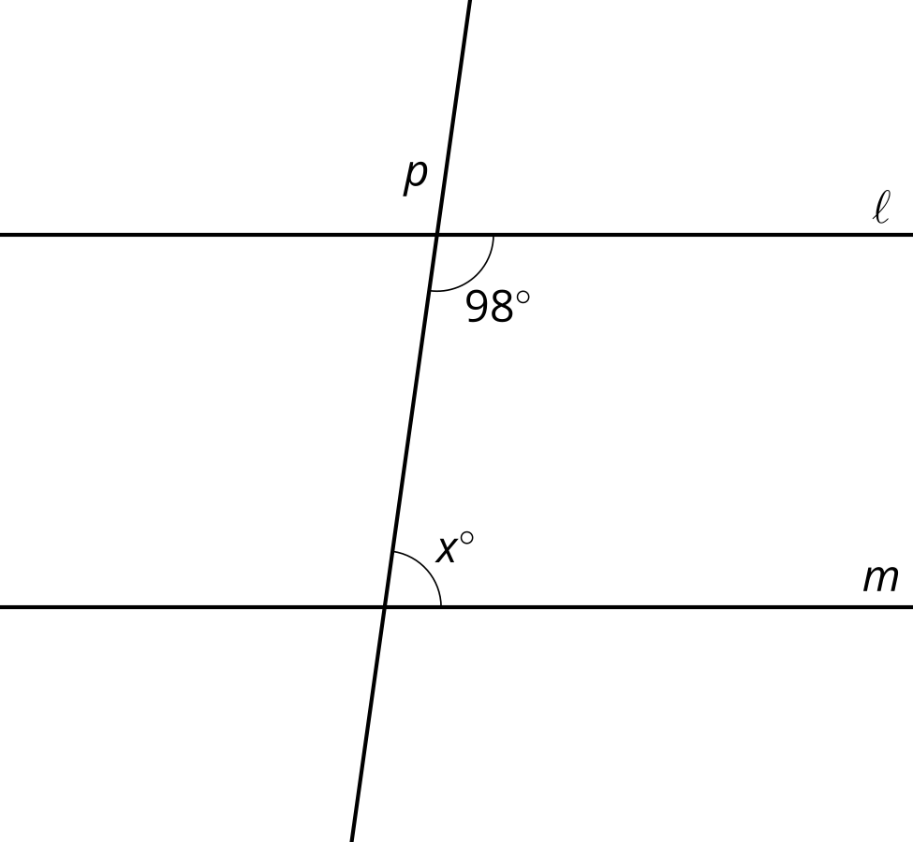

Figure D
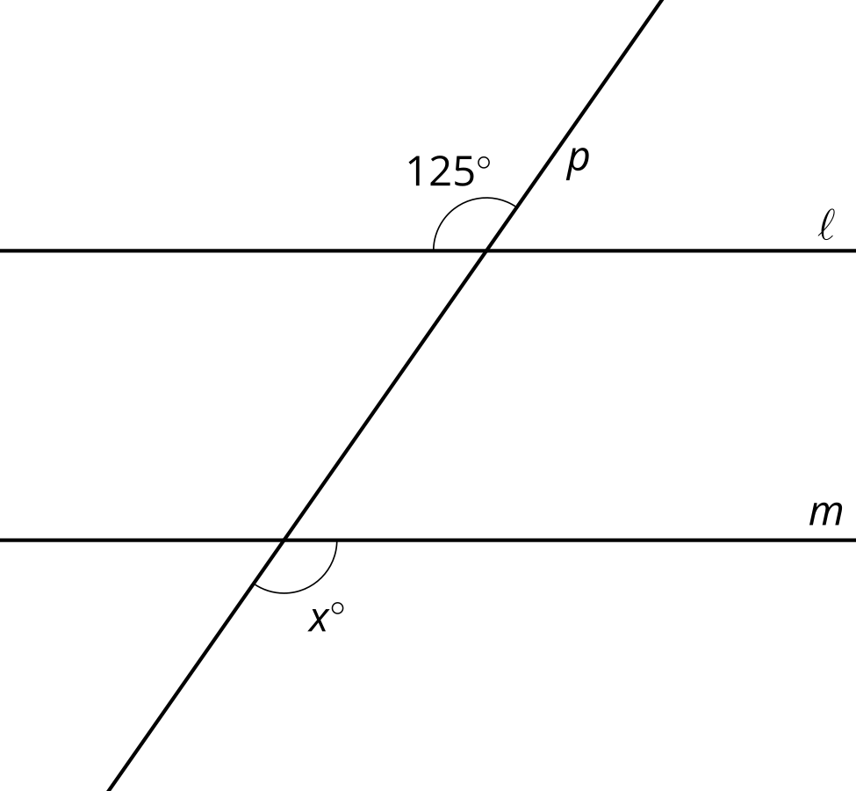

2 Make a Mark? Give a Reason.

Student Task Statement
Here are intersecting lines $AE$ and $CD$:
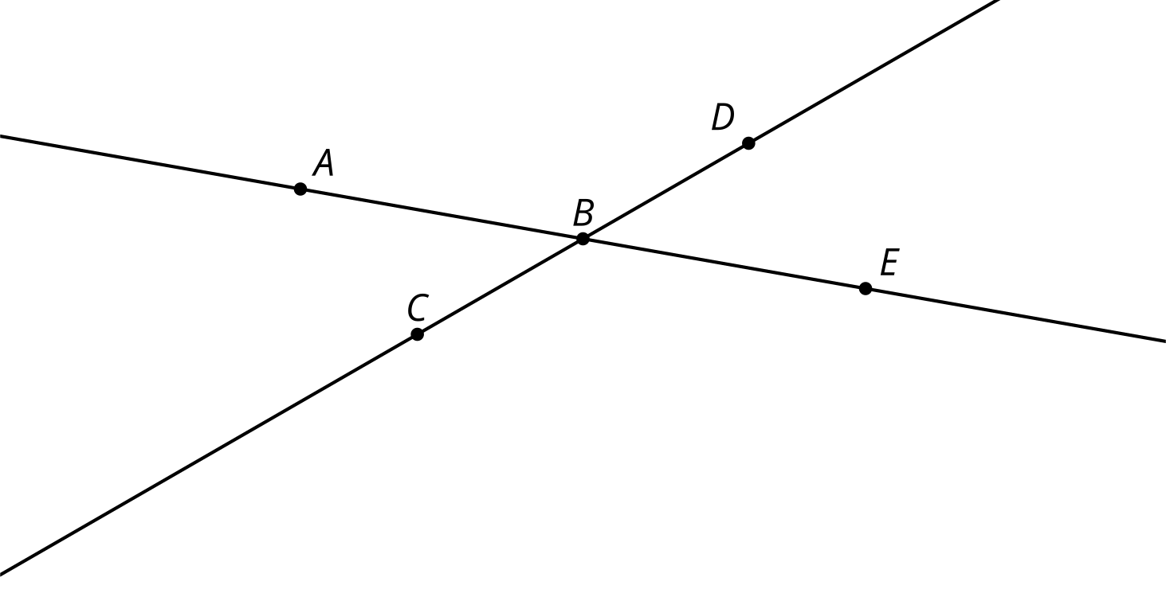
- Translate lines $AE$ and $CD$ by the directed line segment from $B$ to $C$. Label the images of $A,B,C,D,E$ as $A^{′},B^{′},C^{′},D^{′},E^{′}$.
- What is true about lines $AE$ and $A^{′}E^{′}$? Explain your reasoning.
- Take turns with your partner to identify congruent angles.
  - For each pair of congruent angles that you find, explain to your partner how you know the angles are congruent.
  - For each match that your partner finds, listen carefully to their explanation. If you disagree, discuss your thinking and work to reach an agreement.

3 An Alternate Explanation

Images for Launch
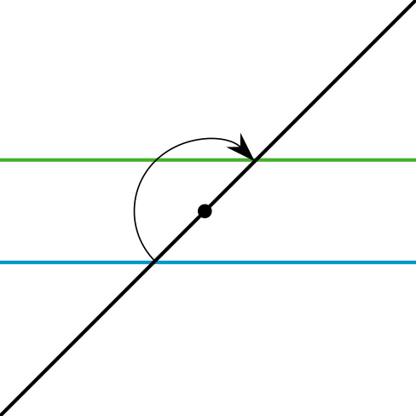

Student Task Statement
Here are intersecting lines $AE$ and $CD$:
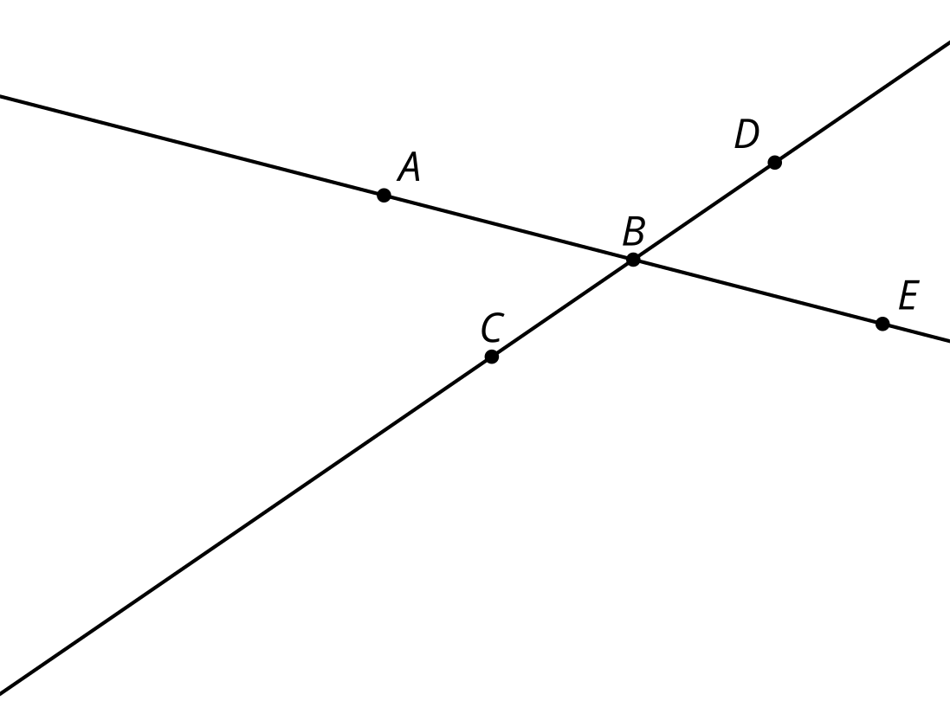
- Rotate line $AE$ by 180 degrees around point $C$. Label the images of $A,B,C,D,E$ as $A^{′},B^{′},C^{′},D^{′},E^{′}$.
- What is true about lines $AB$ and $A^{′}B^{′}$? Explain your reasoning.
- Take turns with your partner to identify congruent angles.
  - For each pair of congruent angles that you find, explain to your partner how you know the angles are congruent.
  - For each match that your partner finds, listen carefully to their explanation. If you disagree, discuss your thinking and work to reach an agreement.

Images for Activity Synthesis
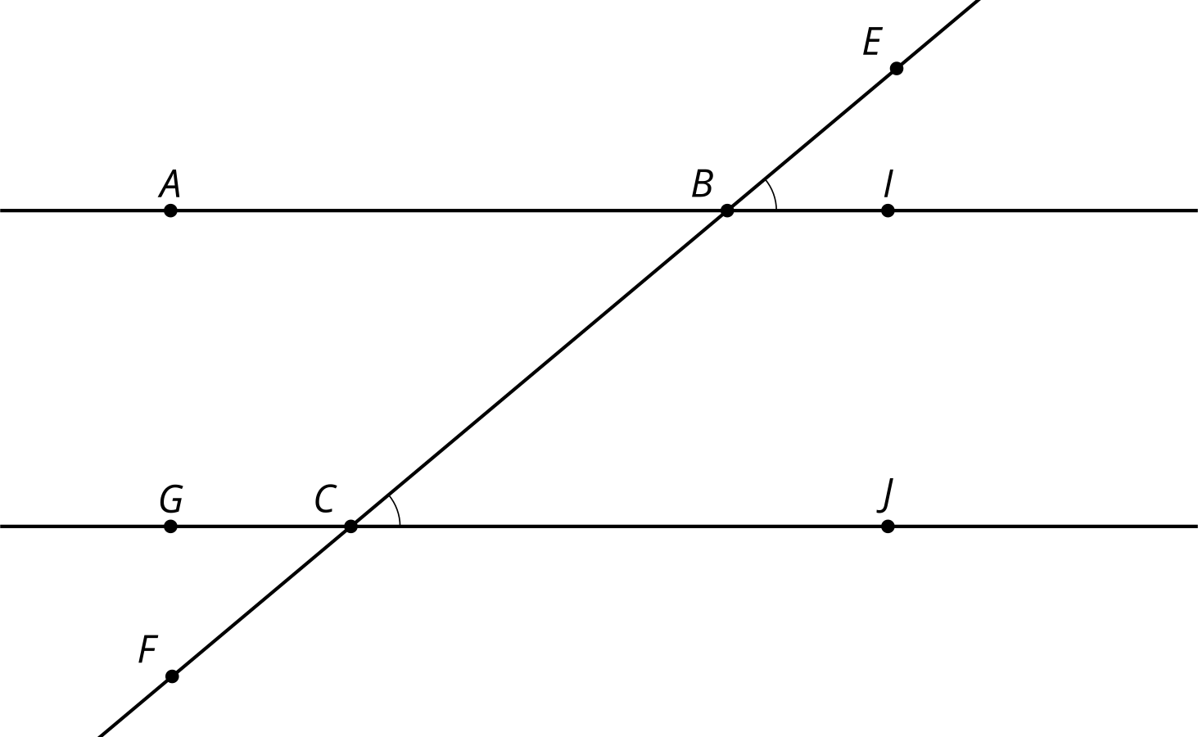
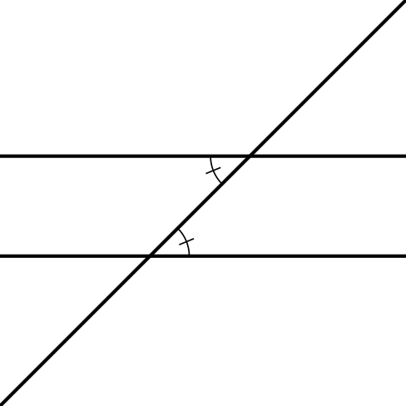
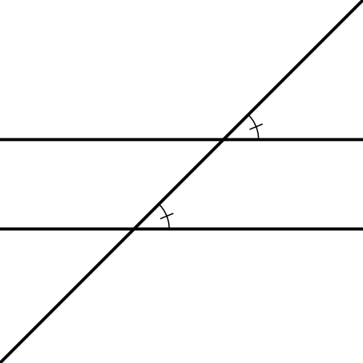
© CC BY 2019 by Illustrative Mathematics®

