Lesson 16: Compare Perimeters of Rectangles
- Let’s solve problems about rectangles of different sizes.

Warm-up: Number Talk: Two and Four Times a Fraction
Find the value of each expression mentally.
- $2×\frac{3}{2}$
- $4×\frac{3}{4}$
- $4×\frac{9}{4}$
- $\left(2×\frac{3}{4}\right)+\left(2×\frac{9}{4}\right)$

16.1: Pipe-cleaner Perimeters
How many different rectangles can be made using the entire length of one 12-inch pipe cleaner?
- Record as many pairs of side lengths as you can think of. Be prepared to explain your reasoning.
- length (inches) | - width (inches)
- 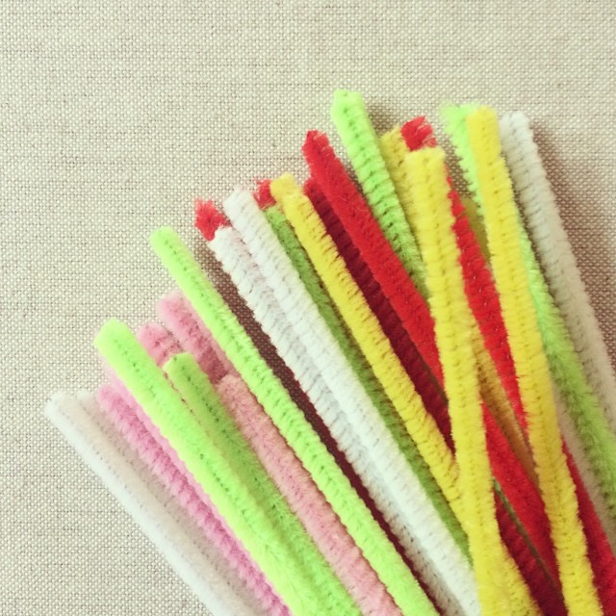
- Which pair represent the side lengths of a square?

16.2: Perimeter Predictions
- Your teacher will assign a pair of side lengths to you. Use a pipe cleaner to build a rectangle with those side lengths.
- What is the perimeter of your rectangle?
- Two 12-inch pipe cleaners are joined (with no overlaps) to make a longer stick and then used to build a square.
  - What is the side length of this square? What is its perimeter?
  - How do the side length and perimeter of this square compare to those of the first square?
- Several pipe cleaners are joined (with no overlaps) to build a square with a perimeter of 60 inches.
  - How many pipe cleaners are used? Explain or show how you know.
  - What is the side length of the square?
  - How do the side length and perimeter compare to those of the first square?

16.3: Gridded Rectangles
- Draw the following rectangles on centimeter grid paper. Label each rectangle. Record the side lengths and the perimeter of each.
  - Rectangle A has a perimeter of 16 centimeters.
  - Rectangle B has side lengths that are 3 times the side lengths of rectangle A.
  - Rectangle C has side lengths that are $\frac{1}{2}$ of the side lengths of B.
- rectangle | - length (cm) | - width (cm) | - perimeter (cm)
- A |  |  | - 16
- B
- C
- Rectangle D has a perimeter of 96 centimeters.
- The perimeter of D is:
  - __________ times the perimeter of A
  - __________ times the perimeter of B
  - __________ times the perimeter of C
© CC BY 2021 Illustrative Mathematics®

